# Afterthought: A family story

by Heather Marie Akou

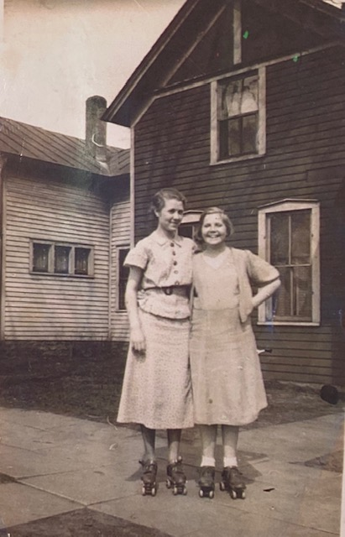

*To my mother, Alice, who was Lila’s daughter*

Prologue

I never met Lila, but her life cast a long shadow on mine.

Both of my parents came from large families. My father’s parents were Catholic and had eight children. My grandfather graduated from high school when he was 15 and wanted to be a lawyer, but his mother needed him on the farm. He farmed until he developed a severe allergy to the mold in hay. When my father was a small child, they moved into town and my grandfather started a business with two of his brothers, selling farm equipment and building pole barns. My grandparents expected their children to be well educated; some of them grew up to be teachers. Holidays at their house in Bloomer, Wisconsin (population: 3,000) were filled with good food, debates about politics, ‘catching up,’ and turkey-induced naps on the living room floor. In the summer, my grandparents had a big garden that filled their backyard. Most of their grandchildren (including me) also grew up in Wisconsin. There were tragedies from time to time, like my aunt Phyllis dying from breast cancer when she was only 28, but for the most part, it was a loving and stable group of people. When I became the first person in my extended family to earn a PhD, I dedicated my dissertation to my paternal grandparents. They would have been proud.

My mother’s family was also large, but very different. Since her parents had both passed away, family visits involved different stops. Aunt Bonnie lived in Sparta with her husband and children. Uncle Larry had been adopted by a family near Holmen. His adoptive father, Grandpa Peterson, let us feed carrots to his Shetland ponies. Grandma Peterson made the most delicious sandbakkels (Norwegian sugar cookies) and always gave us a paper plate full of treats for the drive home. I loved visiting them. Aunt June lived in Indiana, so we didn’t see her very often. Uncle Randy had been adopted by Grandma and Grandpa Schneider (Myrtle and Carl), who lived on the edge of West Salem. They had a big family, which made the holidays crowded. I didn’t realize until I was a teenager that Randy was my mother’s half-brother. My aunts, Laurie, Pam, Charlou, and Uncle Steve were actually my cousins. John Schneider was Myrtle’s second husband—not Randy’s adoptive father—but he was also my great-uncle. We were all related in multiple and confusing ways.

Aunt Myrt (Myrtle Joyce) lived in La Crosse. By the time I was born she was a single mother with four children, living in public housing. Although I didn’t know it at the time, her life was the most similar to Lila’s. Compared to my father’s family her house was chaos. There were lots of strangers and drinking and nobody ever talked about politics. One of my early memories is sitting around with some adults watching *Halloween*, which is about a costume-wearing serial killer who stabs children. It must have been my first R-rated film. We had cable at home, but my parents never watched adult movies; even MTV was forbidden. I wasn’t sure what my aunt (or really most of my mother’s family) did for a living. When Myrt’s son started going to prison, my parents warned me to stay away from him.

Some of my mother’s family members showed up for my high school graduation party, but we didn’t have much to talk about. I was leaving for college in the fall. None of them had been to college; some had not even graduated from high school. The most highly educated one in the family was my mother’s younger sister, Bonnie, who worked as a nurse. When I got married just before my twenty-first birthday, there was a noticeable sense of happiness and relief in my mother’s family. I had done something they could relate to! Now my parents would be able to have grandchildren! I imagine they were somewhat disappointed when I stayed in college and continued into a graduate program instead of having babies right away. My first child was born when I was 29. My choices made us mutual strangers.

From time to time while I was growing up, I asked questions about my mother’s parents. Where did they live? What were they like? How did they die? My father had an opportunity to meet my grandfather, Herman Schneider, who died from a heart attack a few months after my parents’ wedding. I met his second wife, Emma, who lived in a tiny house on French Island and was a very sweet and quirky woman. She only had one tooth and refused to wear dentures. One winter she grew a beard! (She said it was cold and she didn’t feel like shaving.) My grandfather was a farmer, but I eventually learned that he never had his own farm. He dropped out of school after 4th grade and worked for other farmers in La Crosse County for the rest of his life.

My grandmother, Lila, remained a mystery. My mother, Alice, was only eleven years old when she died. In many ways, Lila was a big question mark to both of us. In my late twenties, I was diagnosed with an autoimmune thyroid disorder. Realizing that it was a genetic condition I told my parents they should get tested. My mother said, ‘Oh, your grandmother had a goiter.’ That was the kind of information I always got about Lila—random facts. Never enough to get a real sense of what she was like. I knew some (not all) of her siblings’ names. I knew she was in her thirties when she died. I knew she had given birth to at least seven children, but most of them were not my mother’s full siblings. My grandfather was not the only father. How many others were there? I had many questions, but the answers I received were always brief and confusing. The subject made my mother uncomfortable. At family gatherings there were whispers. Once I heard my mother describe my grandmother as a ‘hussy.’

I went to graduate school to study textiles and clothing. I wasn’t all that interested in American history; I spent a semester in Africa when I was in college, and I wanted to go back. Instead, I ended up studying the history and politics of dress among Somali refugees. When I moved to Indiana in 2004 to work as a professor at Indiana University, my research shifted to contemporary Islamic fashion.

Along the way, I started having children of my own. My son was born when my daughter was two years old, and I was overwhelmed. I thought of both my grandmothers; one had seven children and the other had eight. How did they cope? I couldn’t imagine having even a third child. As my children grew self-sufficient enough that I could do things at home besides making meals, changing diapers, and giving baths, I started working on my genealogy. It was amazing what resources had become available. I discovered that only half of my mother’s family (her father’s family) was German, not 100% like she had always told me. Lila’s ancestors had come to North America from various parts of northwest Europe, including the British Isles, France, and the Netherlands. Two of them were on the Mayflower. One was an accuser at the Salem Witch Trials. Most were farmers, but not the prosperous kind.

During the process of getting divorced, I started thinking about my family history again. Being a single mother was better than being married, but it was never something I had planned for. Why did I assume that the only way to have children was to get married? I wasn’t ashamed to be a single mother. I had a good job. I could take care of myself. Unfortunately, I realized that I was also vulnerable. I thought the children were getting old enough to stay at home while I ran errands, but what if something happened while I was gone? What if they turned on the stove and started a fire? What if a maintenance person showed up at the apartment and thought that I had ‘abandoned’ my children? Is that how my mother and her siblings ended up in foster care? I wondered how Lila had coped with being a single mother. Was there anyone who supported her? My mother (Lila’s daughter) had stopped working when I was born; my parents always claimed that it was a choice they made together, but it severely limited my mother’s independence. For better or worse, Lila had forged a very different path. I started to feel like maybe Lila had been judged unfairly by her family and by society at large.

In 2017, I became director of the Elizabeth Sage Historic Costume Collection at Indiana University, a position I held for four years until the staff was restructured. This led me to new interests in American history, especially working-class men and women and minorities (groups that are not very well represented in ‘fashion’ collections). In the summer of 2019, I decided to write a novel about Lila. If I couldn’t get answers to my questions, I would take my best guess by writing historical fiction. I wanted to explore generational trauma, how women make choices about their lives, and of course—given my background as a historian of fashion, dress, and the body—the landscape of dress and what it was like to be a working-class woman in Wisconsin in the first half of the twentieth century.

--------------------------------------------------

Through a combination of intelligence, white privilege, financial aid, and determination to be independent (and avoid turning into my mother) I slowly made my way into a middle-class lifestyle as a professor. My story could have turned out very differently. My father worked in a factory for most of my childhood. While my classmates were out drinking and having sex and starting to have babies, I taught myself how to get into an elite, private college by reading books from the public library. I was in love with learning. It was my ticket out. In ten years, I earned a bachelor’s degree, a master’s degree, and a PhD. I knew I wanted to have children someday, but birth control gave me choices that Lila did not have.

Lila had a very different sort of life. In a little over ten years (1944-1955) she had seven children. It was a particularly bad time to be a single mother. Between the end of World War II and the Roe v. Wade decision that legalized abortion, hundreds of thousands of pregnant teens and young adults were sent away and forced to give their babies up for adoption.[1] There was enormous pressure from parents, the communities they lived in, the government, and from a rapidly-growing ‘adoption industry’ to hide those pregnancies and to stigmatize mothers who thought they could raise a child without a husband. As far as I know, Lila was twenty-two years old the first time she gave birth. She managed to keep that child and got married before having two more, but she had little support to manage her growing family. She died in 1958 when she was only thirty-six years old. The official cause of death was malignant hypertension, but the truth was more complicated. Unrelenting work and stress, repeated pregnancies, and abuse of amphetamines had destroyed her mental and physical health.

The Slaback family was not proud of Lila, the afterthought who could never just accept her place in life. Absorbed in their own problems, they expected her to be self-sufficient, but when that turned into real, adult independence they punished her for it. Lila wanted more. Her choices were not always good ones, but I admire her strength and her desire to have more—to love and laugh freely and to be her own person. It was not the kind of life a good woman in the early twentieth century was supposed to want.

I *The Slaback Family*

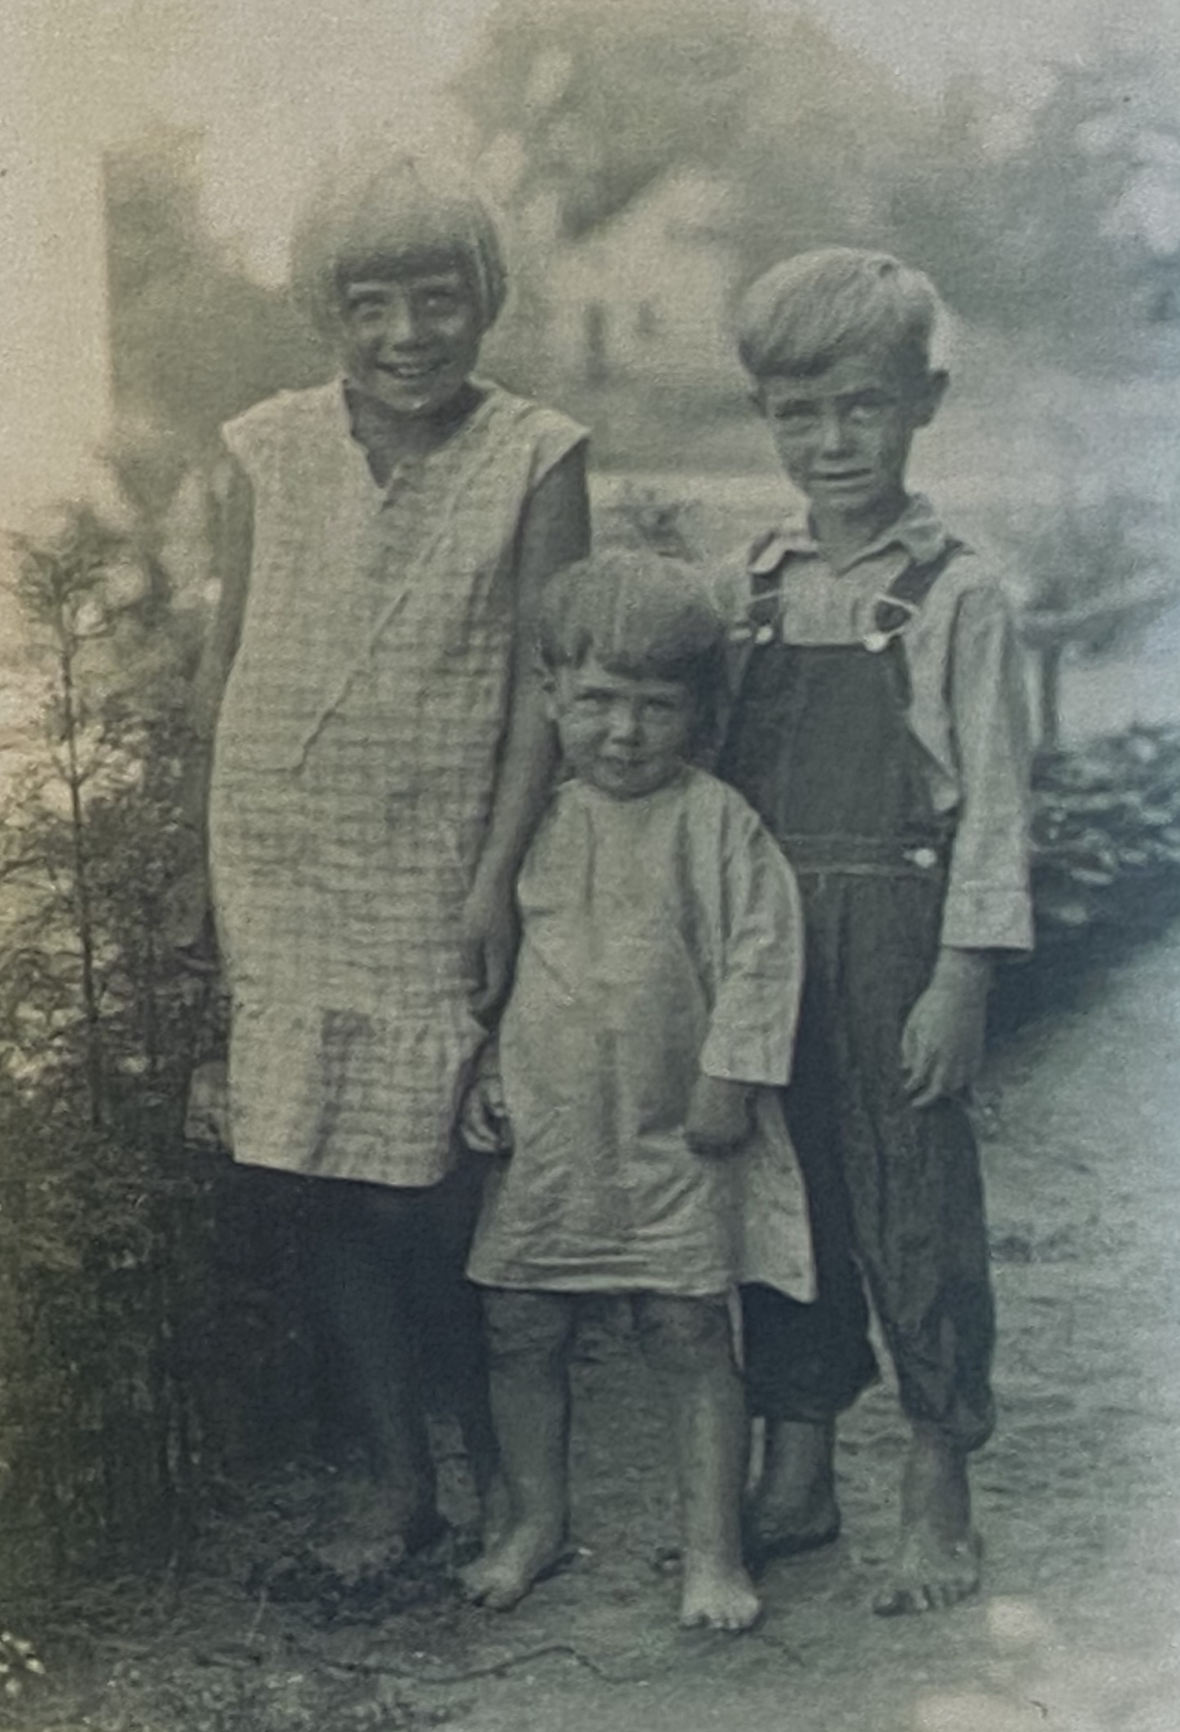

Lila with her younger brothers, Earl and Looy, c. 1931

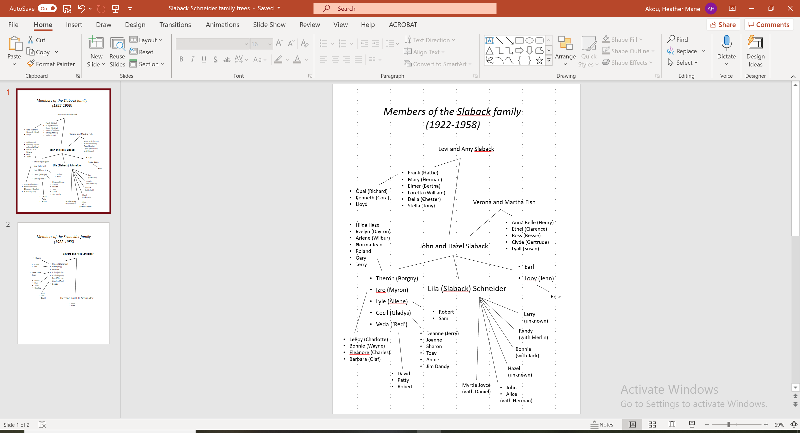

Chapter One

Lila was five years old when her family moved to La Crosse. She told her doll, Elizabeth, “Don’t be scared. I won’t let anything happen to you.” There was barely enough room in the wagon for everyone to sit. Izro made her sit in her lap. She didn’t want to—she wasn’t a baby! Earl, who was only three years old and the real baby of the family, sat in their mother’s lap. Izro whispered into her ear, “Are you excited about getting on the train?” She nodded her head. Her parents had been planning this trip for a long time. They were moving to a new house in the big city. Lila could tell that everyone was excited.

In truth, Lila was also sad. She was thinking about her cat, Annabelle, and how she would never see her again. One of the cats that lived in their barn had a litter of kittens the year before. Annabelle was the only one that survived. She was a tiny ball of gray fluff when Lila picked her up and carried her into the house. Her mother ordered her to take it back outside, but Lila was in love. The kitten was so soft and had beautiful green eyes. She kept sneaking the kitten back into the house until finally, her mother gave up and said the cat could stay. Lila fed Annabelle scraps from her plate until she was old enough to hunt for mice. She didn’t stay in the house very long. Lila looked for her whenever she went outside. There were plenty of other animals around the farm, but Annabelle was the only one that was truly hers. That morning with all the commotion, Lila had not been able to find her. She looked in the barn, behind the house, under the chicken coop, down by the creek—everywhere she could think of—but Annabelle was not there. (She didn’t know it, but Annabelle was hiding with her first litter of newborn kittens.) She was too old to cry about it. Her brothers would have teased her for caring so much about a stupid cat. Izro was busy helping with the cleaning and her mother never wanted the cat in the first place. There was nothing that could be done, so Lila tried not to think about it.

Lila had never been on a train before. On quiet nights she could hear their whistles off in the distance, but she had never seen one up close. Her father purchased tickets from the man who ran the grain elevator and they sat on their trunks to wait, which were packed with everything they owned. The first train, which took them from Soldiers Grove to Prairie du Chien, had only one car for passengers. The rest of the train was for hauling freight. Aside from the conductor and the brakemen, the Slabacks were the only people riding the train that day. Lila’s mother insisted that she sit next to her on the hard wooden bench. Earl was getting fussy, but he stopped as soon as the train started moving. Veda, who was two years older than Lila, sat next to her. She was smiling, but Lila noticed that she was gripping the bench like it was the only thing saving her from certain death. It seemed like everyone was holding their breath as their seats rumbled and the train picked up speed, taking them away from Crawford County.

Hazel and John had both grown up in Crawford County. John had inherited the family farm from his parents, Levi and Amy Slaback. Although he was the youngest of nine children (since his younger brother, Warren, had been killed as a young child when he was kicked in the head by a cow), most of them were girls who had gone to live with their husbands as soon as they got married. Elmer, John’s older brother, was good at math in school and decided that he didn’t want to be a farmer. He had started his own business as a builder and was living with his wife and five children in a different town. Frank, his much older brother, had waited so long to get married that everyone thought he would be a bachelor forever. His wife, Hattie, was a widow with two children when they met. They had moved to the big city of La Crosse, where Frank found a good job as a cutter at the rubber mill. Lila didn’t know if at the time, but Hattie was also working outside of the home at a restaurant for tourists known as The Pearl.

Lila wished that she had been allowed to sit by the window, but at least she could see the tops of the trees as they flew past. It took less than an hour to reach Prairie du Chien, which had a special building just for train passengers. While her father went over to a man standing behind a window to purchase more tickets, the rest of the family sat down by the big clock in the middle of the room and started eating their lunch, which they had carried with them in a basket. Soon it was time to get on the train again. This one was just for passengers. The cars were shiny and the benches had cushions with soft fabric. It was so comfortable and very fast—much faster than the first train. Lila’s mother relaxed a bit and allowed her to stand by the window so Lila could see what was happening. Not long after they left the station, the trees cleared and she could see an enormous stretch of water. It was dark blue and there was a long, flat boat being pulled by a smaller boat. Her brother, Theron, told her it was the Mississippi River. Lila didn’t know there was that much water in the world. Already, the landscape was very different from the farm.

Although she didn’t mean to, Lila fell asleep on the train. One minute she was watching the river and the next minute Izro was telling her, “Wake up, Lila. We need to get off the train and you’re too big to carry.” They had arrived at another train station, but this time they were not going inside. Uncle Frank was waiting for them with a truck. “Welcome to La Crosse!” he said and gave Lila’s mother and father a warm hug. When John was thinking about getting out of farming, he and Theron had traveled to La Crosse and stayed with Frank and Hattie for a few days. During the last long winter on the farm, they had shared their stories about the city so many times—about the tall buildings, the cars, the places to shop, and the crowds of people dressed in fancy clothes—that to Lila, the city already seemed like a familiar friend.

As they stood in the train station, Lila counted her brothers and sisters and parents and Uncle Frank. Ten people. She wasn’t in school yet, but she was proud that she could count. Izro had taught her how. Her father left to find the trunks and her uncle said, “Who wants to go first?” Her mother decided that she would go, taking Izro and the younger children. Their new house was on the northern edge of the city. John had built it with help from Elmer, who knew the best places to buy lumber and fixtures. Hazel wanted to open the windows and let in some fresh air before they moved everything inside.

There was just enough room in the front of the truck for Uncle Frank, Hazel, Izro, Veda, Lila, and Earl. Lila sat in Izro’s lap again and for once she was glad. A truck was much faster than a wagon. What if they crashed? What if Uncle Frank drove into the river? They closed the doors and started driving down the street. Lila was relieved that he wasn’t driving too fast. By the time they reached their new house, she thought maybe driving wasn’t so bad.

Chapter Two

Early the next morning, Lila woke up and realized that it had really happened—they were in the new house. She was in her new bedroom, sharing a bed with her two older sisters, Izro and Veda. It was cozy and warm under the quilt. Last night they had taken their clothes out of the trunks, hanging them on nails around the bedroom. Lila’s doll, Elizabeth, was waiting patiently on a bench next to the bed, along with Veda’s doll, Francine. It was still quite cold at night, so Izro had closed the window before they went to bed. The house smelled like fresh wood, but there was another good smell; her mother was cooking eggs and bacon. Her older brothers were laughing. Lila slipped out of bed and walked to the bathroom next door. She could hardly believe that they lived in a place where it was no longer necessary to use the outhouse—they didn’t even have an outhouse! In the back there was just a garden, waiting for them to plant new seeds. The night before, Izro told her that she should wash her hands every time she went to the bathroom. There was a bar of soap sitting in a bowl next to the sink and a piece of cloth hanging on the wall. It was a thrill to turn the taps and watch the water rushing into the basin. Lila had played in the creek behind their old house, diverting the water with sticks and mud and watching it rush back out when the ‘dam’ broke. It was fun, but most of the year it was too cold to play in the creek. The sink had one tap for cold water and one for hot water. How did the water get hot?

When she went back to the bedroom, Izro and Veda were starting to wake up. Izro said, “Let’s get both of you dressed.” Lila and Veda dutifully took off their nightclothes and put on their dresses. Izro combed Lila’s hair and tied it back with a strip of cloth. Lila and Veda were wearing nearly identical dresses; their mother had made them from the same pattern, using blue fabric for Lila’s dress and green fabric for Veda’s. They fit loosely and had strings at the top to adjust the neckline. At the bottom, they had neat lines made by hemming extra lengths of fabric. The hems could be removed as necessary to make the dress longer. Izro had recently removed two of the lines from Veda’s dress because she was having a growth spurt. It wouldn’t be ladylike to wear a dress that was too short. Since it was not very warm yet, they would have to put on their stockings, shoes, and sweaters before going outside. Lila hated all the layers because the wool was so itchy. Inside, their dresses were enough.

Veda had beautiful hair that was nearly golden and liked to have it braided, so Izro did that and then the two younger girls skipped off for breakfast. Izro stayed behind to change her clothes and comb her own hair. She would join them soon. Lila sometimes let Izro braid her hair, but it was a challenge to sit still. She preferred to leave it loose, even though Izro teased her that she looked like a ‘wild animal’ with her hair down.

Later that morning, while Izro was helping her mother clean up from breakfast and start preparations for lunch, Lila and Veda went outside to explore the neighborhood. Earl was too young to go with them and Cecil was too old—he was eleven and wanted to see what his older brothers were doing; he didn’t want to spend the day with two girls. That first day, they were only brave enough to walk around the block. By the end of the week, they were crossing the street and exploring the neighboring blocks. There were so many houses! Some were tiny and some were large; they had many different colors and shapes. A few had fences, but mostly Lila and Veda could see into their yards. Many of the houses had gardens and lines for hanging wet laundry; a few had an extra building for a car. One of their neighbors even had a little house just for his dog. It was a big black dog with curly hair and he was not very friendly. When he started barking, they would walk as quickly as they could until that house was behind them. One day the dog’s owner came out and yelled, “Stop bothering the dog!” Lila thought it wasn’t fair—she wasn’t doing anything to make the dog act that way—but good girls didn’t talk back. She and Veda put their heads down and walked a little faster. They said nothing to their parents. Veda was always ashamed to be scolded and did her best to avoid it.

As the weeks passed, they started discovering other children. Edith and Margot’s parents were very strict and spoke German. Lila and Veda could visit, but Edith and Margot were never allowed to go beyond the family’s yard without their parents unless they were walking to school. Their father was a beer maker who lost his job because of Prohibition. Ruth, Anna, and Magnus had recently come from Norway. Their mother didn’t speak any English, but she made delicious cookies. Margaret didn’t have any brothers or sisters. What a surprise! She lived in a tiny blue house and had several pets: a cat, a dog, and a pair of yellow birds that lived in a beautiful cage. Lila was jealous. She missed her cat, Annabelle, and wondered how she was doing. Margaret’s mother was a sweet woman who always invited the girls in for sandwiches. Some days, Lila and Veda forgot to go home for lunch. The first few times their mother scolded them, but eventually she decided that it was fine as long as they were back in time for dinner.

Izro had warned them to stay away from the river. It wasn’t like the creek behind their house on the farm. The section closest to their neighborhood was the Black River and not the Mississippi (it joined the Mississippi at French Island), but the current was still very strong and it was not safe to play around. One hot day that summer, Lila and Veda decided to go down to the water and dip their toes in. What could it hurt? The cool water felt delicious on their feet. Veda stayed at the edge, but Lila started splashing and wading in a bit deeper. Veda said, “Lila, what are you doing? We’re not even supposed to be here!” but it was like her voice was muffled. It was so pleasant to feel the water swirling around her legs and wetting the hem of her dress. All of a sudden, she was completely under the surface. The water instantly filled her mouth and nose, but her eyes were still open. Not that it mattered, because the river was so murky that Lila could barely see anything. Before she could panic, Lila felt a tug on the back of her dress. A man living on a houseboat had noticed the girls playing by the river and sprinted over as soon as Lila disappeared. “What are you doing here?” he yelled. “Go home and don’t come back! It’s not safe!” The girls both started running.

As soon as they were out of the man’s sight, Veda burst into tears. She kneeled on the ground and covered her face with her hands. The water from Lila’s dress and hair were pooling at her feet, turning the dust into mud. What were they going to tell their parents? Once Veda had calmed down, she decided they should stand there until Lila was dry. “If the neighbors see you like that, someone will tell mom and dad for sure.”

Houseboats along the river in La Crosse; Library of Congress Prints and Photographs Division, #LC-USF33-003063-M4; photograph taken by Arthur Rothstein (1915-1985) in 1939

Chapter Three

Shortly after they arrived in La Crosse, Uncle Frank and Aunt Hattie took the family to Grandad’s Bluff for a picnic. There was a park at the top with a magnificent view of the city. Lila had met Uncle Frank the day he picked them up from the train station, but it was her first time meeting Aunt Hattie and her cousins, Kenneth and Lloyd. Hattie was taller than her mother and older too—more like a grandmother than an aunt. She was wearing a light blue dress with short sleeves, a long string of beads, and a matching hat with a darker ribbon. Lila didn’t mind when Aunt Hattie leaned down to give her a little hug, her dress was soft and she smelled like flowers. (That night, her mother made a comment about the short length of Hattie’s dress and how scandalous it was for a woman her age to dress that way.)

Her cousin Lloyd was seventeen—almost the same age as her brother, Lyle, except that he was the youngest in the family. He had wild black hair and dark eyes with a look of mischief. Lila heard her uncle say that Lloyd had left school and was training to be a cabinet maker; maybe he could work for John. Lila felt a mixture of excitement and nervousness around Lloyd. Her own brothers ignored her most of the time, but Lloyd did not. They played a thrilling game where Lloyd held her by the feet and spun her around in a tight circle, with her arms and hair flying out. Veda didn’t want to give it a try; she said just watching made her feel dizzy. Lila and Earl took turns until Aunt Hattie said sternly, “That’s enough now.”

Lila, Izro, and Aunt Hattie went into the kitchen to finish preparing the lunch. The night before, Izro had baked several loaves of bread and two pound cakes. They put some in a basket along with a container of butter, some jars of pickles (which Hazel had made from the tiny beets and cucumbers that were just starting to appear in their garden), a big block of cheese, a sack of fresh peas, and two jars of strawberry jam. They also added a knife to cut the bread and cheese, a cutting board, cups for water, and some plates and silverware. Lila’s mother commented that the younger children would not need plates; they could hold their sandwiches and wander off to play. Lila thought that was a good plan; maybe she wouldn’t have to eat the peas. She didn’t really like them, but children had to eat whatever food they were given. It was a rule.

When the picnic basket was ready, the group filed out the front door. They would walk together to the nearest streetcar line and then ride the rest of the way. Lila’s father carried Earl on his shoulders. Although she knew it was wrong, Lila felt a bit jealous. She consoled herself by thinking, “At least I’m old enough to walk on my own. I don’t need to be carried.” Before she knew it, they had reached the first stop on the streetcar. It was five cents to ride. Uncle Frank paid for the tickets. The first streetcar took them past Frank and Hattie’s house (Lloyd pointed it out to his cousins). When they reached downtown, they switched to another streetcar that would take them down Main Street and up the hill, close to the top of the bluff. Built on a plain next to the Mississippi River, most of the city was flat. Although the bluffs on the other side of the river went all the way to the shore (which made it impossible to farm and difficult to build houses), Grandad Bluff was two miles east of the river. In the summer, it was popular for families to go hiking and take picnics. Aunt Hattie had been there many times with her friends. When the line ended, it was just a short walk into the park.

At the edge of the park there was a wooden deck where you could go to get the best view. Lila went up to the railing, but Veda shook her head and refused, saying that it was “too scary.” They were high above the city. Lila wondered if she could spot their house. She found the bridge that went over the river and was looking around trying to find their neighborhood when suddenly she heard, “Lloyd Spencer Slaback, you get away from there this instant!!” Aunt Hattie was furious. Instead of staying on the deck, Lloyd was going around the railing to the very edge of the cliff. Lloyd laughed and said, “I was just trying to have fun.” Lila felt sick to her stomach. It made her nervous for Lloyd; nervous that he could fall, but also worried about what Uncle Frank would do to him once they got home. If her brothers behaved that way, her father would have hit them with a belt. Aunt Hattie went back to talking with Lila’s parents like nothing was wrong, but Lila wasn’t able to eat much when it was time for lunch.

Chapter Four

That fall, there were two big changes. At the beginning of September, a new baby came to live in the Slaback house. Lila had noticed that her mother was getting bigger, but she didn’t really understand why. She was only two years old when Earl was born. (She didn’t know it, but her older siblings had learned about pregnancy by watching the cows on the farm. Lila and Earl were the only members of the family surprised to get a new brother.) Looy hardly slept. For the first few months it seemed like he would never stop crying. He was healthy, but his little face would get dark red and he would cry for hours. The only way to soothe him was to bounce him or take him outside for a walk in the fresh air. All he did was cry and throw up and make stinky diapers. Looy’s arrival made Hazel even more impatient and angry than usual.

The second big change impacted Lila more directly. A few weeks after Looy’s birth, John took Lila, Veda, and Cecil to register for school. Lila had not been old enough to attend when they lived in Crawford County, so it was a new experience. She had a lunch pail that Izro had filled with an apple and some sandwiches wrapped in a piece of cloth. The school was so big that there were many different classrooms. Lila was shocked when her brother and sister were led away to other parts of the building. She would be in first grade and was assigned to Miss Miller as a teacher. One of the women from the office took her hand and said, “Come with me, young lady.” They walked down a long hallway past several other doors and the woman said, “This is the one!” There were many other children already inside the classroom. Miss Miller was standing at the front of the room and asked her to sit at one of the desks. Lila chose a seat next to a girl with freckles and curly red hair. She smiled and the other girl smiled back. The desk was smooth, with curlicues of metal on the sides. Most of the room was filled with desks lined up in neat rows. Lila would spend many hours running her fingers around the curlicues to pass the time. The boys liked to sit in the back so they could make jokes and cause trouble, but Lila was determined to be a good girl and sit quietly in her seat.

Miss Miller had all the letters of the alphabet written on the blackboard and asked the students to copy her writing on their slates. Lila was astonished to realize that her desk had a slate and two pieces of chalk inside… every student had one. Even more astonishing was the next week when Miss Miller handed out books: they were blue and she gave a copy to every student. Lila had never held a book. She knew about reading—her parents and older brothers sometimes read aloud from the newspaper while the rest of them listened. Miss Miller said, “Please keep these inside…” but Lila barely heard her instructions. The book was filled with colorful pictures of animals and children. The first story was about two children and a mother cat. She thought they must be on their way to church; the girl had a big white bow in her hair, a frilly white dress, and blue socks. Lila didn’t have such fancy clothing, but she was satisfied with her appearance. She was more interested in the pictures of the animals.

During lunch, Lila was relieved to see her sister and brother and many of the children from her neighborhood. Some of the boys were playing a rough and silly game of Red Rover. She quietly ate her sandwiches, not talking or being asked to talk—nothing out of the ordinary. At home, her parents and older brothers did most of the talking. They talked about the new truck (which was for work, not for the family to ride in), what lumber mills had the best prices, where they could sell the extra vegetables from the garden, who was building a new house two blocks away, and when they might have guests over to play cards. Even if Lila had a chance to speak (which was rare), the adults were not interested in that scary dog on the next block, what kind of cookie was Lila’s favorite (chocolate chip), or what happened at school that day. The world was a place for adults and Lila would just have to wait her turn.

Chapter Five

One night that fall while the family was eating dinner, Theron said that he needed to make an announcement: he was planning to get married. Lila’s mother stood up, handed the baby to Izro, and went over to Theron to give him a big hug. Although she had tears in her eyes, she was clearly not sad. She said, “Oh Theron, I’m so happy for you!” Lila turned to Veda and said, “What does that mean?” Veda said, “Theron wants to have a wife so they can become a mommy and daddy.” It wasn’t long before she heard the word ‘marriage’ at school. Some of the girls were playing a clapping game: “First comes love, then comes marriage, then comes the baby in the baby carriage!” Is that what her parents had done? Lila had learned where babies came from thanks to her new little brother, but thought she knew nothing about love and marriage.

A few weeks later, a stranger named Myron arrived at their house for dinner. It wasn’t that unusual to have a guest over. Maybe he was one of her brother’s friends. Lila’s father shook his hand and the men went out to the backyard to look at the garage and the truck while Izro and her mother finished cooking. Izro handed a stack of plates to Veda and the silverware to Lila and told them to go set the table. She wasn’t exactly rude about it, but she seemed nervous—not her usual self. Lila noticed that her cheeks were pink.

At dinner they talked about Myron’s family. His parents had lived in La Crosse and his mother was best friends with Aunt Hattie before they moved to Onalaska. His parents were from Norway and changed their names from Lars and Anna to Louis and Antoinette. (Lila thought that was fascinating; she had no idea that it was possible to change your name.) There were seven children in Myron’s family, three girls and four boys. He was the youngest son, the sixth out of seven kids, exactly the same as Lila. It was nice to hear about something besides lumber prices and vegetables. Then Myron said, “Mr. Slaback, what I came to ask you is… would you allow me to marry your daughter, Izro?” Lila’s mother had been so happy when Theron said he was getting married, but that night she was very quiet. Lila was confused about the difference in her reaction. Was she angry at Myron for some reason? Did she not want Izro to get married? Her father said “yes” and her older brothers gathered around to laugh and slap Myron on the back and to say, “Welcome to the family!” Lila looked across the table at Izro and thought she must be running a fever, because her cheeks had turned from pink to red.

The family decided to have a double wedding in January and it was very cold—the kind of cold where the snow is crunchy and it screams when you step on it. Lila was still on vacation from school and she was wearing a new dress that her mother had made on the sewing machine. It was the same shape as the other two dresses she wore to school, but this one was thicker (and warmer) with a pattern of red roses on a blueish-green background. Lila felt beautiful in the new dress, especially with a matching red ribbon in her braids. She had received the dress and ribbon for Christmas, along with an orange, a new pair of mittens (made by Izro), a scarf for her doll (knitted by Veda, who was just learning), and a rope for playing games outside. Her mother told her to start putting on her coat and hat because Uncle Frank would be there soon with the car to pick them up and take them to church. Lila vaguely remembered going to church back when they lived on the farm—it already seemed like they had been in La Crosse forever. Where was Izro? “She’s at the church waiting for us,” said her mother. Without Izro there to give her a reminder, Lila forgot to put on her mittens. Her mother scolded her when she noticed.

Theron and Izro were getting married in the Norwegian church. It was just far enough from their house that Lila had never noticed it before. When the car pulled up to the curb, she could hardly believe how tall it was. The main part was brick and shaped like her school, but in the front the church had an enormous tower with a tall gray roof. Lila had heard about castles and wondered if this was one of them. The size of the building was breathtaking; the front door was big enough for a giant. Lila got out of the car with her mother and the younger children and together they stepped into the building. The entrance was dark, even though it was daytime. As they went up the stairs, however, and the bright interior came into view, it was like climbing into heaven. They entered from the back of the main room, which was filled with rows and rows of wooden benches. (Lila wondered how many… she wished that she could walk from one end to the other and count them all.) The walls were painted white, but they were streaked with colors from the light streaming in through the windows, which were filled with pieces of colored glass. The effect was incredible. At the front of the room there was a very large wooden cross hanging on the wall, a table with a white cloth, racks of large white candles, and a wooden railing with a long bench in front of it. There was soft music playing. Where was it coming from?

There were already people sitting in the first few rows. Lila recognized Uncle Frank and Aunt Hattie, her cousin Lloyd, and her older brothers, but most of them were strangers. Myron and Theron were standing in the front of the room by the railing. Where was her father? Where was Izro? Her mother handed Looy to Aunt Hattie; as she took off her coat and hat and placed them next to Lila, she ordered Veda to look after Earl (“Make sure he doesn’t leave this bench”). Then she turned and left. “Where are you going?” Lila asked, but her mother didn’t answer her. Aunt Hattie said, “Your mother will be back soon, Lila. Please be a good girl and stay quiet.”

Shortly after her mother returned, the music changed and everyone turned to look at the back of the room. There was a beautiful woman with blonde hair standing next to a man who she didn’t recognize. As they started walking slowly towards the front of the church, Lila saw that there was another woman behind her—it was Izro! She was standing with their father, who was wearing his best shirt and pants. Izro looked shy and nervous, but her father was calm. As they arrived at the front of the room, Lila noticed a man wearing a dress and she giggled—why was he wearing a dress? Her mother nudged her, which was a clear sign to be quiet. She saw that Izro and the blonde woman (whom she would quickly learn was named ‘Borg-knee’) were both wearing long white dresses and veils made of beautiful white lace. How could they see with the veils over their faces? As they reached the front, Izro stood next to Myron and Borgny took her place next to Theron; Lila was relieved when the men lifted the lace and pulled it back so the women could see. Maybe she really was in a castle because they both looked like princesses.

Lila thought most of the service was boring. The man in the dress read from a book and told everyone what to say. Each groom gave his new wife a ring and the man said, “You may now kiss the bride.” Ew! Lila had never seen a man and a woman kiss before. Sometimes Izro kissed her on the cheek or on the top of the head, but this was different. They were kissing on the lips and some of the young men watching from the pews cheered and clapped. Izro blushed, but she was smiling as the couples walked past. Her mother told Lila they were heading downstairs for lunch and to please bring her coat and hat. As they ate ham sandwiches and pickles and drank coffee (which Lila was usually not allowed to drink; her father warned that it would “stunt your growth” if you drank it as a child), Lila looked around the room. Everyone was smiling, even her mother. She thought a wedding must be a very good thing.

Chapter Six

That night, Lila slept upstairs in the attic for the first time. There was plenty of space, but she didn’t understand why it was necessary for Izro and Myron to have the room downstairs to themselves. Myron’s parents (who were old, even older than her own parents) were sleeping there too, “Just for the night.” It took her a little while to fall asleep in the unfamiliar space, which is how she noticed that Myron’s father was snoring. Lila giggled. It was a deep rattle like the sound of a bullfrog, but there were no frogs in the winter. Although it was cold in the attic, she was warm enough sharing a bed with Veda. They had the quilt that they usually shared with Izro. She hoped that Izro was warm enough downstairs without it.

The next morning, everyone ate breakfast together. There wasn’t quite enough room at the table for everyone to sit at the same time, but the older boys said they could wait. Izro and her mother cooked an endless number of pancakes, which they ate slathered with butter, maple syrup, and raspberry jam. When they were finished, Myron’s father said, “I guess it’s time that we should leave.” Izro, Myron, and his parents put on their coats and everyone started hugging. What was happening? Where was Izro going? When she gave Lila a hug, Lila started crying. She knew she was being a baby, but she couldn’t help it. Izro told her, “Don’t cry… I’ll start crying too.” Lila did her best to dry her tears. She didn’t want to cause Izro any trouble. Lila wanted to go outside and watch them leave, but her mother told her to watch from the window. That night she and Veda went back to their old bedroom, but it was lonely without Izro. Who would give her a kiss goodnight and comb her hair in the morning? Her mother was busy with Earl and Looy. Lila, Veda, and her mother were the only girls left in the house. Lila was grateful that she was sharing a room with Veda.

A few days later was the start of the new term at school. Everyone was excited, talking about the fun things they had done over the break and showing off their presents. The principal came into the classroom and said that they would have a new teacher starting tomorrow. Miss Miller (who was now Mrs. Johnson) had left her position to get married. One of the boys asked why and the principal explained: married women could not be teachers, because they would be too busy having babies and taking care of their houses. Lila had not been very attached to Miss Miller, but losing her compounded her sense of loss from Izro moving out.

During lunch, she told her friend, Kathleen (the girl with the red hair and freckles who occupied the desk next to hers) about the wedding. “How lovely! I can’t wait until I get married. I want to have a big white dress… even fancier than the dress I’m wearing for First Communion next year… and my whole family will be there and it will be so happy and beautiful. I wonder what my new last name will be? I wonder how many children I’ll have? Tell me about your sister’s dress!” Lila wished that she could be so excited. The church and the wedding dresses were beautiful, but she had mixed feelings about what happened after the wedding. It might be exciting to live in a new place, but would you miss your family? Would they miss you? Izro was living in Onalaska now and Lila had no idea when she would see her again.

For a few weeks, their mother braided Veda’s hair in the morning. She was not very gentle or patient. Lila thought it must hurt when she combed out the snarls in Veda’s hair, but Veda never complained. Then Veda would attempt to braid Lila’s hair. She was also not very good at it—not like Izro. By lunchtime her braids would be loose; by the time the girls walked home from school, at least one braid (sometimes both) would be completely undone. One of her ribbons got lost and her mother scolded her for being careless. By spring, their hair was starting to get a bit wild. One day, her mother announced that she was tired of dealing with it—she was giving Lila and Veda a haircut. Veda’s eyes opened wide and she looked like she was going to cry, but they both knew that it was no use complaining. Lila’s first haircut was so short that she looked like her brothers. When they visited Aunt Hattie that weekend, she said, “Your hair is so stylish now, Lila! You look like a flapper.” Lila thought it was just plain ugly. She didn’t know what a ‘flapper’ was or why any girl would want to look like a boy.

Chapter Seven

While the adults in Lila’s neighborhood were going to work and entertaining themselves with picnics and card games, the children occupied themselves with school, climbing trees, ice skating, and endless games of tag, duck-duck-goose and kick-the-can. Birthday parties were a special treat, with cake and ice cream, games that were only played at parties and small presents for the birthday boy or girl. Lila’s classmates often anticipated their birthday parties for months, especially who would be invited to attend. Telling a friend, “You’re not invited to my party!” was an insult. Although a few mothers invited the whole class, most could not afford to have so many guests, which made invitations a kind of currency; giving and withholding invitations was important for establishing one’s social status. Having parents who could afford a big party was an easy way to become popular.

Lila was not one of the popular girls, but she was invited to parties from time to time. At the start of second grade, Viola Johnson invited Lila to attend her party. She was the oldest child in her family; her sister Myrtle had just started first grade. They lived in the same neighborhood as Lila, but on the opposite side of the school—close to the church where Theron and Izro were married. Their father spoke English with a thick Norwegian accent. To decorate the house for the party, the girls had made strings of paper flowers and their mother had baked a fancy cake with white and pink frosting. They had also made a large drawing that they would use to play “pin-the-tail-on-the-donkey.” Lila had only played once before, but she thought it was fun. Starting with the birthday girl, each child would be handed a “tail” (a strip of paper with a pin in the end), blindfolded, spun around and then released in the direction of the donkey. The winner would be the person who came closest to putting the tail in the right place. Some people would miss the drawing entirely or pin the tail in a funny place like the donkey’s ear. There was no way to tell what you were doing with the blindfold on.

To Lila’s surprise and delight, they also played “musical chairs.” There were eleven children at the party (including Viola and Myrtle) so they set ten chairs in a circle in the middle of the sitting room. Viola explained the rules: her father was going to play music on his fiddle as everyone walked around the circle. As soon as he stopped, everyone should sit down as quickly as possible. The last person (who would not have a place to sit) would be declared “out” for the rest of the game. They would then remove a chair and do the same thing again until there was only one chair left. The last person with a place to sit would be the winner. Lila recognized the song that Viola’s father played: Pop Goes the Weasel. She was the third person to go “out,” but she didn’t mind—it was just as fun watching everyone. Viola and her sister lasted longer; when Myrtle went out, she burst into tears. An older boy named Peter was the winner.

All of the children ate cake and watched as Viola opened her presents. Lila’s mother had given her a present to take to the party; it turned out to be a little sack filled with candies. Viola said, “Oh thank you, Lila!” But as she unwrapped the other presents, Lila felt a bit embarrassed. It seemed like the rest of the presents were much nicer—a teddy bear, some clothes for her doll, a jump rope, and even a yo-yo (a new toy that was becoming popular at school). Viola thanked every person. As they were leaving, Mrs. Johnson thanked all of the children for coming. Lila said politely, “Thank you for inviting me.” She was used to roaming around the neighborhood with Veda and increasingly with Earl, but her brother Cecil was waiting at the door to walk Lila home. That was a nice surprise. She had expected to walk home alone.

As soon as they could no longer see Viola’s house, Cecil ran off. He was laughing and said, “Catch you later!” Lila sighed. He was probably heading to the playground for a game of baseball. It was a popular thing for boys to do when they were not in school. Cecil even had a small collection of baseball cards, which came in packs of cigarettes purchased by their father and brothers (who would have thrown the cards away if they were not so fun for the children to collect and trade with their friends). Cecil’s prize possession was a card for Pat Malone, the star pitcher for the Chicago Cubs. He liked to pretend that he *was*Pat Malone, staring down famous batters like Babe Ruth and Mel Ott (who were played by his friends, James and Frank). All of them pored over the newspapers for the latest stats, arguing about which team was the best and who would make it to the World Series that year. As Lila walked by the playground, she saw them already absorbed in a game. The boys didn’t notice her.

When she got home, her mother was outside in the garden. “You’re just in time. Go change your dress and help me pick these vegetables. I want to sell some of them tomorrow.” Now that Izro was married and Veda and Lila were growing up, her mother was demanding more and more that they help with the chores—weeding and watering the garden, washing the dishes and putting them away, making the beds, sweeping the floors, and peeling the fruits and vegetables as she prepared the rest of the dinner. Veda was nine years old and able to do almost all of the chores. Lila was seven and still learning, but she preferred taking care of the younger boys instead of cleaning. It was more fun to make up games and take them for walks around the neighborhood than to be stuck in the house or the yard doing chores.

The worst chore of all was the laundry. In the summer, it could be done outside. After they filled the wash tub with dirty clothes, pails of boiling water and a bit of soap, it was Lila’s job to stir the clothes for a while with a wooden paddle—like making soup, except there was nothing delicious at the end of the process. Then the clothes would have to be scrubbed on the washboard, rinsed in a tub of clean water, put through the wringer, and hung on the line to dry. It was hot, exhausting work. Although nobody in the house had much clothing, every week the family had at least two tubs of dirty clothing plus two tubs of sheets and towels. The diapers had to be washed even more frequently (but thankfully, not ironed). In the winter they did laundry in the basement, which was cold and dark. One side of the basement was filled with ropes to hang wet clothing, which turned the dirt floor into mud. In the summer, the dried clothes smelled like sunshine and flowers; in the winter, they smelled like a graveyard.

Lila’s mother was always in a hurry. It was not enough just to do the chores; she expected them to be done efficiently and well. Nothing Lila did was ever quite good enough for her. There was always a better and faster way. Lila didn’t understand why it was fine for the older boys to play endless games of baseball while she and Veda were stuck doing chores. Shouldn’t the boys help with the cooking and cleaning? Wouldn’t it be reasonable for them to help take care of Earl and Looy? For a while, Lila said these things out loud, but her mother’s response was always so angry that she stopped saying anything. It didn’t take long to realize that it was easier just to do what she was told and keep her head down. When the family ate dinner that night—two whole chickens plus a big tray of roasted squash, dripping with butter and brown sugar (one of Lila’s favorites)—there was no discussion about the work it took to get the meal on the table. Chores would be one of her lifelong frustrations.

Chapter Eight

One day that fall, Lila arrived home from school and found her mother and Aunt Hattie sitting at the table. They were drinking tea and it looked like Hattie had been crying. Lila was surprised that they were together, because her mother didn’t like Hattie very much. She didn’t think it was appropriate for a married woman to work outside of the home. (Hattie was not fond of Hazel either, but the Slabacks were the only family she had in La Crosse.) “Please go into the kitchen and peel the potatoes,” said her mother. Lila wanted to ask what was wrong, but she knew it would only make her mother angry. Uncle Frank joined them for dinner; but it was unusually quiet at the table. They talked about work and about Izro and Myron—they were expecting their first child. Aunt Hattie had recently paid a visit to Myron’s mother.

The next day when Veda was gathering rubbish from the house, she found a newspaper folded to an article with Lloyd’s name. She read it out loud to Lila.

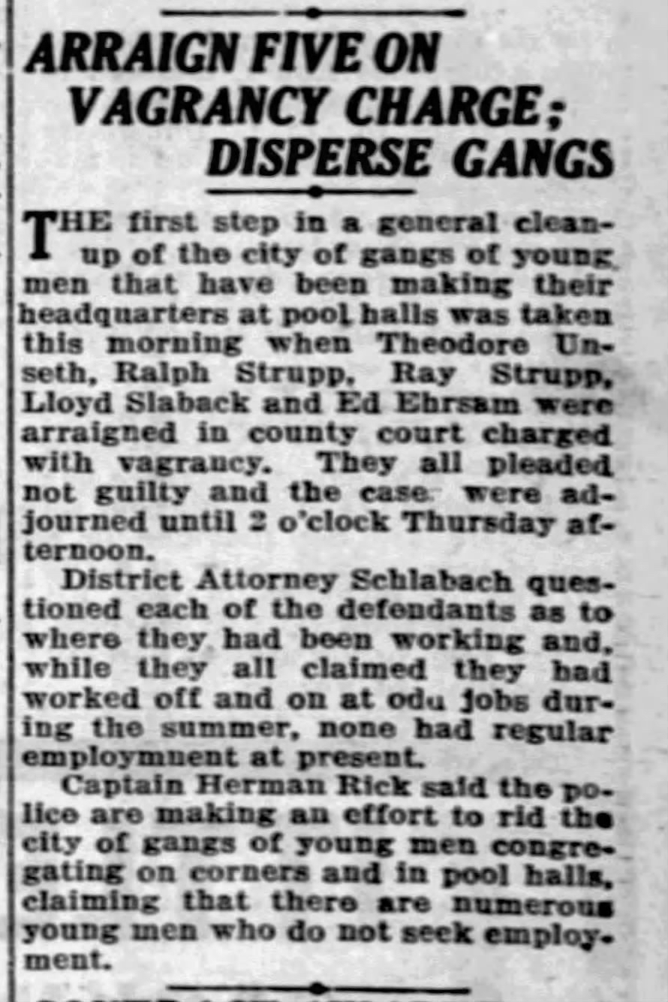

Article on the front page of *The* *La Crosse Tribune*, November 5, 1929

Lila was confused. Lloyd was working for her father… she had seen him at their house. She asked Veda, “What is vagrancy?” Veda said she didn’t know, but it must be something bad if the police had arrested him. No wonder Aunt Hattie had been crying.

Lila was still wondering about Lloyd when a stranger knocked on the door one night during dinner. “Can I help you?” said her mother. “Yes, I’m here to collect information for the census.” She let the woman into the house and told Cecil to give up his seat. The census taker said, “This won’t take long, but if you don’t mind I’ll sit with you and fill out the forms while you eat.” She sat down next to Lila and opened her book to a page that was nearly full of the most beautiful handwriting, even nicer than Veda’s. “Mr. Slaback, is it? Could you kindly tell me your full name and your relationships to these lovely young men and women?” She had so many questions about their names and ages, the value of their house, where their parents had been born, and who was attending school. She asked the children to raise their hands if they could read. Lila raised her hand with pride. This was fun!

At the end, she asked Lila’s father if he was employed and to describe his line of work. He said, “Yes, I’m working. I do odd jobs around the neighborhood.” What? Suddenly, Lila felt sick to her stomach. She remembered the article about Lloyd; in the courtroom he had claimed to be doing ‘odd jobs.’ Was her father going to be arrested too? Lyle was working for her father’s plastering business, but she noticed that the census taker had recorded him as being ‘in school.’ Lila said nothing and looked around the table. Her mother and father did not seem concerned and did not correct the census taker’s mistake. Lila was relieved when the woman thanked them and stood up to leave. Her mother followed her to the door and said, “Have a nice evening.”

There were plenty of good jobs available in La Crosse—at the rubber mill, the iron foundry, the tobacco works, the MotoMeter factory, the railroad—but John Slaback chafed at working for other people. He didn’t want to farm, but he didn’t want other people telling him what to do. His views on work boiled down to one statement: “My ancestors didn’t come to this country to be slaves to the rich.” His brother Elmer had taught him how to plaster houses. It was satisfying work, but unpredictable. Sometimes, he would be so busy that Lila would barely see him for weeks. At other times, there was barely any work and their budget would be stretched razor thin. It was dangerous to ask for anything during the lean times.

That night in bed, Lila asked Veda if their father was going to be arrested for doing odd jobs. “No, silly! Why would you ask that?” Lila recounted how Lloyd had been doing ‘odd jobs’ when he was arrested by the police, but the newspaper said he was unemployed. “Lloyd should be getting married instead of drinking and playing pool; daddy has been married for a long time.” Lila was not entirely convinced. After a few minutes of letting the matter swirl in her mind (what was ‘pool’ and why did it matter if he was married?) she decided to trust her older sister’s wisdom and quickly fell asleep.

Chapter Nine

In 1930 there were still eight people living in the house that Lila’s father had built on Kane Street, but it seemed unbearably quiet without Theron and Izro. To cheer the family up, her father decided to buy a radio. They made a place for it near the table so there would be plenty of room to sit and listen. Lila’s mother insisted that dinner time should be for conversation, but otherwise their evenings were suddenly filled with music, news reports, and serial programs. A quick favorite for the whole family was “Amos ‘n’ Andy,” which was about two friends trying to make it in the big city. The show was funny, but it also made them feel better about their own problems—at least the Slabacks weren’t *that* stupid. While most of the programs on the radio were entertaining, the news reporters were always very serious talking about the stock market, unemployment, and President Hoover. Her father was not working as much as he did the year before, but Lila thought her family was doing fine. They had a house to live in, clothes to wear, and the shelves in their basement were loaded with jars of food.

Theron built two wooden benches in the back of the truck so the whole family could ride. During the summer, they started taking trips out into the country. Although it was nice to spend time with their uncles, aunts, and cousins (so many cousins that Lila could not keep track of all their names), they could also do some work in exchange for food. A few hours of weeding and picking might lead to crates of string beans, baskets full of zucchini and tomatoes or bushels of apples. Some of it they ate right away, but Lila and Veda would help their mother preserve the rest so they would have plenty of food for the winter. It was hot work since the jars had to be sterilized and the vegetables needed to be blanched in boiling water. Lila did not enjoy eating spinach, but she loved watching it shrink in the heat—a whole basket of spinach could fit into a single jar after the blanching process. When meat was available, they turned it into sausages. The basement was cold, but salt and spices would keep the meat from going bad regardless of the temperature. One year—inspired by a neighbor from Germany—Lila’s mother decided to try making sauerkraut. Good lord! Lila thought the smell was awful, like rotting eggs and sweaty socks. No matter how hard she tried, Lila could not force herself to eat it, although her father claimed that it was delicious with the sausage. They never made it again.

One day, Uncle Frank and Aunt Hattie came to visit and they decided to take a walk out by the river. Veda and Lila were nervous and held hands the entire time, but it was beautiful that day. The sky was stunningly blue and the banks were lush with milkweed, black-eyed Susans, and Queen Anne’s lace. As they walked along the coarse sand and rocks that had been worn smooth by the river, Uncle Frank told a story about Lloyd. Lila never forgot it, because it was quite revealing about their family.

One day, when Lloyd was eleven years old, he went to a birthday party. (“What was the name of that friend?” he asked Aunt Hattie, who shrugged and said she couldn’t remember.) The party was held on a steamboat, which was docked just two blocks away from their house on State Street. Since it was hot in August, the party was held in the evening—they were planning to take a ‘moonlight cruise’ on the river. One of his friends knocked on the door and they walked down to the river together. Uncle Frank and Aunt Hattie had to go to work the next day, so they were going to bed at their usual time. They told Lloyd that they would leave the door unlocked. “Have a good time, be careful, and please be quiet when you get home.” Lloyd promised that he would, so everything seemed fine. When Aunt Hattie checked his bed in the morning, however, Lloyd was not there. She woke up everyone in the house. “Frank... Lloyd is missing! Kenneth… have you seen your brother?!” She made everyone go outside to start knocking on doors. After what seemed like forever (but was probably just a few minutes), one of the neighbors told Aunt Hattie that her son had been at the same party and invited Hattie to take a seat and wait for him. When William (“Oh right, that was his name”) arrived in the sitting room, he said “The last time I saw Lloyd, he had fallen asleep on one of the benches.”

Although Aunt Hattie had been running through all the worst-case scenarios in her mind (maybe he drowned, maybe he was hit by a car!), she realized now what had happened: Lloyd was a sound sleeper and he didn’t wake up when the party was over. She thanked William and rushed back home to call the steamboat company. They told her that the name of the ship was The Capitol, currently on its way to Winona (on the Minnesota side of the river). She thanked them and rushed out to send a telegram to the Winona police: “Lloyd Slaback, age 11, fell asleep on The Capitol. Please send him back to La Crosse.” Knowing that it would take hours—maybe even a day—for Lloyd to return, Aunt Hattie and Uncle Frank went off to work. He was home by the time they returned, eating a sandwich and playing card games with Opal and Kenneth like nothing had happened. The next day the story was in the newspaper: “La Crosse Boy Sleeps on Boat, Lands at Winona.” Lila’s mother said, “My goodness, that must have scared you half to death!” Uncle Frank said, “Not really… all’s well that ends well.” Aunt Hattie blushed. “I was horrified. Why did the reporters have to write that story? The neighbors could not stop talking about it; they said I was a bad mother for not waiting up. That incident was the reason we left State Street and moved to the house on Copeland Avenue.” For a few moments they walked in silence, and then Hazel changed the topic to preparations for dinner.

Was Aunt Hattie really a bad mother? Lila and Veda exchanged nervous glances and Veda gave Lila’s hand a little squeeze. Her family wouldn’t forget about her and let her fall asleep on a steamboat… would they?

Lloyd was in the newspaper again that year.

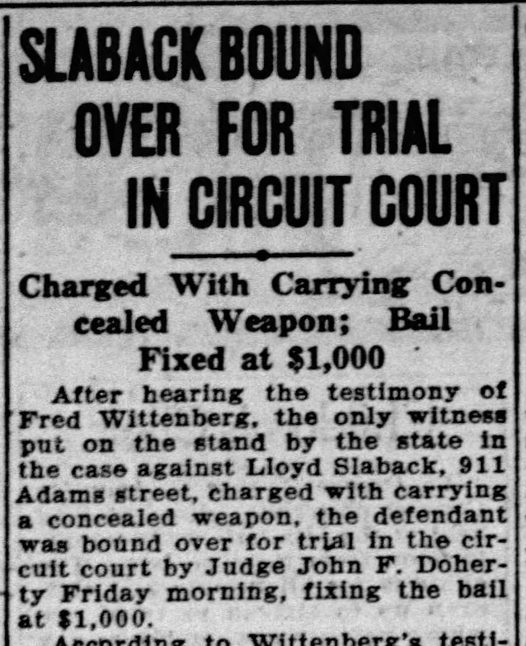

Page 6 of *The La Crosse Tribune*, August 15, 1930

“Well, I never…” said Lila’s mother. They were all sitting at the table and Lila’s father had just finished reading the article out loud. Lloyd had threatened someone with a loaded gun. He told the judge that he was too drunk to remember what happened.

$1,000 was an unimaginable amount of money. Lloyd was going to prison for sure. Her father said, “Lloyd is no longer welcome in this house. I want all of you to stay away from him. Do you understand? Please tell me that you do.” Around the table there was a chorus of “Yes, father.” Lyle’s head was hanging down; he considered Lloyd a friend. When Lloyd worked for their father, his jokes made the time go faster. Lloyd was as funny as anyone on the radio. John put his hand on Lyle’s shoulder. “Lyle, I also want you to promise; Lloyd is drinking in public and spending time with the wrong kind of people. He is nothing but a hoodlum.” Lyle said, “I understand… I promise.” Lila knew that going to prison was bad, but she was confused about why the family was pushing him away. Did they have to punish him too?

Chapter Ten

In 1931, Cecil was in eighth grade, Veda was in fifth grade, and Lila was in third grade at Roosevelt Elementary (named after Teddy Roosevelt, not that communist). The Depression was taking a real toll on their classmates. Some of the older students were dropping out of school to work. Some had to leave La Crosse because their fathers were looking for jobs in other cities. Veda’s best friend, Minnie, was sent away to live with her relatives, who still owned a farm in Vernon County. Although Lila’s parents did not seem too concerned about the whole situation, worry began to follow her around like a hungry wolf. Lila was not the worst student in her class, but she was also not one of the best. The worry made it difficult to concentrate.

Aunt Hattie had stopped working as a waitress. She was in her 50s and said that it was important for older people to let young people have the jobs, but in truth it also gave her time to do charity work, throw parties, and work on improving her reputation (which had been damaged by the repeated stories in the newspaper about Lloyd). Theron’s wife, Borgny, was content to be a housewife and volunteered with the ‘Bethel Busy Bees,’ which made quilts, visited sick people in the hospital, and organized fundraisers. Like Borgny, everyone in the group was a member of Bethel Lutheran, the neighborhood church where she and Theron had been married. Aunt Hattie was not a regular member of any church, but she made that work to her advantage; it allowed her to host events in her house for a variety of groups—one week it might be the LDS Ladies Relief Society, the next week it could be Saint Wenceslaus or the American Legion Auxiliary. She had a beautiful silver tea service and a large set of matching china; as a hostess, she was always very gracious and elegant. The constant rotation of groups kept ‘Hattie Slaback’ on everyone’s mind as a model of generosity, but it also kept them from getting too close and asking questions.

The house on Kane Street was full for Easter. Izro and Myron were visiting for a few days so everyone could meet their son, LeRoy. Theron and Borgny’s daughter, Hilda Hazel, had the honor of being the very first grandchild (and being named after her grandmother), but LeRoy had been born during the same month. With blonde hair and blue eyes, the two of them looked practically like twins. Lila was dismayed to realize that she was no longer one of the ‘children.’ She was allowed to do the children’s egg hunt in the park, but otherwise it was like every other day: beds to make, food to prepare, dishes to wash, and younger brothers to keep out of trouble. Izro was a guest now and could not be expected to help with the chores. Lila burst into silent tears when her mother told her to sweep the floors. Hazel’s patience had been wearing down all day and Lila’s tears were the last straw. “You need to grow up, Lila… if you can’t stop crying, you should go join the babies in the other room.” Izro found Lila in the kitchen washing dishes (still crying) and gave her hug. Lila had missed her so much.

Some people forget to eat when they’re having a difficult time. Lila was the opposite; the worry and sadness made her eat more. Being in the kitchen all the time, it was easy to get extra food: a taste of the soup to make sure it was done, a dinner roll that accidentally dropped on the floor (hide the evidence!), or a few bites of dessert that one of the younger children had failed to finish. It would have been a shame to waste anything when so many people were going without. Like her teacher said, it was her civic responsibility to do what she could. As a result, Lila was getting a bit ‘stout.’ When she looked in the mirror in the bathroom, the only thing she admired was her eyes. They were like the color of a quiet lake—dark green, with a hint of blue from the sky’s reflection. Her hair was light brown (so boring), her nose was a little big, and her cheeks were way too big. Nobody else in her family had a head shaped like a pumpkin.

Chapter Eleven

Inevitably, the ladies that Aunt Hattie was hosting began to make inquiries—not so much about Lloyd, but about her membership (or lack thereof) in a church. Where was she baptized? Where did she get married? It was a real problem, because Aunt Hattie and Uncle Frank only went to church for weddings, funerals and the occasional Christmas or Easter service. One time, Hattie claimed that she was a Presbyterian—it was the least controversial church she could think of. The Lutheran Church was for the Norwegians and Germans, the Catholic Church was for the Irish. She had nothing against the Mormons, but she wasn’t about to claim that she was one of them; it would have been social suicide.

There was a Presbyterian church close to Lila’s house. As a demonstration of her faith, Aunt Hattie decided that Veda and Lila should get baptized. Lila’s mother pointed out that they had been baptized in the local church when they were babies, but Hattie said it was fine—it was common for people to get baptized again once they joined a church in the city. She would buy new dresses for the girls; afterwards they would have a lovely party at her house. Lila’s parents were not immediately convinced, but Veda desperately wanted to go shopping with Aunt Hattie. She quietly asked their mother about it every few days until finally, she threw up her hands and said, “Fine, I guess if you really want to get baptized again you can.”

On the day of the shopping trip, Uncle Frank arrived in his car to pick up the girls. Aunt Hattie had invited their mother, but she decided that she couldn’t leave the younger boys without supervision. Veda and Lila were secretly thrilled… what an adventure! Uncle Frank drove them downtown and dropped them off in front of Doerflingers, which was Hattie’s favorite department store. The savings from her years of work allowed her to shop in ways that Hazel could not have imagined. Lila’s astonishment began when they went through the revolving door. Aunt Hattie said, “Come along dear.” In her breathless state, Lila had stopped walking and was blocking the door for other customers. The building was five stories tall with an atrium in the middle; the roof was supported by enormous columns that were clad with dark granite. It was so highly polished that as they walked by, Lila could see a bit of her reflection in the stone. Their footsteps echoed on the tile floor, which had an elegant pattern of black and white squares.

The grand staircase at the far end was covered with emerald-green carpet, but instead of heading for the stairs Aunt Hattie turned to the left. There was a man patiently standing there, wearing a gray suit with two rows of shiny gold buttons and gold trim around the collar, a flat gray cap, and white gloves. He said, “Which floor would you ladies like to visit today?” Without hesitation, Aunt Hattie said, “Third floor please.” He pushed a screen into a space behind the wall and said, “Ladies first.” It was Lila’s first ride in an elevator. There were mirrors all around the walls, which made it appear as if they were standing in a crowd of people who looked exactly like them. When Lila lifted the corner of her dress, so did the rest of the girls. When she waved her hand, they all waved back. She could have stayed in the elevator all day, but suddenly there was a “ding!” and the man in the suit said, “Third floor ladies, please watch your step.”

When the door opened, it appeared that they had just entered the sitting room for a very fancy house. It had a matching set of sofas and chairs covered in velvet, a large oriental rug, an enormous radio, a crystal chandelier, and a low table set up for tea with a silver tea service and various colors of china. The back wall was filled with bookcases. Lila could not imagine that anyone would be able to fill so many shelves, but the room was impressive. It was a teaser for the floor above, which was filled with furniture, linens, cookware, and china. Veda and Lila followed Aunt Hattie past the men’s clothing, shoes and hats, around the back to the children’s section which contained a mixture of clothing for boys and girls. There were also toys—china dolls with curly hair and frilly dresses, miniature tea sets, a rocking horse with a mane and a tail made of real horsehair—but Lila knew better than to touch anything. They were here to shop for dresses for the baptism, not for toys. A woman approached them and said, “May I help you with anything today, ladies?” Similar to the man who helped with the elevator, she was also wearing gray, but instead of gold buttons her dress was accented with a crisp white collar and cuffs. Aunt Hattie told her, “Yes dear, we’re here to find dresses.” To clarify ‘for the girls,’ she put her arm behind Veda and gently nudged her forward. The woman reached out for Veda’s hand and said, “Oh, aren’t you a beauty! I know just the dress for you.”

After pulling out some dresses that Veda and Lila could try on, the woman indicated that they should follow her to the back. The fitting room was large enough to hold all four of them. It was painted dark green and there were two large mirrors hanging together in one corner. Aunt Hattie sat down on the elegant sofa and said, “You can take off your shoes and dresses, but leave on your panties and undershirt.” Although Aunt Hattie behaved like they were doing the most natural thing in the world, Lila found it unsettling to take off her clothes in front of a stranger. The saleswoman held out a beautiful light blue dress and said to Veda, “I think you should try this one on first; the color will be lovely with your eyes.” Veda blushed and said, “I like that one too.” Aunt Hattie insisted that she try on several dresses (just to be sure), but everyone agreed that the blue one was the best. Veda looked stunning—like a young woman instead of a child. The fluttery sleeves and full skirt accented her tiny waist. Aunt Hattie said, “We’ll need to get you some nice shoes to go with that.”

While she was still trying on dresses, the saleswoman held one out for Lila. It was white with red polka dots and a red sash. “I think this one will look gorgeous on you.” Much to Lila’s dismay, however, the dress would not fit over her hips. Aunt Hattie said, “Don’t pull on it, Lila, it’s alright if the dress doesn’t fit.” The saleswoman added, “Don’t worry, dear. I’ll find you a larger size.” The woman left the room and came back with five more. “Unfortunately, I don’t have a larger size for the red-and-white dress, but here are some others that I think you will like.” None of those dresses fit either. Lila was starting to feel very embarrassed. Why did trying on dresses have to be so easy for Veda and so difficult for her? When one of the dresses finally fit (it was yellow and made Lila feel like a giant goldfinch), she put on a big smile and said, “Oh, I love this one.” The saleswoman could not disguise her sigh of relief. “You look beautiful, dear. I’m so happy that one works for you.” She turned to Aunt Hattie and said, “Is there anything else you need today, or shall I take your packages downstairs?”

Before heading to another shop to look for shoes, Aunt Hattie took them to the tearoom on the second floor so they could have lunch. A waitress (who, Lila observed, was wearing the same gray dress with a white apron) brought them a tray with tea, milk, sugar, little sandwiches cut into triangles, a bowl of fruit, and a plate of cookies. Some of the sandwiches were filled with egg salad (delicious); others were filled with cream cheese and had a slice of cucumber on top. The cookies were dark pink and filled with cream. The first one was so good, but when Lila reached for one more Aunt Hattie said, “Do you really think you should be eating that?” Lila pulled her hand back and was silent for the rest of the meal.

A few weeks later, Aunt Hattie invited them back to her house for tea. Veda was thrilled. Aunt Hattie was so glamorous. Veda wanted to live in a house like hers someday, with a modern stove and washing machine and big beautiful sitting room to entertain guests. After they had the first cup of tea Aunt Hattie said, “Veda… on top of the dresser in my bedroom is a big jewelry box. Why don’t you go pick something out to keep as a present? A young lady like you should have an elegant piece of jewelry to wear to parties.” Veda’s eyes lit up with excitement and she said, “Really?” Aunt Hattie smiled and nodded her head. She said, “Go on, dear.”

Once she was out of earshot, Aunt Hattie turned to Lila and said, “Your sister is such a beautiful girl. In just a few years she’s going to be very attractive as a bride.” Why was Aunt Hattie telling her this? Lila knew that Veda was beautiful, but it was hard to imagine her as a grown up. “As for you…” Aunt Hattie continued, “You need to pay more attention to your diet. Stout girls do not get invited to parties.” Lila was so embarrassed. She had no idea what to say. She looked down into her empty teacup and resolved to stay away from Aunt Hattie.

Chapter Twelve

A few months after he started driving the truck for a living, Theron joined the Teamsters. He didn’t really understand the purpose of a union, but it gave him access to steady and better-paying delivery jobs. The dues were a small price to pay. During a strike in 1932, he felt lucky to find a different job right away. With a wife, a daughter and Borgny pregnant again, he couldn’t afford to be out of work. La Crosse County was building a new highway and needed drivers to haul gravel. He was also perpetually grateful to have the use of his father’s truck. He didn’t have much of a talent for building and hated the idea of working in a factory, but driving was actually fun. It barely felt like work at all.

Sometimes, when he picked up the truck in the morning, he liked to spend some time at his parents’ house, chatting and having breakfast. Lila noticed that her parents were different when he came to visit—softer, more patient and more likely to smile. Their affection for their first-born son was obvious. Lila was sure that her parents loved all their children, but they had their favorites. Hazel expected Lila to be quiet and helpful at all times (and frequently criticized her for failing to meet her impossibly high standards), but her younger brothers, Earl and Looy, were quite spoiled. They never had to mind the children since they were the youngest. Her older brothers had some responsibilities, but they were much smaller than Veda and Lila’s. Cecil was responsible for mowing the lawn and shoveling coal into the furnace. Lyle took the rubbish to the curb for collection days and helped his father with repairs around the house. When there was snow, Theron did the shoveling around the sidewalk and driveway so he could get the truck out of the garage. Veda and Lila did everything else. Earl was already nine years old, but he didn’t have any regular chores. It must be nice being a boy, thought Lila.

One Friday morning in November, Theron (as usual) was over for breakfast. Since it was a school day, everyone except Looy was awake. As soon as Earl finished eating, he went outside to play. Veda was reading a book. Lila preferred to eat slowly and enjoy her food, knowing that less-pleasant activities were waiting… clearing the dishes and walking to school. When Theron finished eating he said, “I guess I better be going now.” He gave their mother a kiss on the cheek and headed through the kitchen to the back door. They heard the truck starting and Lila’s mother sighed. “This weekend I want to give the house a thorough cleaning. When you get home from school, please gather the towels and dirty laundry and then we’ll strip the beds in the morning.” Lila started clearing the dishes and said, “Yes, ma’am.” Her friend Nora was having a birthday party on Saturday, but she knew it was no use asking to go. Her mother would never change her plans once her mind was made up.

A few moments later there was a loud knock at the front door. “Who could be calling at this hour?” said her mother. She went to the front door and Lila followed; anything was better than cleaning. Their neighbor, Mrs. Bay, was standing there in her robe and said, “There was an accident! You need to come with me right away!” Veda set her book down and they all went outside. At the end of the block, there was a small cluster of people. Theron was kneeling in the street, rocking back and forth. Lyle was standing next to him looking white as a ghost. Their mother was running now, saying, “Theron… what happened... are you alright??” One of the neighbors stopped her and said, “Mrs. Slaback, your son Earl has been hurt. My husband took him to St. Francis Hospital.” Mr. Bay pulled up in his car and said, “Let me give you a ride, Mrs. Slaback.” Their mother turned and told Lila, “Go back to the house and wait for me there. I’ll be back as soon as I can.” Lila wanted to stay and figure out what was going on, but like a good girl she said, “Yes, mother” and turned back around.

It was so quiet inside the house. For a few minutes, Veda and Lila just stood there, not making a sound. Although it was a school day, their mother’s instructions had been clear: wait inside the house. Finally, Veda said, “I guess I better check on Looy. Why don’t you clear and wash the dishes?” Lila had never been so grateful for chores. Her mind was racing, but it was good having something familiar and productive to do. As the hours passed with no word from their mother (or even their brothers… where was everyone?), Veda and Lila did all the chores they could think of. They made the beds and swept the floors. They played games with Looy and made two batches of snickerdoodles. There was a roast thawing for dinner, so after lunch they cut up some carrots and potatoes and put everything to bake in the big roasting pan. They even cleaned the bathtub and toilet and took all of the dirty laundry to the basement. The roast smelled delicious. Lila was getting hungry, but Veda said they should wait until everyone was home before eating dinner. Lila reluctantly agreed and set the table.

The sun was setting by the time they heard the truck pulling into the garage. Cecil was the first one into the house. He said nothing and went straight to the bathroom. Lyle also went upstairs without a word. What was going on? Their mother walked in the door. Her eyes were red; it was clear that she had been crying. Their father was right behind her and said, “Girls… please go to the living room; I’ll be with you in a minute.” Veda sat down on one of the chairs and picked up the book that she had been reading that morning. Lila also sat down and was idly swinging her legs. She wasn’t sure what else to do.

When their father entered the room, Lila thought he looked older, somehow, like ten years had gone by in one day. He said, “Girls, I need to tell you something. Your brother Earl is dead.” What? Veda’s jaw dropped open; Lila felt like she had been punched in the stomach. They all sat there for a few moments in silence. What do you say to that kind of news? Finally, Veda asked, “How did it happen?” Their father responded that he wasn’t sure; Lyle had seen the accident, but was still in shock. Theron was last seen giving a statement to a police officer; he didn’t go to the hospital. Cecil wasn’t sure what had happened either. Looy spoke up and said, “Where is Earl? What is ‘dead’?” Their father put his hands over his face to hide his tears, but his shoulders and back were shaking from the sobs.

Lila knew what death was. Earl was an annoying little brother, but Lila didn’t want him to die. Who was with him when it happened? Would there be a coffin? One of her classmates had died the previous year from scarlet fever. His family was too poor to have a coffin, so they buried him in a canvas bag. Although some people had stayed away (out of fear that the body might still be contagious) Lila had gone to the funeral. Everyone who attended went through a line so they could see Edward one last time and talk to his family. His mother had given her a hug and a kiss on the head. Lila knew that everyone died eventually, but losing a child was the worst. Just like Earl, Edward had been perfectly healthy and normal. He was eating, going to school, playing games with his friends, and then boom. Gone forever.

The next day, the story made the front page of the newspaper. It said that Earl had fallen out of the truck, which ran over his chest. He was able to get up and had started walking back to the house, but he was dead from internal injuries by the time Mr. Bay arrived at the hospital.

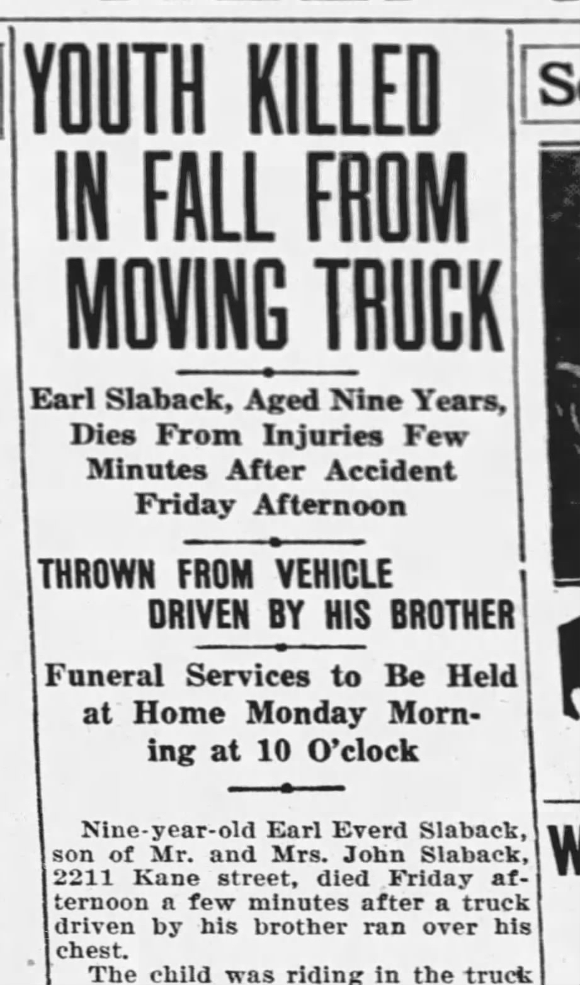

Front page of *The La Crosse Tribune*, November 4, 1933

Chapter Thirteen

Outside of the house on Kane Street, life continued as normal. Lila heard later that Nora had her birthday party. Of course she did. Her little brother was still perfectly alive. Veda and Lila had already cleaned most of the house, so to pass the time they listened to the radio and played with Looy. Their mother disappeared into her bedroom on Friday evening and didn’t reappear until Monday morning—not even for meals. Lila thought she must be starving, but knew better than to comment. Even in good times, her questions were usually ignored or met with anger. Everyone was so quiet. Lyle and her father left for a while to do some work since they would not be able to work on Monday. Cecil stayed upstairs for most of the weekend.

On Monday morning, Lila woke up to find that several of the neighbors were getting the house ready for the funeral. They brought extra chairs and platters of food; Lila had never seen the table so loaded. She was combing her hair and putting on her clothes (regretfully, she noted that the yellow dress barely fit) when the undertaker arrived. He set up a small platform near the front door and then a few of the men helped carry in the coffin. Lila was relieved to see that her brother would have a proper burial, but she was also curious. What did he look like in there? Shortly before the service, the reverend arrived and opened the top half of the coffin. As soon as he left the room to speak with her parents, Lila went up to the coffin to take a peek. Earl was wearing the clothes he usually wore to school. She noticed that two of the buttons on his shirt were broken, but otherwise there was nothing out of the ordinary; Earl looked like he was sleeping. Veda was standing beside her, quietly crying, Lila was usually the more emotional one, but on this particular morning she was surprised to feel nothing. She wasn’t angry or frightened or even sad. Maybe, she thought, this is what it meant to be “in shock.” Lila touched Earl’s hand like she had done many times before, but it was so cold and stiff—so lifeless—that she quickly pulled her hand back.

By ten o’clock the house was filled. Many people were standing. Some had to stand in the kitchen or outside; there wasn’t enough room for everyone. Lila recognized many of Earl’s classmates. Aunt Hattie and Uncle Frank were sitting in front with her parents. Theron and Izro were also in front. Lila had not noticed when Izro arrived. Since there would be another service before the burial in Crawford County, the reverend did not speak for long. When the line formed so everyone could see Earl and talk with her parents, Lila joined the line for food. The neighbors had put together an impressive spread. In addition to a huge plate of ham sandwiches, there were bowls of vegetables, bowls of pickles, trays of cookies, a basket of apples, and numerous pots of coffee and tea. When Lila bit into one of the sandwiches, she was surprised to find that it had a generous slab of butter; it was not what she had expected, but it was good. She went back for a second helping (and then a third helping) and nobody said a word.

By noon, most of the visitors were gone. The adults were standing near the front door, having a discussion. Aunt Hattie said, “Well it’s settled then; Hazel and John will ride with us and Lyle will drive the children.” It was time for the men to carry Earl to the truck. One of the neighbors, Mrs. Christiansen, was still standing over the coffin. Her husband and son had been killed in an automobile accident just a few weeks earlier. Lila was surprised that she was there. The reverend put his hand on her shoulder and said, “Mrs. Christiansen, can I walk you back to your house?” She nodded and started moving towards the front door. Theron softly closed the lid as the men lifted the coffin off the pedestal. They carried it to the truck and placed it in the middle of the flatbed. As Lila climbed in and sat down, she thought about their most recent trip to Crawford County. Just two weeks ago, the truck had been filled with bushels of apples from Aunt Stella’s farm. Today, instead of weeding and picking vegetables, they were on their way to put Earl in the ground. It was so desperately strange and wrong.

Earl was the first member of the family to die in La Crosse. To Lila’s parents, it seemed natural that he should be buried with the rest of the family in Crawford County. To Lila, it was yet another insult. They were going to leave Earl out there, all alone, and go back to La Crosse like nothing ever happened. There had been frost on the ground that morning, but by the time they arrived at the church next to her grandparent’s farm it was becoming a beautiful day. The sun was warm and the air was rich with the smell of fallen leaves. The snow could start falling any day now; every last bit of sunshine was a gift. Only five years had passed since the family moved to La Crosse, however, Lila barely remembered the church. The building was already packed when they arrived. As they filed into the first pew, Theron, Lyle, Cecil, and her father carried Earl’s coffin to the front.

“Today, we are here to bid farewell to our beloved brother, son, nephew, and grandson, who was called to Heaven at such a tender age…” Lila barely heard the rest of the service. She could feel the weight of her body sitting on the bench, her lungs filling and releasing the air, her heart pounding in her chest, and her toes pressing into her shoes (which were far too small, but it would be months before her family could afford another pair). Physically, she was very much alive, but it seemed like her feelings had died the same day as her brother. Veda’s handkerchief was already damp with her tears. Lila’s handkerchief was sitting in her pocket, unused. All around the church, she could hear people sniffling and quietly crying—their grief was like a weight pressing on her shoulders and chest. She did not feel like she could join them; in her mind was a phrase that she had heard many times: “Big girls don’t cry.” Earl was her brother, but she felt like a stranger looking at the scene through a glass window.

After the burial there was another dinner. The food was delicious and there was so much of it: roasted chicken, smoked ham, baked potatoes with butter and sour cream, pumpkin pies, apple pies, bowls of pickles and a giant block of cheddar cheese. For a little while she played with her younger cousins, but the pinched look of disapproval on Aunt Hattie’s face ended the fun. She was supposed to be in mourning like a proper young lady. It felt like another injustice. She tried so hard to be good, but Aunt Hattie never seemed to notice her good behavior. By the time they drove home it was already getting dark.

Chapter Fourteen

The day of Earl’s funeral was the day everyone’s childhood came to an end. Hazel and John were both crushed by the loss of their son. For John, it called his choices into question, especially the decision he had made to stop farming and move the family into the city. Would Earl still be alive if they had stayed in Crawford County? There were dangers everywhere, but the city was filled with vehicles and that was the cause of Earl’s death. Although everyone knew that the accident was not Theron’s fault, Hazel quietly blamed him. He should have looked for Earl before driving off. What had possessed him to be so careless? Theron blamed himself too, but Lila would not know that until years later. He stopped coming by for breakfast and started parking the truck on the street in front of his own house instead of pulling it into the garage. It seemed like their father barely noticed; a few weeks after the funeral, he stopped working. He didn’t have the energy. Lyle took over the business and Cecil dropped out of school to help.

For a few weeks after the funeral, the family had a steady stream of visitors; friends and neighbors stopping by to check on them, often with a casserole. (Many of the dishes were good, but Lila would never think about casserole the same way again). Viola and Myrtle came to visit with their mother, who made a beautiful sour cream and raisin pie. Although her parents didn’t know them very well—Myrtle was in the grade between Lila and Earl—it was a good day in the Slaback house when they visited. Everyone was dressed; nobody was crying or yelling. When Mrs. Johnson said that she was “so sorry about what happened” and to let her know if there was anything she could do to help, her mother said, “Thank you so much for your kindness. We’re managing.” Lila knew that was not the truth, but her mother was too proud to ask for help. If someone offered something specific (“let me bring some extra jars of pickles for your pantry”) she wouldn’t say no. Everything else, they would take care of themselves. It was an unspoken rule. Eventually the visits stopped, and the offers of help faded away. Everyone assumed that the Slabacks must be ‘doing fine’ if they were not asking for anything.

Truthfully, they were not doing so fine. When their mother started drinking (which was easy now that Prohibition was over), Veda became the de facto head of the household. If Looy had been younger she might have dropped out of school to take care of him. Thankfully, Looy was just old enough to start attending school in January. Veda was nearly fourteen and could do everything necessary to keep the household running, including the laundry, taking care of the garden, preserving food for the winter, and making sure that Lila and Looy were going to school. Lila took charge of making the beds, cleaning the bathroom, and cooking breakfast for everyone. Their mother usually made oatmeal, but Lila decided that toast would be easier. She could make bread for the whole week and toast a whole tray of slices under the broiler. With some jam, tea, and hard-boiled eggs, it would be a complete and nearly instant breakfast for the whole family. Nobody said a word about the change. A lot of things were changing.

Underlying the emotional depression going on in their house was the Great Depression. Lila could barely stand listening to the news on the radio—strikes, soup lines, banks going out of business, organized crime, unemployment, terrible dust storms in Kansas—there seemed to be no end in sight to the difficulties the whole country was having. Although Aunt Hattie had worked as a waitress and her daughter worked at the Electric Auto-Lite factory, Lila realized that married women were not ‘supposed’ to work outside of the home. Her teachers said that if every family had just one job per household, the problem of unemployment would be solved. Married women should stay home to take care of the cleaning and children and leave jobs to the men. Lila spent many hours thinking about it while she did chores. Her parents were married, but at the moment neither one was working. Did ‘odd jobs’ count as jobs? If so, there were two people working in her house (Lyle and Cecill) but they were supporting seven people. Shouldn’t there be some kind of allowance for the size of the family? Did farming count? Lila wished that chores counted as jobs. She would be rich if she could get paid for doing housework.

Sometimes she fantasized about what it would be like to be rich. She would have a big fancy house—like the gray-and-white one next to the streetcar line heading downtown, which had a big tower over the porch (just like a castle!)—and it would have stained glass windows and beautiful rugs and feather pillows. She would have three cats (Annabelle, Izro, and Nora) and she would hire boys and girls from poor families to do all the chores—that way they could afford to stay in the city and not leave for somewhere else. It was hard saying goodbye to friends. As a rich person, she would never have to do laundry again and could eat cake and ice cream every day for dinner. She would buy all of her clothes at Doerflingers and tell the elevator man, “third floor, please” like it was the most natural thing in the world. She would have a car and Veda could be her “show-fur.” Lila giggled thinking about that one. What a silly word for someone who drives a car for other people. One day she was so busy fantasizing about being rich that she burned the toast. Nobody said anything at breakfast, but internally she kicked herself for the rest of the week. She would have to be more careful about getting lost in her thoughts.

Chapter Fifteen

It wasn’t just Lila’s immediate family that was having difficult times. Lloyd had gone completely wild and it seemed like nothing could tame him. Aunt Hattie was torn between worrying about him and washing her hands; his behavior was damaging the entire family’s reputation. Slaback was not a common name; when people saw his name in the newspaper, it reflected badly on all of them. Soon after Lloyd was released from prison for threatening that woman with a gun, he was sentenced to another year for committing a burglary. After that, nobody wanted to hire him. Why hire a twice-convicted criminal when there were so many decent, law-abiding people desperate for a job?

Lloyd showed up on Kane Street one day in 1934 looking for work. Lila was the one who answered the door. Lloyd smiled and said, “Hey there, good lookin.’ When did you get so grown up?” Lila blushed. Lloyd was her cousin, but it was the first time a man had complimented her looks. She wanted to invite him inside for coffee; it was the least the family could do. Lyle came to the door and said, “Sorry, but you need to leave now.” Lyle told her that they couldn’t afford to get involved in Lloyd’s problems when they could barely take care of their own.

From what they heard from Aunt Hattie, the only thing Lloyd did consistently was drink. He had tried to get a license to work as a bartender, but every time Lloyd applied he was turned down. Even his brother, Kenneth, had a difficult time getting a license. He had to go before the city council to explain that although his last name was Slaback, he and his brother were very different people. For a little while, Lloyd worked at the rubber mill making shoes, but he was fired when he went on a drinking binge and didn’t go to work for five days. It was especially embarrassing to his father, Uncle Frank, who had worked his way up at the rubber mill from cutter to supervisor. Aunt Hattie had kicked Lloyd out of the house, saying that he was a “no-good drunk” and a bad influence on his niece (Aunt Hattie’s granddaughter).

For a few months, Lloyd had drifted around to various relatives including his much older sister Ruby, who was living in Winona. Although her husband, Ben, was reluctant to let him stay with them, Ruby convinced him that it was their duty as good Christians. Lloyd was grateful and even found a job. It looked like he might turn his life around, but then he was arrested again. By the time of the trial, the La Crosse newspapers had picked up the news of his latest crime.

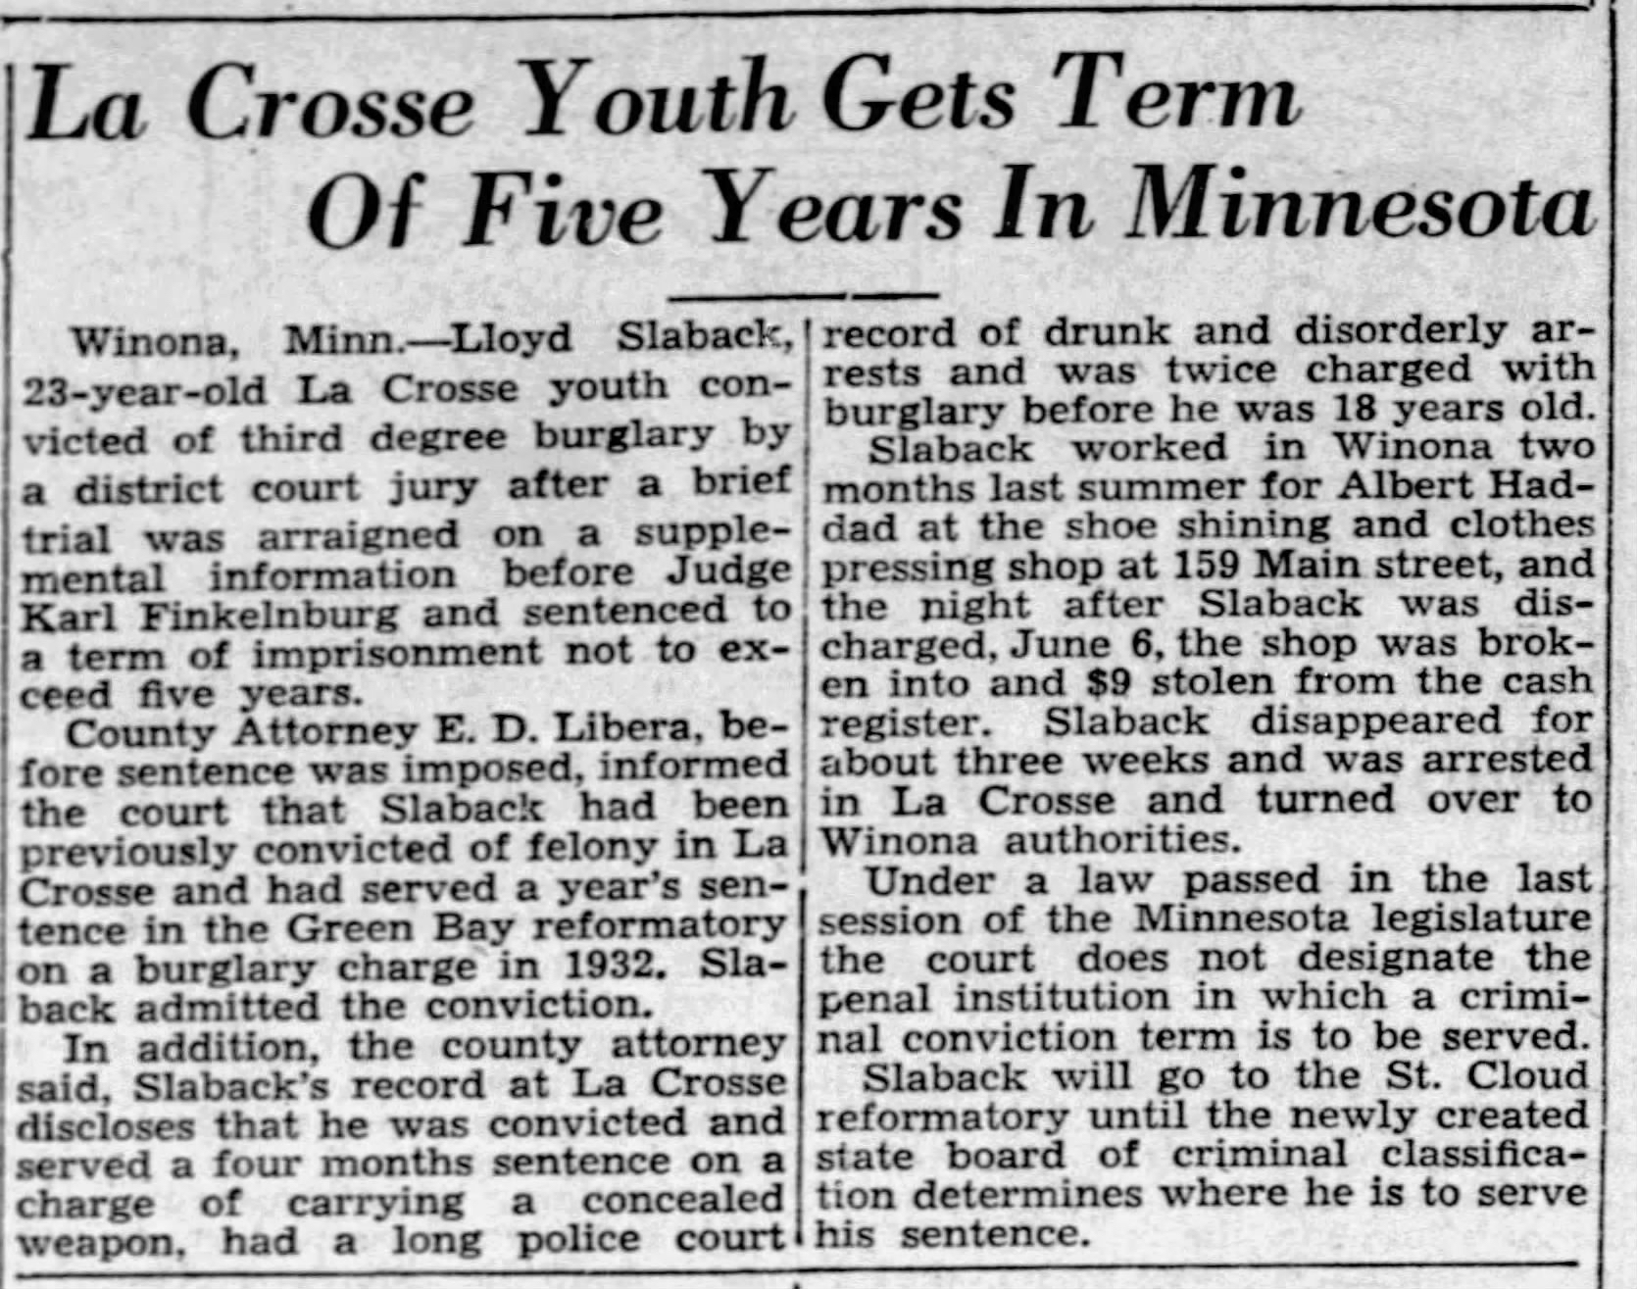

Page 8 of *The La Crosse Tribune*, Ocober 4, 1935

Lila knew that Lloyd was a terrible influence, but he was also funny and smart. Five years was an awfully long sentence for stealing nine dollars. Aunt Hattie spent more than that just buying dresses and shoes for the baptism.

Chapter Sixteen

That year Theron’s twin daughters, Arlene and Evelyn, were born. It was a shock adding two babies to the family at the same time, especially with the ongoing Depression. Theron was lucky to be employed, but money was tight. To stretch their budget, he started doing some semi-professional wrestling. Matches were held at the Avalon ballroom, close to where Uncle Frank and Aunt Hattie lived on Copeland Avenue. Lila was never allowed to go (it wasn’t a place for young ladies), but she heard about it from Lyle and Cecil. The large ballroom had tiny lights in the ceiling, making it look like a sky filled with twinkling stars. Although Theron rarely won—Lyle complained that the matches were “fixed”—he was strong and fast enough to be a solid competitor. He wrestled until 1937, when the Avalon closed due to a fire.

Those years were mostly a blur to Lila: endless days of cooking and dishes and laundry and going to school. But they were also marked by a string of tragedies. In 1936, Theron and Borgny had another daughter, Norma Jean. It should have been a happy event, but their father was still barely working and their mother had become a recluse. Veda was constantly worried about the family’s finances. To earn cash, she started taking small jobs outside of the house, such as helping an elderly neighbor with the laundry or watching the neighbor’s children after school. Lila had to pick up the slack on the household chores, but she didn’t mind. Someone had to pay the taxes and utilities. When she was sixteen, Theron taught Veda how to drive. They didn’t have another car, but sometimes the neighbors would hire her to run errands with theirs—for example, to drop them off downtown and pick them up after a day of shopping. It was easy work, but the good fortune didn’t last very long.

One day, Veda was driving Mr. McCune and four of his grandchildren downtown for a performance at the Rivoli Theater, when another car sped through the intersection and crashed into them. The oldest grandchild, Lois, was thrown out of the car, fracturing her arm and skull. They were all badly bruised and shaken. Veda refused to go to the hospital and started walking home; by the time she walked through the door she was sobbing. Although the accident was not her fault, it brought back terrible memories of the day Earl was killed. Veda stopped driving; in fact, she never drove again. Later in life, she would claim that she never knew how.

Lyle also had an accident. One Saturday he borrowed the truck from Theron and was on his way to pick up a date so they could go to the movie theater. Just two blocks from home, an elderly man stumbled into the road and Lyle was unable to avoid hitting him. The newspaper noted that the man had died as police were lifting him into the ambulance.

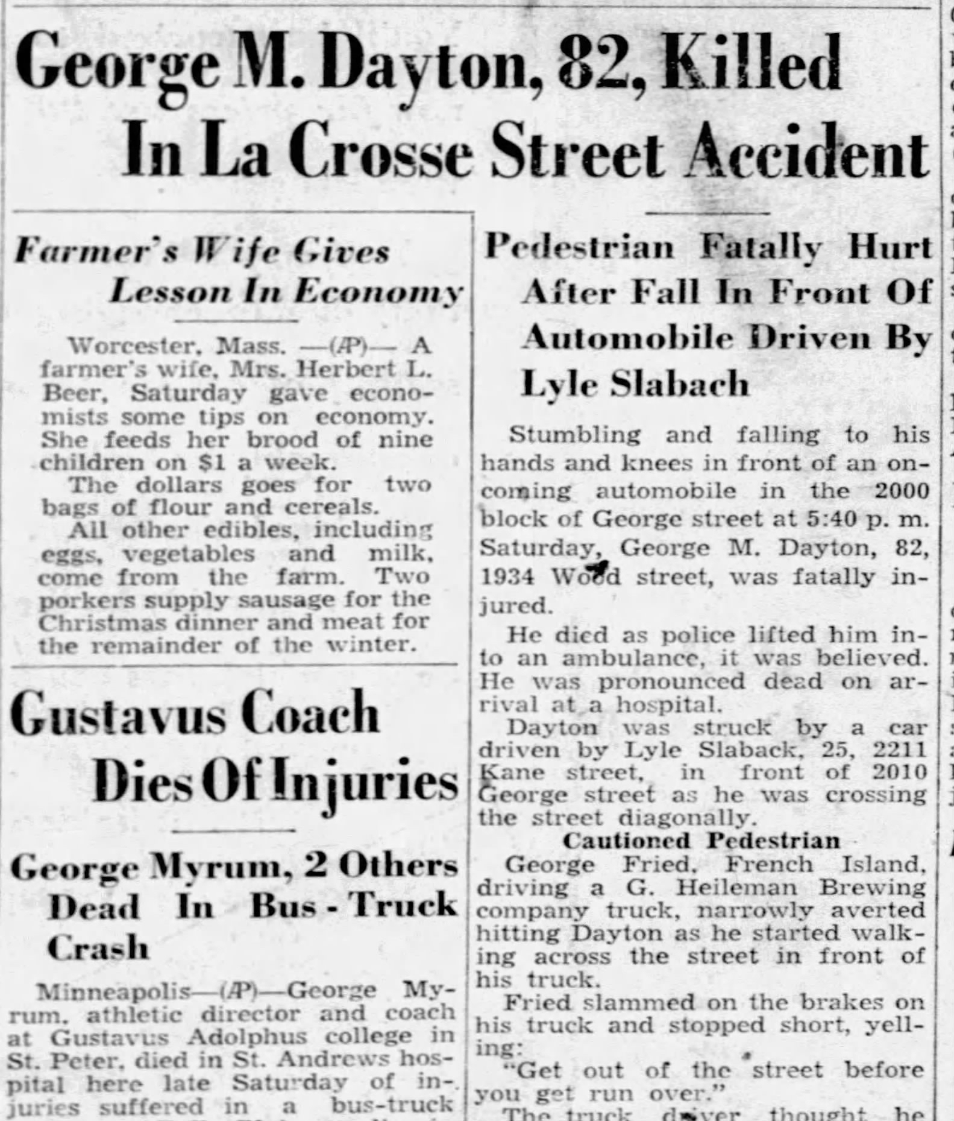

Front page of *The La Crosse Tribune*, November 13, 1938

To her parents, the accidents were further proof that moving to La Crosse had been the wrong decision. Lila did not agree, but she was starting to wonder if the Slaback family was cursed. One day while she and Veda were in the basement doing laundry, she mentioned her theory. Veda’s eyes opened wide and she said, “Do you really think so?” Veda shuddered and added, “Let’s try not to think about it. There’s nothing we can do whether it’s true or not.”

That was also the year that Cecil became a father. The girl’s father was furious that his sixteen-year-old daughter was pregnant. They had a ‘shotgun wedding’ and Gladys had to drop out of school to have the baby. It was an event that filled Lila with both horror and interest; she was struggling in school and often wished that she could drop out.

Chapter Seventeen

Hazel seemed to have given up on life. During the day, she stayed in her bedroom and slept. At night, she listened to the radio and drank whiskey. Lyle was the one who bought it for her. Nobody talked about Hazel’s drinking problem, but Lila knew; she had never been a good sleeper and often saw her sitting alone late at night. On the rare occasions when Hazel ventured outside, the neighbors would always say, “Why hello, Mrs. Slaback, I haven’t seen you in ages! Good to see you up and about,” but Lila was sure they could see that something was very wrong. Hazel was gaunt and her hair had turned completely gray.

Aunt Hattie was the one who decided that something must be done. Lila was wary about her schemes, but on this she had to agree: her mother’s behavior was not normal. The cure, Aunt Hattie said, was to get Hazel back into the community; being of service to others would help her stop focusing so much on her own situation. When presented with the idea, Hazel said, “Fine, but no churches; I will never stop being angry at God for taking my son away.” Lila’s heart skipped a beat; it was the first time her mother had said anything about the cause of her turmoil. Without batting an eye, Aunt Hattie said that would be no problem; the American Legion Auxiliary and Wilson Colwell Relief Corps were always looking for new members.

Much to Lila’s surprise, within a few months her mother was an officer for three different organizations. Hazel’s specialty was running “bunco” games for charity. Everyone knew that bunco was a dice game of pure luck—associated speakeasies and criminals—but it gave Hazel a dark sense of glamour. It also raised a lot of money. Hazel started joining the family for meals and regained the weight she had lost, but she never stopped drinking entirely. Later in life she took up rug braiding as a hobby, keeping a stash of whiskey in her box of fabric strips.

Lila joined the Girl Reserves. Ironically, Aunt Hattie had switched from being concerned that Lila would never get invited to parties to being worried that she was a ‘fast’ girl who would bring shame to the family. Her daughter, Opal, had been in the Girl Reserves, and she thought it was outstanding for building good character.

Poster advertising the YWCA and Girl Reserves; Library of Congress Prints and Photographs Division, # LC-USZC4-5551

Lila knew the group required uniforms and was worried about the cost, but Aunt Hattie assured her that she would pay for it. Lila was excited for an opportunity to get out of the house and to do something on her own. Aunt Hattie still had her daughter’s old uniform; unfortunately, it was too small for Lila to wear. Lila was relieved when she hired a dressmaker to make a new one instead of taking her shopping. The outfit had a white shirt, blue culottes (which felt odd, since Lila had never worn pants for anything besides chores), and a blue kerchief. It made Lila feel like she was posing for a box of Cracker Jacks. During the fitting, the dressmaker asked her why she kept giggling. Lila stopped and made up a lie to avoid seeming rude, “Oh… I was just thinking about something I heard at school today.” The dressmaker’s daughter had also been in the Girl Reserves; she told Lila how proud she was of her daughter, who was all grown up and married with children of her own.

At the first meeting, Lila received a small poster with the group’s pledge that she could hang in her bedroom. She had to admire how the first letter of each line spelled out the name of the organization. It would make the pledge easier to memorize.

**As a Girl Reserve, I will try to be**

**G**racious in manner

**I**mpartial in judgment

**R**eady for service

**L**oyal to friends

**R**eaching toward the best

**E**arnest in purpose

**S**eeing the beautiful

**E**ager for knowledge

**R**everent to God

**V**ictorious over self

**E**ver dependable

**S**incere at all times

She was skeptical about her ability to live up to it. “Maybe Veda could do it,” she thought to herself. Veda never complained about the chores. She was beautiful, hard-working, loyal to her friends, practically perfect in every way. Lila admired and loved her, but at times she wanted to hammer a nail into her perfect forehead.

Nothing she did would ever be as good as Veda. Veda was a ‘good girl.’ Earl had also been a ‘good boy.’ He could never be bad, since being dead prevented him from doing anything wrong. Lila reflected that the rest of them took turns being the ‘bad one.’ Theron had killed Earl. Lyle killed that pedestrian. Cecil had a shotgun wedding. All of those things were pretty bad. Lila had never done anything like that, but she was not a young lady like Veda. She ate too much, laughed too much, and asked too many questions. She hated doing the chores and had to be reminded sometimes to do them. She wasn’t a good student or as popular as Veda. She wasn’t sure it was possible (or even desirable) to be one of the good ones.

Chapter Eighteen

Life was a bit easier when their father started working again. With Cecil out of the house, there was also one less mouth to feed. Veda continued doing odd jobs, but now she was allowed to keep and use some of the money. One weekend she suggested to Lila that they should take a walk. Lila protested, “Really? I’m so tired… I don’t want to go anywhere,” but Veda insisted. It was a hot, muggy evening. As they walked along the river, Lila complained about the swarms of gnats and mosquitoes; she was going to be covered with bites. Veda said, “Better keep walking then… it won’t be much farther.” Lila was just about to insist that it was time to turn back when they suddenly reached their destination: the Riviera Theater, which was showing *The Wizard of Oz*. “Surprise!” said Veda. Lila could not believe it. Were they really going in? She had heard about the movies, but she had never seen one. She must have had a real look of surprise on her face, because Veda squealed and gave her a big hug.

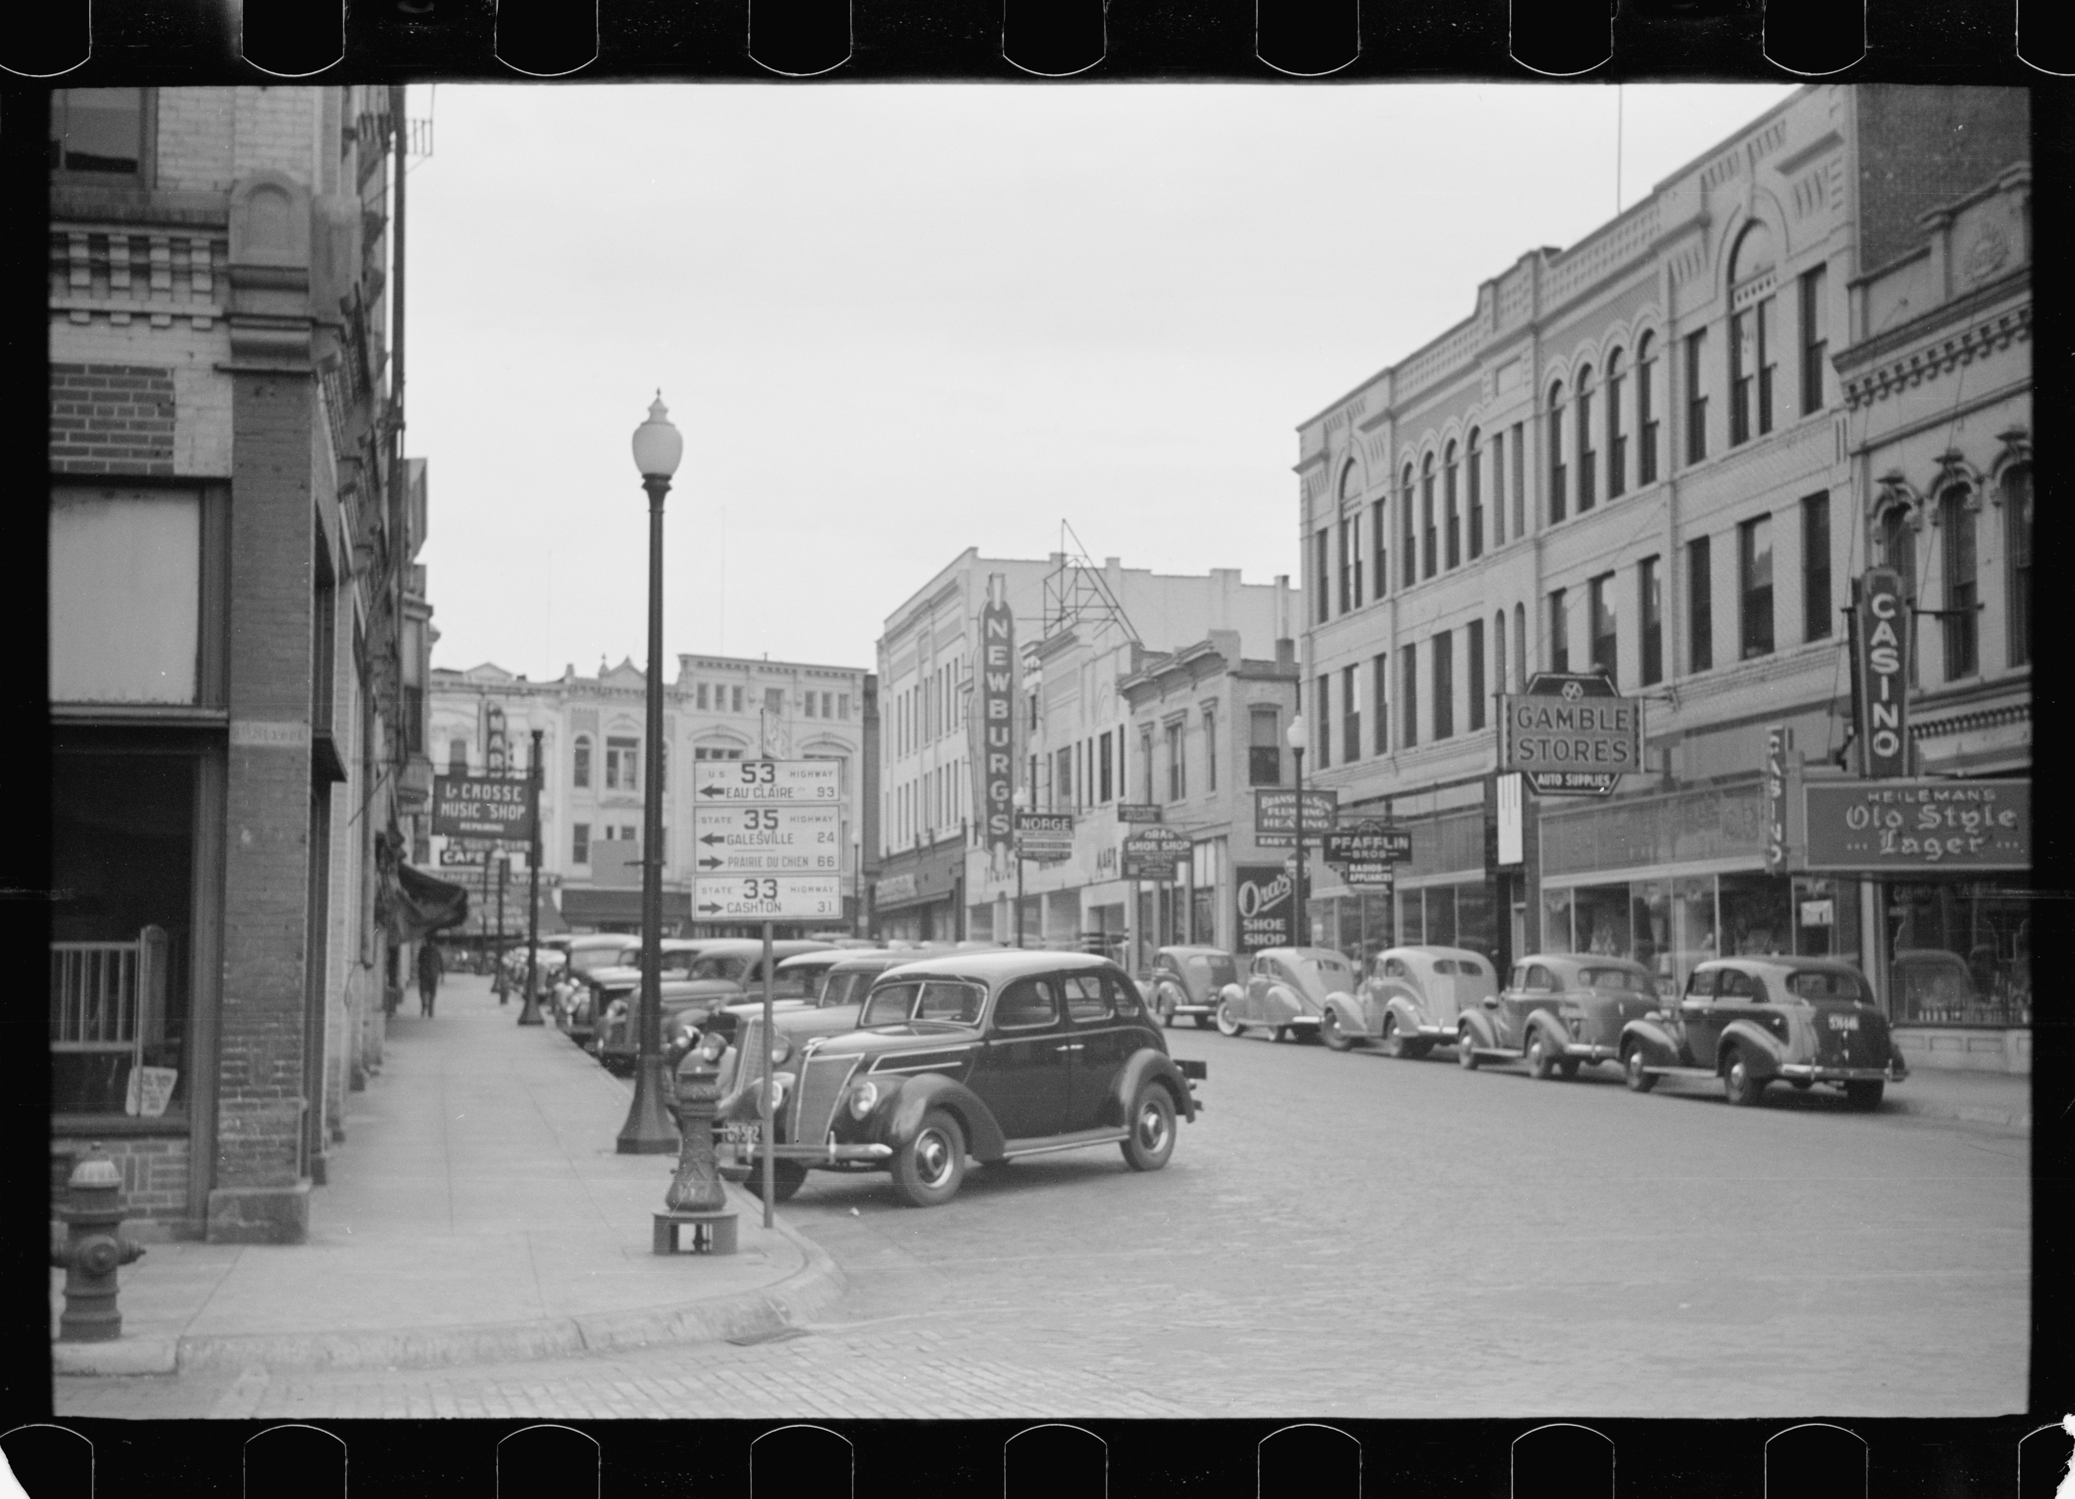

A busy street in downtown La Crosse, 1939; Library of Congress Prints and Photographs Division, #LC-USF33-003068-M2

It was 40 cents for two tickets plus popcorn. There were four ushers wearing uniforms; red suits trimmed with gold braid and shiny black shoes. One of them took their tickets and led them to seats in the middle of the theater. There was a stage in front with a large velvet curtain. Lila started to eat her popcorn while they were waiting; it was so salty and delicious. It was not Veda’s first movie—earlier in the year, she and her friend Rebecca had seen *It’s a Wonderful World*—but they were both very excited. As the lights dimmed and the curtain lifted, Lila felt like she was being transported to another world. It was an incredible sensation, soon enhanced by Dorothy’s own journey to the land of Oz. The colors were like jewels. Who wouldn’t want a pair of ruby slippers or a magic wand or to have such wonderful friends? By the time Judy Garland sang, ‘Somewhere Over the Rainbow,’ Lila was completely transfixed.

They talked about the film all the way home and for days afterwards. Lila said that her favorite part was when the tinman, the lion, and the scarecrow snuck into the castle and melted the witch with a bucket of water. To Veda’s horror and secret delight, Lila imitated the speech for days, especially when they were washing the dishes. “I’m melting… melting! Ohhhhh what a world, what a world.” Veda said her favorite was when they arrived at Oz and they all went to the beauty parlor for some washing and polishing. Wasn’t Dorothy just breathtaking? Lila had to admit that she was, but it made her feel a bit sad. She would never be as beautiful as Dorothy or have such a grand adventure. There was no yellow brick road in La Crosse.

Lyle often took his dates to the movies. Since Veda and Lila were not dating yet, they decided it was best to go with one another; it was not too difficult to earn 40 cents, especially now that Lila was also taking odd jobs. Her specialty was childminding. Some mothers in their neighborhood (like Borgny, for example) stayed at home—especially if they had many children or their children were not yet old enough for school—but there were plenty who worked outside of the home, mostly in factories. Hiring a young woman to mind the children between the end of the school day and the end of the workday was an affordable way to make sure they were fed and kept out of trouble. Hazel gave them a stern warning that their “adventures” better not interfere with the cooking and cleaning, but in the end it made no real difference. Ved and Lila just did the chores more efficiently.

A few months later they saw, *Gone with the Wind*. For different reasons, they were both captivated by Scarlett O’Hara. Veda wanted her clothing; she was obsessed with the bounce of her hoopskirts, the elegant fabrics, and her coquettish way of wearing hats. Veda said it was an ‘inspiration.’ Lila wanted to *be* Scarlett. She was beautiful, but she was also a firecracker. She wasn’t afraid to break the rules; she knew what she wanted, and nobody was going to stop her. For two young women quickly approaching the age of marriage, the movie made a serious and lasting impression. It was not just entertainment. Veda wanted to be like Scarlett’s friend and sister-in-law, Melanie Hamilton Wilkes; she proclaimed how romantic it would be to marry a soldier going off to war. Lila thought Scarlett’s relationship with Rhett Butler was much more passionate and exciting. It was the first movie they went to see twice.

Chapter Nineteen

When Veda and Lila went back to school in January, Viola Johnson announced that she was dropping out of school to get married. It was not the first time this had happened; the first was Lila’s friend, Kathleen, who got pregnant when she was fifteen. Her boyfriend, Michael, was only sixteen, but their parents—who were all Catholic—insisted that they fix the problem immediately by getting married. Lila had attended her wedding. As she had always dreamed, the wedding was big and so was her dress. Despite being ‘knocked up,’ it was a beautiful day. The church was packed and Kathleen was radiant. Two years later, with two children and a third on the way, she still claimed that she was thrilled with her new life. Lila wondered if that was really true; her own mother was never thrilled by anything. Kathleen and Michael were living with his parents until they could save enough money for a house of their own.

Unlike Kathleen, who was nearly the same age as her husband, Viola’s husband-to-be, John Schneider, was several years older. How did they meet? Viola wouldn’t say. Everyone knew that her first love was Samuel Collins, but her father wouldn’t give Viola permission to marry (or even date) one of those dirty Irish Catholics. Later, Lila heard that Viola’s father had discovered that Viola and Samuel were holding hands and passing love notes in school. His solution was to find her a good Lutheran man and get her married as quickly as possible. The fact that she was months away from getting her high school diploma made no difference. Even Viola’s mother agreed that it was a waste of time for a woman to plan a career; Viola should be planning to have children and then stay home to raise them. Viola was a good student, but she was also a good girl. She knew it was no use arguing with her parents. A few months later, her sister Myrtle also decided to drop out of school and marry John’s younger brother, Carl. Myrtle had never dated and was giddy to be a ‘real woman.’

Like Viola, Veda was also a good student. She had her eyes set on finishing her degree and becoming a nurse, not on dating. As a result, she was the first member of the Slaback family to graduate from high school. Lila thought her parents should have been proud; curiously, they were indifferent. As long as Veda continued to do her chores, it didn’t seem to matter what she did with the rest of her time. They never said that school was a waste of time for a woman, but they also never encouraged her to pursue anything besides getting married. (To be fair, they also never encouraged the boys to finish school or to get a job outside of the family business.) Veda reasoned that she would need to work for at least one year to earn enough money for nursing school, so she applied to work as an usher at the Riviera. Lila thought it was a brilliant move. She could earn money and watch the movies for free.

That job was where Veda met Red. He was two years older than Veda and was living at his uncle’s house until he could afford to move out. At the end of her first shift, Red offered to walk her home. “You never know what kind of hooligans might be roaming at night, waiting to take advantage of a beautiful young woman like yourself.” Veda blushed and accepted his offer. Although his real name was Francis, everyone called him ‘Red’ because of his hair. His parents were Catholic and had ten children. Red was the oldest one; he had moved to La Crosse to find work. Veda couldn’t stop talking about him. Red is so handsome! Red has such a funny laugh! Did I tell you what he said about that new Disney film, *Pinocchio*? One day Lila stopped her in midsentence and said, “Veda, I’m tired of hearing about Red all the time. Are you in love with him or something?” Veda’s mouth dropped open and she said, “Yes, I suppose I am.”

They decided to invite him for dinner. Veda said she was nervous, but they agreed that there was no point in trying to keep a relationship secret; someone in the family was bound to find out eventually. Why not just get it out in the open? It was January, so they decided to have him over on Sunday and make a big, hearty pot of beef stew. Veda said she heard that ‘the way to a man’s heart is through his stomach.’ It might not be true, but why take chances? Although they didn’t tell anyone that Red was coming over for dinner, the whole family was there, even Cecil and Gladys and their daughter, Deanna (who Lila’s mother said was ‘totally spoiled’). He rang the doorbell promptly at 6:00 and Lila answered the door. She had imagined that he would be tall and handsome, but aside from having red hair and freckles he was actually pretty average. Lila wondered what Veda saw in him. Red politely asked, “Is Veda home?” and Lila stood aside with a sweep of her arm, indicating that he should enter.

Dinner was oddly quiet. Lila wondered if Red was going to ask for Veda’s hand, but it seemed that he was truly just there for dinner. As usual, her father and brothers talked business. One of their neighbors was moving to Iowa to be with her daughter (who had five children and another one on the way); she had hired them to fix all the woodwork and refresh the plaster. It was an old house, so there was plenty of work to do. Finally, her father said, “So… Red, is it? Tell us a little about yourself.” He went back to eating his stew and Red stammered, “Well, I guess there isn’t too much to say. My parents are farmers; they live in Marquette County, about halfway between La Crosse and Sheboygan. I came to La Crosse to look for a different line of work… I supposed I’m not too interested in being a farmer.” John’s father nodded his head; it was the same choice he had made years earlier. Lila’s mother spoke up and said, “Do you have any brothers or sisters?” “Yes ma’am, four brothers and five sisters. I’m the oldest.” Veda (who was usually silent at dinner) spoke up and said, “We work together at the Riviera Theater.” And surprisingly, that was it. As soon as Veda spoke, the conversation moved on. They had chocolate cake and coffee for dessert. Red said that he “better get going” and Veda walked him to the front door. Did anyone notice that Veda was in love?

When they cleared and washed the dishes, Lila noticed that Veda had regained some of the color in her face. Veda said, “Well that went alright.” Lila said, “Yeah, I guess. What are you going to do now?” Veda said, “I don’t know. Keep working together, keep walking home together… watch movies.” Lila thought it sounded pretty boring. Why settle for the first man who showed an interest when you were as beautiful as Veda? Scarlett O’Hara didn’t settle for Rhett Butler just because he wanted her to.

Chapter Twenty

Not long after the dinner with Red, Lyle announced that he was getting married. Lyle and Allene met through Aunt Hattie; her daughter, Ruby, knew the bride’s family from church. Since Allene’s family lived in Minnesota, the wedding would be held across the river in Winona. With hardly a pause in the dinner conversation their father said, “Congratulations son, it’s about time.” Lyle was 26 and had dated so many women; the whole family had started to wonder if he would ever settle down. Veda said she would ask for the day off from work.

The day of the wedding, the weather was gorgeous. It had been a cool spring, but it was warm and sunny on that particular day in June. The apple and plum trees were in full bloom and the farmers were busy planting their fields. Everything smelled so fresh and green. Lila and Veda and Looy rode to the wedding with Cecil and Gladys; their parents were riding with Uncle Frank and Aunt Hattie. Lila smiled all the way to Winona, basking in the sun; it was a relief to be away from the adults. With a little of the money she had earned by childminding, Lila had hired one of the neighbors to make her a dress. She had slimmed down as a teenager and loved how the light green dress fit closely around her waist and hips. When she tried it on, the neighbor told her, “You look so glamorous!” A few days before the wedding, Lila had set her hair into a finger wave and shined her shoes. That morning, she picked a peony bud and pinned it near her left shoulder. For the first time she could remember, she felt truly beautiful. She wished she could wear lipstick but knew her parents wouldn’t approve. Lipstick was for whores.

Allene was six years younger than Lyle, but hardly a child bride. She wore a dress that had been passed down through her family. It was white with beautiful panels of handmade lace and embroidery around the bodice and hem. She also wore a crown of flowers instead of a veil. The effect was glorious; Lyle looked like he was ready to burst with joy and desire. The church was full, mostly with members of the bride’s family. Lloyd was still in prison, but Lila thought of him. What was it like in Stillwater? Lila wondered if he would return to La Crosse and if the family would ever forgive him. She felt sorry for Lloyd. He had made some mistakes, but the punishment had been very harsh.

When Lyle and Allene said their vows, Veda cried silently into her handkerchief. Lila gave her a nudge to say, “This isn’t a funeral…” and Veda whispered, “I’m just so happy for them.” When the ceremony was finished, everyone walked across the street to another building. It was filled with tables and chairs and there was a long table piled with food: big platters of ham and beef roast, spring vegetables, loaves of bread, big pitchers of beer, and the largest cake that Lila had ever seen. Lyle had just married into a family of German-Hungarian farmers. As Lila would soon learn, there was nothing they loved more than a beautiful wedding celebration with good food, good beer, and good music.

The bride’s father thanked everyone for coming to the wedding and wished the couple many years of health and happiness. By the time everyone had a plate of food, the musicians were warming up for a lively night of dancing. Lila had a glass of beer with her lunch and was already feeling very relaxed. One of Allene’s cousins asked her to dance and she eagerly agreed. She had no idea what she was doing, but quickly realized that it didn’t matter. The group was moving in a circle and would just pull her back and forth; it was exhilarating. All the younger people were dancing—even some of the older people—and the time flew by.

It was very late when they left the wedding. Cecil and Gladys were also having a good time. It was like the wedding they wanted but didn’t get to have. When Lila’s parents left that afternoon with Uncle Frank and Aunt Hattie, they took Deanna with them so they wouldn’t have to worry about the baby. Aunt Hattie said she was “too old for this foolishness,” but the young people should enjoy themselves. Lila had not expected to have such a taste of freedom. It made her feel temporarily sorry for disliking Aunt Hattie so much. Cecil had to stop drinking early so he would be sober enough to drive home, but they had a fantastic time celebrating. Lila could not remember a time when she had felt so happy. Between school and chores and childminding, it felt like all she ever did was work.

When it was time for Lyle and Allene to leave and the bride tossed her bouquet into the crowd, Veda was the one who caught it. Lila squealed and said, “Your wedding must be next!”

Chapter Twenty-One

A few weeks later, Veda confessed that she wanted to marry Red. “But there’s one problem… he wants to get married in a Catholic church and promise to raise our children as Catholics.” Lila raised her eyebrows. “Is that what you want?” Veda said, “Well… sure… I would do anything to marry Red, but he said that we need to find a church here in La Crosse. I need to start taking some classes and then we can ask for a dispensation.” Lila said, “You need to take classes to get married? You must really love him.” Veda blushed. Lila was happy for her, but she couldn’t imagine going to such lengths just to get married. She had begun thinking about dropping out of school when she turned eighteen in July.

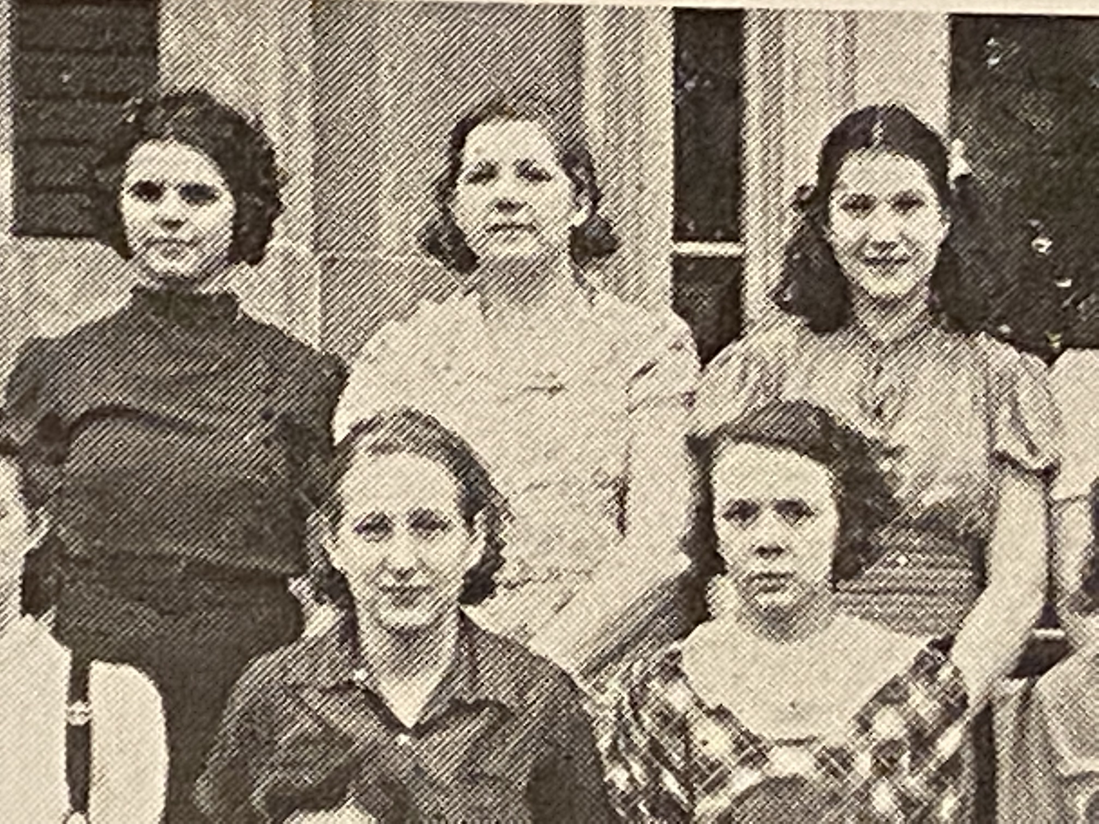

Lila (middle of the back row) as a sophomore in 1939 with some of her classmates at Logan High School

Veda’s happiness was soon overshadowed by another family tragedy. Theron and Borgny had missed Lyle’s wedding. With five children it was getting hard for them to travel, but they were also very devoted parents and reluctant to disrupt the family’s routine. Hazel still blamed Theron for the accident with Earl, but John was proud of his oldest son and delighted with his grandchildren. He often dropped by Theron’s house to see them. One day that summer, their youngest child, Norma Jean, came down with a cold. It seemed like nothing out of the ordinary. John thought an orange would help—it had helped when his children were sick—so that day he stopped at the grocer’s and bought one. By the time he arrived that evening, Norma Jean was having difficulty breathing. They decided that John and Theron would take her to the hospital and Borgny would stay home with the other children. They had no idea that she would never return home. By the end of the week, Norma Jean had been diagnosed with polio and placed in an iron lung to help her breathe.

The news spread quickly around the neighborhood. Polio had not been a major problem in La Crosse (not like in New York), but everyone knew that it was highly contagious. It was terrifying. A representative from the city health department appeared at their house and said that she would have to place them all under quarantine. “For how long?” said Borgny. “Until the city has determined that the threat has passed.” The quarantine lasted for six weeks, but there was lingering suspicion for the rest of the year. None of the neighbors wanted to take a chance on exposing their children to polio. Even the rest of the family stayed away. Norma Jean lived for seven heartbreaking months, unable to leave the hospital. Theron and Borgny did the best they could, but it was an impossible situation.

Norma Jean was the first member of the family to be buried in La Crosse. It would have been difficult to bury her in Crawford County in the middle of winter, but Theron and Borgny also demanded that they not be separated from their child, even in death. At the funeral it was obvious that Borgny had lost weight from the months of worry. Her skin had turned ashy, and her blue eyes had lost their sparkle. Lila felt terrible for her. Oak Grove was nice though. It was more like a park than a cemetery, with a beautiful arch at the entrance, statues of angels, and curving paths lined with trees. It must be gorgeous in the summer. Lila wished that she could walk around, but the burial service was over quickly. It was too cold to linger.

Within a few months Borgny was pregnant again, but she would never be the same after the loss of Norma Jean. It weighed on the entire family. That year, when Lila’s history teacher held lessons on ancient Greece and Greek mythology, Lila was struck with the realization that Borgny was like Persephone—trapped between the land of the living and the land of the dead. She would live only ten more years. Her doctors ruled that pneumonia was the cause of death, but Lila thought anyone with half a brain could see that the real cause was a broken heart. She was buried in Oak Grove cemetery, right next to her beloved daughter.

Lila should have graduated from high school in 1940, but she had fallen behind. There had been so many struggles; it made it difficult to learn and get her work done. She was not a naturally gifted student like Veda. While her classmates were busy planning their careers and weddings, Lila wondered what her future would be like. She felt little ambition. She wasn’t interested in being a nurse or a teacher or working in a factory. Maybe she would make a good mother, but who would she have children with? Nobody had asked her for a date. She felt like she was on a train just watching the world go by. When she tried to talk about it with Veda, the conversation always ended with, “Oh silly, you’ll figure something out.” She assumed that she would get married and have children eventually, but was that enough for her?

Looking around at her family, Lila was not sure what kind of life she wanted to have. Veda had decided to get married instead of becoming a nurse—was that a good decision? She seemed happy. Her mother had never worked outside of the home, but she had become a very harsh and bitter woman. Borgny was happy until Norma Jean got sick and died. Lila reflected that she wasn’t sure if Aunt Hattie was happy or not. She had been married twice and worked outside of the home, even while married to Uncle Frank. Lila was intrigued, but the thought of asking Aunt Hattie for advice gave her a headache.

Chapter Twenty-Two

Veda’s wedding was held at Saint James Catholic Church, which was only one block away from the Riviera Theater; she had been taking classes there to get the dispensation. Aunt Hattie—who never missed an opportunity for a good spectacle—offered to take Veda shopping for a wedding dress. When Veda announced her offer, however, their mother’s face darkened. “How dare that woman intrude… everyone knows that the mother of the bride is the one who should handle the dress and flowers.” Veda said, “I’m so sorry! I’ll tell her right away that you want to take care of it.” The conflict added a sour note to the planning. Even on the day of the wedding, Hazel was unusually cold to Aunt Hattie. Veda was mortified. She wanted everyone to be happy. Although they could not afford much, Veda looked radiant. Thin, with gorgeous hair and a pale complexion, she would have looked just as beautiful in a flour sack.

Lloyd had been released from prison, but he had not returned to La Crosse right away. To everyone’s surprise (and Aunt Hattie’s dismay), he turned up at Veda’s wedding reception. Lila was eating a piece of cake when Lloyd crept up behind her and whispered, “Hey beautiful, where have you been all my life?” Lila blushed and turned to look at him. He was thinner than the last time she saw him (before he went to live in Winona), but still handsome. No other man had ever talked to her like Lloyd. She felt a rush of excitement. Lloyd asked if they could go somewhere to talk and she agreed. She pretended like she was getting up for another piece of cake and then snuck out the kitchen door. Lloyd suggested that they walk down to the river so he could have a cigarette. He offered one to Lila, who politely declined.

As Lila had imagined, the last few years had been difficult for Lloyd. He talked about what it was like in prison: the mice, the terrible food, being cold all the time, the concrete walls and scratchy clothes infested with lice, and worst of all, never knowing what the guards or other prisoners might do. During his second year in prison his cellmate, Robert, was stabbed to death during an argument. Lloyd said he had forgiven the shop owner and the police and attorneys, but nobody would give him a fair shake at another job. What was he supposed to do with the rest of his life? Lila listened carefully. She couldn’t do much to help Lloyd, but she could listen. She found it flattering that he trusted her. Lloyd’s life was even worse than her own.

Then he paused and said, “Enough about me… how has life been treating you, gorgeous? The boys must be flocking to your door by now.” Lila blushed. She didn’t realize that Lloyd was gauging her experience (or lack of experience) with men. It was so rare that anyone asked her, ‘How are you doing?’ How was she supposed to respond? They had walked all the way to the river and were sitting on a large limestone rock near the Clinton Street bridge. They could hear the constant stream of cars and trucks driving past.

Lila was still thinking of what to say when Lloyd leaned over and kissed her. It was her first time being kissed and she really didn’t know what to think. Lloyd pulled back to see her expression and must have liked it, because he leaned towards her again and gave her a longer kiss. His hands were warm on her cheeks. To her astonishment, she felt him reaching his tongue into her mouth. What in the world was going on? He pulled back again and smiled. “Now what was it you were saying?” Lila blushed. She truly had no idea what to say. Should she tell him about her mother’s drinking problem or the endless years of chores… or how she had decided that it was time to drop out of school? Would he advise her to get married and stop being silly? She didn’t think so, but she was feeling apprehensive about getting advice from the family, even from Lloyd. She held out her hand and said, “I guess we should walk back now.”

Two blocks from the church, Lloyd said he had to go. He was meeting up with some friends. “I’ll look for you another day, don’t worry” and with a smile he turned. Lila waved. Aunt Hattie had noticed her absence and asked where she had been. “I just needed some fresh air, so I took a little walk.” It was not entirely a lie. Aunt Hattie gave her a skeptical look and said, “You missed the serving of the cake.” Thankfully, Allene came to her rescue and said, “There you are! Come dance with me. Lyle says that he’s tired, but I’m just getting started.” One of Red and Veda’s co-workers was a fiddler and he had agreed to gather a small band to play at the reception. It was turning into a lively evening.

Chapter Twenty-Three

True to his word, it was not long before Lloyd returned. One day Lila was walking to her new job (she had answered an ad looking for a ‘girl for general housework’) and there he was, perched on the edge of a stone wall, smoking a cigarette. It was October and the trees were flush with orange and yellow leaves. One leaf had fallen on Lloyd’s head and Lila playfully brushed it off. “Hey, that was my hat,” said Lloyd. They both laughed. “What do you say we go to my place?” Lila was curious to see where Lloyd was living but said “Mrs. Davis will fire me for sure if I’m late for work again.” With a grin he replied, “I’ll be waiting when you finish.”

For several days, Lloyd was waiting for Lila when she finished work. All she wanted to do was walk home, eat dinner, and get some sleep, but Lila appreciated having someone to walk with. Lloyd treated her like a real adult and told the funniest jokes, although his language would have made most women blush (even most men). Lila had never done anything so exciting and dangerous. Spending time with Lloyd was her first major act of rebellion against her parents and Aunt Hattie. She decided that on Saturday she would go with Lloyd to see his place; she could tell her parents that she had been at the movies. Lloyd gave a cowboy “Yahoo!” when she told him and he practically skipped all the way to Rose Street.

As they approached the boarding house, Lloyd said, “When we go in, just follow me and don’t talk to anyone.” It was dim and chilly inside. There were mailboxes and a small desk near the front door. “Good, the desk is empty tonight. I swear that woman thinks we’re just a bunch of good-for-nothing children…” Lloyd took Lila’s hand and led her towards a flight of stairs. As they went upstairs and approached a door in the middle of the hallway, he pulled a key out of his coat pocket. “This is the one!” Lila was not expecting much, but Lloyd’s room was worse than she had imagined. The floor and walls were bare and the room was just barely large enough for Lloyd’s bed; in the corner, there was a pile of laundry and some empty bottles. His bed was not made and it was loosely covered with a ragged gray blanket. Lila could hear someone moaning in the next room. He shut the door and hung his coat on a big nail. “I know it’s not much, but the view sure improved when you walked in.” The condition of the building and its occupants made Lila feel sick to her stomach, but she tried not to show it. She was an adult now.

Lloyd slipped off her coat and laid it over the edge of the bed. It was navy blue wool, but in the dim light it looked black; without her coat it was quite chilly in Lloyd’s room. “Where do you go to the bathroom?” “Oh... just down the hall. Sometimes when I’m too lazy, I piss in one of those bottles.” Lila was imagining what it would be like to piss in a bottle (being a woman, it was something she had never considered) when Lloyd put his arm around her waist. Although he smelled like cigarettes, his body was warm and reassuring. She had never been so close to a man who was not her father or brother. Lloyd said, “I’ll try not to hurt you.” For the first time, Lila wondered what Lloyd had in mind—it was clearly not just a tour of his place. He put his hand on her breast and gently pushed her backwards on the bed. Lila immediately realized that this would be her first sexual experience. She had heard her brothers whispering about it with their friends, but she felt very unprepared. Also, Lloyd was her cousin. Everyone knew that cousins were not supposed to do this kind of thing. She uttered, “Lloyd, I don’t...” but Lloyd whispered, “Don’t worry beautiful, I’ll take good care of you.” As his breathing grew louder and faster, she was surprised to find that hers was too. It was so painful that first time but thrilling in a way that she had never experienced before. Lloyd was clearly enjoying it.

When Lloyd finished, there was a pool of blood on the sheets. Lila was horrified. “I’m so sorry, it must be that time of the month!” Lloyd chuckled and said, “That’s normal for your first time… don’t worry about it.” Although she knew the room was nearly bare, she couldn’t help looking around for something to use as a washtub. She knew that if the blood was allowed to dry it would be nearly impossible to get the blanket clean again, even with bleach. It was the kind of thing that would make her mother furious. Lloyd must have noticed her look of rising panic. As she buttoned the front of her dress, Lloyd put his hands on her waist and said, “It’s OK… Lila… don’t worry about it.” A tear spilled and rolled down her cheek. She felt like a child for crying, but she couldn’t help it. Lloyd gave her a hug and said, “I’ll walk you home.”

For several weeks, Lloyd was waiting for her nearly every day. One day he surprised her with a beautiful scarf. It was so soft—pink, with red roses in the center. Lila had never owned anything so gorgeous, but she didn’t ask where it had come from. Lloyd had secrets. To keep her mother from noticing, she hid the scarf under her mattress. Another time, he gave her a bouquet of real roses. The smell was divine and the petals felt like heavy silk, but Lila giggled, “What am I supposed to do with these?” On the way back to her neighborhood, they took a stroll through Oak Lawn cemetery and laid the roses on Norma Jean’s grave.

One night Lloyd said, “You’re the best thing that ever happened to me, Lila. I wish we could be together like a real married couple.” Lila was ambivalent. She had grown very attached to Lloyd, but did she really want to get married? She had stumbled into a relationship that was starting to seem like an ideal: affectionate and fun, but with no strings attached. One of the best things about being with Lloyd was that they could never get married. As much as she wanted to be an adult (and she was), the thought of starting a family and becoming a housewife filled her with dread. She never dared to ask him if he wanted to get married or what he thought marriage would be like. It was not a relationship that involved deep discussion.

Chapter Twenty-Four

On the first Saturday in December, Hazel went to a holiday banquet held by the Royal Neighbors of America; it was one of the organizations she had joined after Aunt Hattie insisted that she needed to stop drinking. Lila didn’t know much about it, but she was grateful to make dinner in peace and quiet. Lila and Looy were the last two siblings living at home and Lila was taking the brunt of her mother’s never-ending criticism. “Look at this spot you missed when you were mopping. Why is the meat raw in the center? Why are you cleaning the windows with that filthy rag… didn’t I teach you better?” Between her paying job and doing the chores at home, Lila was exhausted. Her knees and shoulders ached like the joints of an old woman. Her hips were so sore at night that the constant pain often woke her up.

When Hazel entered the front door, John and Looy were sitting in the living room and Lila was setting the table. “You won’t believe the gossip I heard tonight: Lloyd was arrested again for burglary.” Lila dropped the pitcher of milk she was carrying. Hazel barked “What is wrong with you, Lila? You’re so careless these days.” Lila said nothing. She looked down at the broken pottery and the pool of milk spreading over the floor. “Get a rag and clean that up.” As Lila got to work, her mother told the rest of the story. Lloyd’s picture had been all over the newspapers; he was running with a gang of three men, and they had stolen some liquor and cash from the labor temple. “When is that fool going to learn his lesson about prison?” Lila felt like she had been kicked in the stomach, but there was nothing she could say or do.

The next day as they were doing laundry, her mother said, “You know, Lila… when I was nineteen, I was already married with a child on the way. Men can wait to get married, but women don’t stay young forever.” Lila sighed. It was not the first time this topic had come up. Now that Veda was married, her mother was on a mission to get Lila married. But as much as she looked forward to getting out of the house, Lila had no real interest in marriage. Where was she supposed to find a potential husband? The usual way to meet someone was at school or at a party, but Lila was out of school, and she was rarely invited to parties. She didn’t have much time for anything besides work, chores, and spending time with Lloyd.

Aunt Hattie was trying to play matchmaker. It had worked for Theron, Izro, and Lyle. She had invited Lila to her house several times for tea, but Lila knew what that meant and kept refusing to accept. It was a quiet thrill to frustrate Aunt Hattie. Couldn’t the family just wait for a few years and let her figure things out on her own? Veda had found her own match.

A few days later, Hazel announced that she wanted to host a gathering for the Service Star Legion. After the shocking attack on Pearl Harbor, families with sons in the military could use their support. When Lila said that she would be willing to help cook and serve the food, her mother said, “Wonderful, we can plan the menu together.” Lila and Hazel cleaned the house from top to bottom and Aunt Hattie allowed them to borrow her good dishes and tea service. Lila expected that they would prepare a full dinner (and was already fantasizing about the different types of pies she could make), but her mother said that finger foods would be easier to make and serve. They settled on tiny sandwiches filled with cream cheese and ham, deviled eggs, Swedish meatballs, cubes of Jell-O, sugar cookies, and mulled cider. When it was too dark to play outside with his friends, Looy helped the effort by setting up a small Christmas tree and making strings of popcorn and paper chains to decorate the walls. When the table was full and they were waiting for the guests to arrive, Lila had to admit that the house smelled and looked wonderful. She felt proud to serve her patriotic duty.

Much to Lila’s surprise, her mother had given her a tube of lipstick that morning. She had often wished that she could have ruby lips like Scarlett O’Hara, but Hazel didn’t wear lipstick or any cosmetics at all; receiving such a gift was like suddenly discovering that your pet dog could dance the polka. Her mother had pressed the tube into Lila’s hand and walked away, giving her no opportunity to ask questions. The night before the party, Lila had carefully set her hair into a wave; wearing the lipstick and her best dress, she felt quite glamorous. Looy was going to help serve their guests; he had been ordered to take a bath and put on some clean clothes and to carry around trays of hors d’oeuvres. It was funny to see him dressed up like he was going to church; it was not Looy’s usual state of being.

Many of the guests lived in their neighborhood. Lila recognized some of the families of her classmates. Marius and Snorre Gronbeck had dropped out of school the year before to join the military; Marius was in Lila’s class. Their parents were Norwegian and spoke English with heavy accents. Lila wondered if they felt like they had to ‘prove’ themselves as Americans. It was not something she had considered when Marius announced that he was leaving. Most of the people who attended the party were parents, sisters, and younger siblings. There were also a few young men who were home on leave or getting ready to enlist. When Lila saw Earl Bright (who was a few years older; he had been one of Cecil’s classmates), she assumed that he fell into one of those categories; he said he was visiting from Illinois.

As they were talking, Aunt Hattie passed by with a smirk on her face. Earl asked if they could go for a walk and Lila went to get her coat and mittens. It was a clear and very cold night. As they walked, Earl pointed to Orion, the north star, and the big and little dipper. Lila was not impressed; everyone knew those constellations. Earl said he was going to enlist in the Navy as soon as the holidays were over. His nose was turning progressively red from the cold. Lila was on the verge of laughing when he said, “I guess we better turn back. I didn’t realize it would be so cold tonight!” He was so boring. That night, Lila fell asleep thinking of Lloyd. The last time he had walked her home from work, he told her a joke about a married couple:

A man tells his wife that he needs to go buy a pack of cigarettes. He goes to the bar at the end of the block, sees a beautiful woman, one thing leads to another, and they end up going to her place.

As soon as the fun is over, he falls asleep. He wakes up and realizes, “Shit, I don’t even have cigarettes! What am I going to tell my wife?” He leaps out of bed and runs outside to rub his shoes in the grass and mud.

He goes home and his wife is still awake. “Where have you been?!” she says furiously. The man says, “You won’t believe it honey… I went to the bar to buy some cigarettes, but I saw a beautiful woman and we ended up going back to her place and having sex.” The wife looks down at his shoes and says, “You lying bastard! You went fishing again!”

It made her smile just thinking about Lloyd and his scandalous jokes. She wondered how long it would be until they could see one another again. Maybe he wouldn’t be sentenced to prison after all. Maybe the police had made a mistake. She pulled the scarf out from under her mattress and fell asleep with it pressed against her cheek.

The next day there was a knock on the door: it was Earl and his parents. Lila was in the kitchen washing the enormous stack of dishes from the party when she heard, “Lila dear, please come out here.” Her mother never said ‘dear.’ She reluctantly dried her hands and walked to the living room, still carrying the dish towel. When Earl saw Lila, he dropped to one knee and said, “Lila, I’ve come to ask for your hand in marriage.” He opened a tiny box with a ring inside—it had a thin band of gold with a square ruby and two tiny diamonds.

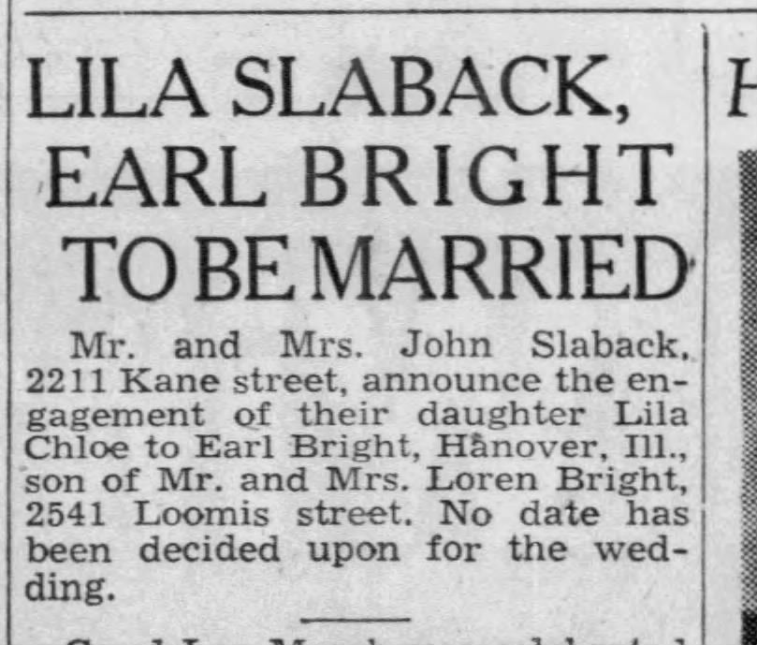

Page 4 of *The La Crosse Tribune*, December 30, 1941

Lila’s heart dropped. She hardly knew Earl. What was the rush? As if reading her mind, her mother said, “Earl wanted to propose before he leaves for the war.” Earl took the ring out of the box and slipped it onto her left hand. The band was a little too big and the ruby drooped to the side; for months, the prongs would dig into her pinky finger, reminding her of that painful and awkward moment. As Lila stood there silently, the room erupted in happy chatter. “Earl is leaving for Illinois…” “Lila can live with us…” “I’ll send an announcement to the newspaper first thing in the morning.” Wasn’t she supposed to say yes or no? Earl gave her a peck on the cheek and his parents began putting their coats back on. Lila was stunned. Aunt Hattie was the one who put the announcement in the newspaper.

Lila knew it was cruel, but she hoped that Earl would be killed in the war. Veda told her it was so exciting to marry a soldier going off to war! Just like a movie. But Lila didn’t want to plan a date for the wedding. A few weeks later, Lloyd was sentenced to serve up to five years in the state prison. Lila wondered what her life would be like in five years. Would she be married to Earl? Would she have children?? It was gut wrenching to think how quickly her life had turned for the worse. She had been happy with her life the way it was.

Chapter Twenty-Five

Veda and Red were living with his uncle until they could afford a house of their own. Since they were both working it was just a matter of time until they could save enough money for a down payment. They had come over for dinner and made their announcement as Lila was bringing out the dessert (a beautiful yellow cake with white icing). Veda blushed and said, “I guess I won’t be able to work for much longer.” Lila looked at her belly, but couldn’t see any difference. How did Veda know she was pregnant?

John cleared his throat and said, “We have some news too.” He turned to Veda and said, “Since Lila is getting married, your mother and I have decided to move. You and your husband can move in here. Lila should stay until the wedding and then the house will belong to you.” Red said, “That’s very generous, but I can take care of my wife. We’re looking at houses in the neighborhood and nearly have enough money saved.” Hazel snapped, “Don’t be stupid. This will give you a proper home for my grandchild and you can use the money for something else.” They all ate their cake in silence. Their parents never explained why they had decided to move, but Lila suspected that her mother was the driving force: she hated living in the city. They also never explained their decision to give the house to Veda and Red. Cecil and Gladys were living upstairs at Lyle’s house and were expecting a baby too… why not them? Why not herself? She had no idea where Earl might want them to live, but his parents lived in La Crosse and it was reasonable to think he would return after his service. Maybe her parents were worried that he wouldn’t survive or would not want to inherit their house.

Lila wrote a letter to Earl and told him about the plan. Lyle and Cecil were going to help her father build a new house out in the country. He had purchased a small plot of land between La Crosse and Onalaska—enough to have a big garden and some distance from neighbors, but not enough to farm for a living. It was a short letter; she didn’t love Earl and had no idea what to say. Hope you survive the war? She hadn’t received any letters from him—she assumed life in the Navy was keeping him busy. Spontaneously, she decided that she would also write a letter to Lloyd. Could prisoners receive letters? She wasn’t sure, but imagined how much it would cheer Lloyd up to receive a letter from her.

February 3, 1942

Dear Lloyd,

I was so sorry to hear about your arrest. I don’t know if you will get this letter, but I miss you and think about you every day. Veda is having a baby. My parents are moving out into the country. Life is boring without you. I go to work and I come home and do more work. I miss our walks together and your funny jokes. Maybe you will learn some new jokes while you’re away.

Love, Lila

She put on some lipstick and kissed the bottom of the letter by her name. Later that week she went to the post office to buy stamps. She addressed the envelope to ‘Lloyd Slaback, Waupun Prison’ and slipped it into one of the mailboxes. Would that be enough? She had no idea, but resolved that she would write to him every week.

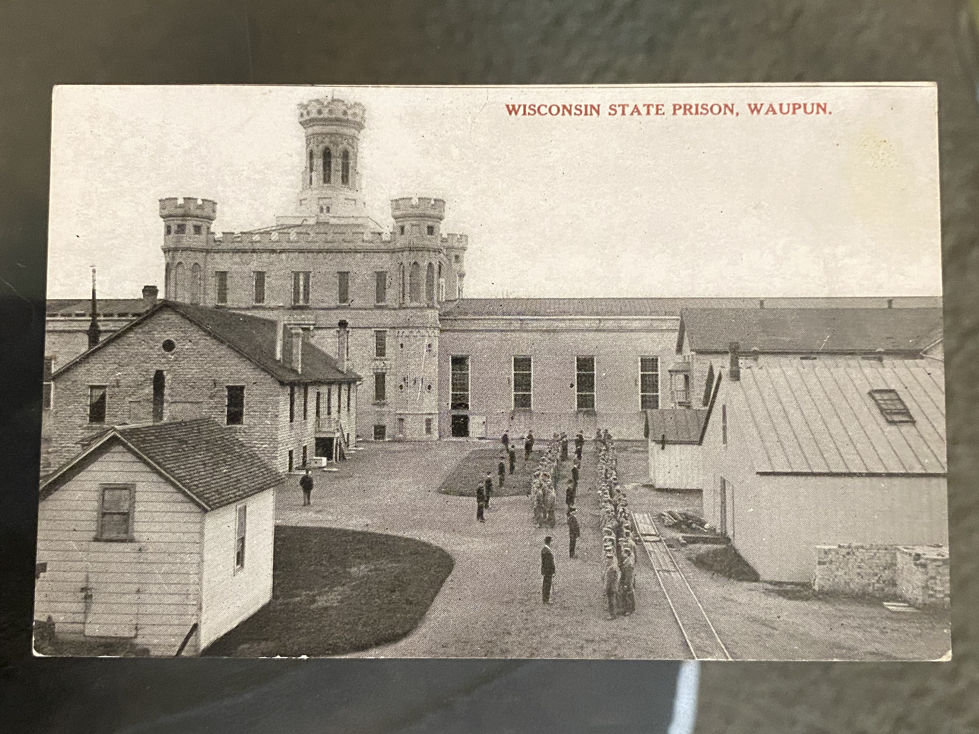

Postcard of Wisconsin State Prison in Waupun, where Lloyd was sent in the 1940s

One day while she was at the post office she bumped into her former classmate, Myrtle Johnson (now Mrs. Carl Schneider). Myrtle noticed the engagement ring on Lila’s left hand and squealed, “Ooh, Lila, I’m so happy for you! Who is the lucky man?” Lila was still holding a letter addressed to Lloyd and hoped that Myrtle hadn’t seen the name. Lila blushed and Myrtle squealed again and gave her a hug. “His name is Earl and he’s in the Navy.” Myrtle said, “Well that’s a coincidence, Carl just left a few weeks ago to join the Navy. That makes us practically sisters! You should come over for tea… we have so much to catch up on.” Unable to think of a good excuse, Lila said, “Sure, that sounds lovely.” Myrtle wrote her address and phone number on the back of a stray envelope and handed it to Lila. “Don’t be a stranger. I’m bored to tears keeping house while Carl is away.” Lila promised that she would drop by on her next day off. They had never been close friends, but it would become one of the most important friendships of Lila’s life, giving her options when she thought there were none left.

As soon as the snow melted, Lila’s father and brothers began building her parents’ new house. Lila moved her things upstairs so Red and Veda could have the small bedroom. As soon as her parents moved, they would shift to the larger bedroom and Lila could have the small one again. It was embarrassing to be almost twenty years old and sharing a room with your brother, even if it was just temporary. Lila nailed three sheets to the rafters to make a little bed chamber and told Looy that she better not catch him snooping. “Oh yeah, so what if I do?” Lila snarled, “Do you really want to find out?” Looy ran off saying, “Oooh… I’m really scared,” but he was thirteen and just as embarrassed to be sharing the room.

Veda was now visibly pregnant. Although she insisted that she was “just pregnant, not sick,” Hazel demanded that she take it easy. The two of them started going through the house, making decisions about what to move and what to leave. Veda and Red had clothes (of course) and had received some household necessities as wedding gift—towels, sheets, pots and pans, etc… Aunt Hattie had given them a small, but very beautiful set of china. Red’s father had given them a little money. He also made a cutting board that so was smooth and lovely; Lila didn’t see how Veda would ever stand to use it for its intended purpose. Hazel said that they would leave most of the furniture. In the attic, they still had Looy’s cradle. “Oh, that will be perfect when the baby arrives,” said Veda. As Lila continued doing most of the cooking and cleaning, Veda made diapers and clothes for the baby using Hazel’s treadle sewing machine.

The house was getting busy again. Veda’s friends organized a baby shower and asked Lila to make the desserts. A steady stream of acquaintances dropped in to tell Hazel how sorry they were to see her go. She loved the attention and treated Lila like a maid, “Go fetch us some sandwiches. Take these plates to the kitchen. Go get Mrs. Taylor’s jacket from the bedroom.” It was so much work that she started to think about quitting her job with Mrs. Davis. Cleaning and cooking around the clock was taking a toll on her knees and back.

Chapter Twenty-Six

Veda’s baby, who they named David, was born just a few days after the new house was finished. Lila thought her parents might wait a few weeks before moving so Hazel could help Veda and they could spend a little time with their new grandchild, but Hazel was clearly anxious to get going. Since there was no high school near their new house and it was too far to drive to La Crosse or Onalaska on a daily basis, the family had decided that Looy would stay behind and live with Veda and Red. As they all said their goodbyes at the curb, Veda promised that they would be up for a visit soon. And that was that. Lila had helped pack their belongings in the back of Theron’s truck; on the first day of summer they drove off.

Although Lila had been in the house on Kane Street plenty of times without her parents, it was strange knowing that they would no longer be living there. They had all known that this day was coming, but Red and Veda seemed to be in shock. Were they really the owners of this house now? Veda went back to taking care of the baby and Red went back to work. Veda was not as demanding as Hazel. Lila was glad that she had not quit her job after all.

One night at dinner a few weeks after their parents had moved, Veda announced that it was time for all of them to start going to church on a regular basis. David should be baptized as soon as possible; it would be a blessing for them to go to confession on Saturdays and mass on Sundays. Lila inwardly groaned—the Slabacks were not church goers. Why did Veda have to be in charge? Looy said, “Do I really have to go?” Without hesitation, Red calmly answered, “As long as you’re living in my house, yes you do.”

That summer Lila finally received a letter from Earl, but it was not the kind of news she had been expecting.

August 2, 1942

Dear Lila,

I should have written to you earlier, but I wasn’t sure what to say. When I tried to join the Navy, they told me I have a heart murmur so I’m ‘not eligible’ to join the service. Can you believe that? I thought they would take anyone right now.

I’ve been living in Illinois and working as a truck driver. There’s no easy way to say this, but I’ve met someone else. Her name is Aline. We got married and we’re planning to move to La Crosse in a few months. I didn’t want you to find out from someone else.

I’m sorry that things didn’t work out between us. You seem like a nice girl. Please keep the ring. You can sell it if you need to.

Sincerely, Earl

Lila knew the family would be upset, but she was relieved. She had never agreed to get married and now she didn’t have to say yes or no. The wedding was off. She tucked the letter under her mattress and decided to think about how she was going to tell everyone. Would her mother and Aunt Hattie start pressuring her again? She was grateful that she had been the one who checked the mail that day. Nobody else knew of the letter’s existence.

After a few weeks, she decided to break the news to Veda. It was Lila’s day off and Red was at work. They were sitting in the front room watching the baby as Veda worked on knitting him a sweater. “Veda, I have something to tell you… I’ll be right back.” She retrieved the letter from Earl, which was looking rather crumpled after all of the times Lila had read it and stuffed it back under her mattress. “I need your advice about something. I want you to listen and then take a moment to think before you say anything.” Veda stopped knitting as Lila read the letter out loud. She stared at Lila and opened her mouth, but for a few moments nothing came out. “What are you going to tell mom and dad?” Veda asked. Lila said, “I have no idea! It’s not my fault that Earl married someone else. It wasn’t even my idea to get engaged in the first place.” Veda said, “Calm down, Lila, of course you wanted to marry Earl. Don’t exaggerate. I just don’t know how you’re going to tell mom or find another man to marry. You should tell Aunt Hattie.” Lila was shocked. She didn’t think Veda was trying to be mean, but was that really her best advice? Lila said, “I need to wash the dishes now” and walked away.

Telling Myrtle was not much better. She burst into tears like Earl had died. Lila didn’t tell her that she had never wanted to marry Earl. After Veda’s reaction, she had decided that it was probably best to keep that information to herself. Through her tears, Myrtle said, “I don’t know why I’m the one who’s crying… I should be comforting you.” Lila gave her a little hug. Why did this have to be so hard? She wasn’t even sure she wanted to get married, but everyone was acting like her life was over unless she could get engaged again. It seemed to be the only thing anyone cared about. After a few minutes, Myrtle went into the kitchen for another plate of cookies. “We just need to find you another man. That will make everything better. In a few months we’ll say, ‘Earl who?’ and laugh about the whole thing!” Lila doubted that was true.

With the wedding off and Lloyd in prison, Lila decided to become a regular at the movie theater. The price of tickets had increased by three cents, but it was bliss. No chores, no talk of ‘finding a man,’ just a box of popcorn and two hours of escape. She skipped *I Married a Witch* based on the title but watched everything else—war movies, cartoons (*Bambi* was popular that fall), science fiction, mysteries, dramas—she enjoyed them all. The comedies were her favorite. The first time she saw Claudette Colbert was that year in *The Palm Beach Story*. What a smart and funny woman! When her husband couldn’t provide for her, she didn’t sit around moping about it. She took matters into her own hands and left to find an exciting new life. Lila was still wearing the ring from Earl, but she took it off that night.

Chapter Twenty-Seven

One day Lila went to work and was shocked when a man answered the door. “Can I help you?” he said. “Yes, I’m here to clean for Mrs. Davis… is she in?” The man looked her up and down and said brusquely, “My mother has become very ill. The doctors are not expecting her to survive much longer… your services are no longer needed here.” He shut the door in her face before she could respond. It was the end of the week and Mrs. Davis was supposed to pay her the next day. She knocked on the door again, but the man didn’t answer.

Veda had relented on telling Lila to go to church, but did ask her to ‘set a good example for Looy.’ On the occasions when she went to mass, Lila would inevitably look around at the other parishioners and think, ‘Is this really my life?’ It was so boring. Lila could have found another cleaning job, but decided that she needed something more exciting. With the last bit of money she had earned by working for Mrs. Davis, she took a streetcar downtown to purchase a dress and a new pair of shoes. Her usual ‘housedress and apron’ was good enough for cleaning, but it was not going to help her land a job as a waitress. With the war going on, many young women were working as waitresses; there weren’t enough men to fill all of the jobs and it was becoming much more socially acceptable. Lila had already stopped at five places to inquire if they were hiring, but they all said something like, “Sure, leave your phone number and we’ll give you a call.” Lila didn’t have a phone or a phone number.

The first place she went to look for a dress was Doerflingers, but she felt so conspicuous. She walked up the stairs to avoid the elevator man. When the sales staff asked if she would like any help, she politely said, “No thank you, I’m just looking.” She noticed that two of the clerks were engaged in a quiet conversation. Were they talking about her? After a few minutes she left and walked down Main Street. It was her first time wandering alone downtown and there were so many shops. Shops for shoes. Shops for jewelry. Shops just for flowers.

At the end of the block was ‘the five-and-dime,’ F.W. Woolworth. Lila pushed open the door and immediately felt better. The lights were bright and cheerful, and the store was full of people of all ages—regular people like her, not rich people. Lila walked past the lunch counter near the front. Signs informed her that ‘Ladies Clothing’ was on the second floor. As she began trying on the dresses, Lila was relieved to find that she had no trouble fitting into them. It was very different from her first experience shopping with Aunt Hattie. After some consideration, she decided to buy a knee-length, navy blue dress with white trim around the collar and a new pair of pumps. Food was being rationed, but clothes and shoes were not. The total cost was eight dollars and forty-five cents. Lila was not used to spending that kind of money, but the next day when she put on the outfit Veda said, “Wow, Lila! You look stunning!” It was a good feeling. At the first restaurant she walked into with her new outfit, the manager offered her a job on the spot.

Lila could hardly believe it, but the pay at Carroll’s was more than double what she had been earning from Mrs. Davis. Sometimes she helped with a little cleaning (sweeping floors or washing the dishes), but overall it was much more easy and fun being a waitress. Lila enjoyed talking with the customers and making suggestions. Often it was just about the weather (‘Boy it sure is a nippy one today!’), but sometimes they asked, ‘What is your favorite?’ or ‘What do you think about the soup of the day?’ It was a joy for someone who loved to eat. Lila often tried the specials since the meals were free for employees. Although she had to wear a uniform—a light blue, button-down dress with a white apron and a little white cap—the owner gave everyone on staff extra money to purchase their uniforms from a particular shop downtown. It saved money and made it easy to get dressed for work. Lila felt proud to be part of the Carroll’s team. She even won the award for ‘employee of the month’ in October.

After 6pm, the restaurant turned into a bar. In the back of the building there was a dance hall and a small bowling alley. It was always packed, especially on the weekends. Not far from La Crosse there was a large army base—Camp McCoy. Lila had heard that recruits were being sent there for training before heading off to war. La Crosse was the place where they went to get drunk. As she walked to and from work, Lila had noticed that the number of bars in La Crosse was increasing rapidly: Killian’s, Fish’s, the Cavalier Lounge… even Cecil was talking about opening a bar. One day the manager at Carroll’s asked if she could stay for a few minutes after work. She worried all day that she had done something wrong and was about to be fired, so she was relieved when the manager said, “Could you start working in the evening? You would make a great cocktail waitress, Lila.” It was flattering to think that she might be ‘great’ at something. Without thinking she replied, “Yes, I’m willing to work in the evening.” She didn’t know how she was going to justify the late hours (or working in a bar) to Veda and Red, but why not?

The uniform for evening was different—a short, red dress with a matching shrug tied in a bow to give a glimpse of cleavage, and strappy, black high heels. No apron, no pockets, no pads of paper for writing down orders. It was very glamorous, but in the beginning Lila was nervous. There were so many things to learn, like the names of all the cocktails. What on earth was a pink squirrel? She laughed the first time someone ordered one.

The first weekend she worked at the bar, Lila told Veda that she was going to the movies for a double-feature. Veda replied, “Oh that sounds like fun! Have a good time.” Lila carried her uniform in a grocery sack and put it on right before her shift. One of the other waitresses noticed her changing in the tiny women’s bathroom. While touching up her make-up, she said, “You look great… just try to have a good time. Act like you’re at a party and not at work.” Lila smiled but didn’t respond. She was too nervous. She hoped that nobody would notice when she returned home at three o’clock in the morning. For a few months, it seemed like nobody did.

Chapter Twenty-Eight

As Lila settled into her new job, she found that there were many advantages to working as a cocktail waitress. The pay was better and so were the tips. The money was piling up in a cookie tin under her mattress; she had never imagined that she would be able to save so much. What if she saved enough to buy a car or even a house? The possibilities were exhilarating. It was also fun to flirt with the young soldiers. She felt good about serving them and bringing a little joy into their lives. It was a thrill to be called ‘beautiful’ every day by so many handsome young men. Lila had never felt so desirable. Her mother always said that it was lazy to sleep past six o’clock in the morning, but working at night and sleeping late was such a pleasure! Lila had never felt so alive. How could something so enjoyable be wrong?

One day she was washing laundry when Veda said, “Lila, we need to talk.” She asked if it could wait—the laundry wasn’t going to wash itself—but Veda insisted. Lila sighed and said, “All right, Veda, what do we need to talk about?” Veda looked nervous. She said, “Lila… I’ve noticed that you’re sleeping later than usual. I thought you were just going to the movies in the evening, but Mrs. Christiansen has insomnia… she told me yesterday that sometimes you come home as late as four o’clock in the morning.” Lila stopped cranking the wringer and said, “That old busybody… I don’t know why anybody listens to her.” She started cranking again, but Veda put her hand on Lila’s arm. “Lila, I’m worried about you. I know Earl is the one who called off the wedding, not you, but you’re twenty years old and you’re not married. What are you doing so late at night? The neighbors think you’re selling yourself to men.”

It was like a verbal slap in the face. Lila narrowed her eyes and said sharply, “Is that what you think of me?” Veda blushed and said, “Well not really, but I don’t know what to think. You come with us to church and then you disappear at night. It can’t be good! David is too young to notice, but what kind of example do you think you’re setting for Looy?” Lila was angry. Was it so terrible wanting to work and not get married right away? Had Veda already forgotten that she once planned to be a nurse? Lila said, “I am not ‘selling myself,’ Veda. I’m offended that you would think that.” Veda quietly said, “I think I hear David crying” and that was the end of the conversation. Veda bounded up the stairs like she had seen a snake in the basement.

Lila wanted to tell Veda everything—about working at Carroll’s and the tin of money, about the joys of flirting with men and sleeping late, even about Lloyd and how much she was missing him—but how? While Veda was living the ‘perfect’ life with a house and a family and going to church every Sunday, Lila’s pile of secrets was growing. It was easier to avoid talking with Veda than to bridge the gap that was growing between them.

Surprisingly, Looy didn’t seem to mind going to church. He had become active in the youth group and was talking about getting baptized. One of the deacons announced that area farmers would need help picking berries starting in June. With so many young men involved in the war, the jobs would have to be filled by young women and children. He emphasized that as good citizens and Christians, it would be a shame for them to let the crops to go to waste. Lila thought nothing of the announcement, but a few nights later at dinner, Veda asked Looy if he would be interested. He would be fifteen in September. Red turned to Looy with a serious face and said, “Harvesting is hard work, but are you ready to be a man?” Veda said, “Red, he’s still just a boy… I was thinking that Lila should go with him.” Lila’s mouth dropped open. She was stunned that Veda would make such a suggestion, especially without asking her first. The only way to do it would be to sacrifice her job at Carroll’s. Maybe that was what Veda had in mind—to get her away from the city. She wanted to say “no,” but the look on Looy’s face changed her mind. He was so eager for an adventure.

Three weeks later, Lila found herself on a truck with Looy and two sisters from his youth group, Jean and Patty Shuda. Their parents were from Poland and had twelve children—a large family even for Catholics. By the time they were halfway to Richmond, Lila was already tired of their incessant chatter. The girls—who were so close in age and appearance (with blue eyes and white-blonde hair) that they were often asked if they were twins—were very excited and seemed to have an endless amount of energy. They were all sitting in a tight cluster, trading gossip about their teachers and friends. Jean was going to Aquinas (the Catholic high school) and they debated whether Logan High School was better. When they arrived at the farm of William Stanton, their home and workplace for the next four weeks, Lila was relieved to be offered a private room; it was small, but at least she would have a little time and space to herself. In her suitcase she had packed some work clothes (which were clean, but heavily worn), an apron, an extra pair of shoes to wear to church on Sundays, and materials for writing letters.

Lloyd had begun writing back to Lila a few months earlier. The rough, brown envelopes were addressed to “Lila Slaback, 2211 Kane Street,” but never had a return address. Every time she received one, she worried that Veda would want to have a talk about where the letters were coming from. Thankfully, Veda never opened them.

February 6, 1943

Dear Lila,

I miss you like crazy. Thinking about you makes me forget about being in prison for a while. The warden says I might get a reduced sentence if I’m ‘helpful.’ I’ll try to help if I can. Here’s a new joke for you:

Teacher: Why are you late again for school?

Kid: I had to take one of our heifers to the neighbor’s farm for breeding.

Teacher: Couldn’t your father take care of that?

Kid: I guess, but the bull does a better job.

Love you, Lloyd

Under the writing there was a drawing of a man standing behind a cow with his pants around his ankles. Lila laughed. Lloyd had such a dirty mind, but he was also very talented at drawing. It wasn’t until she saw the image that she understood the joke.

By the end of the first week, Lila regretted that she had not said “no” to Veda. Although summer was just getting underway, it was hot, and the mosquitoes were thick. It was fun to pick berries on a Saturday—the Slabacks had done that many times to get berries for jam—but doing it every day was backbreaking work. The strawberries were low to the ground. It was killing her knees. The blueberries grew on higher bushes, but they were so small. It took a lot of picking to fill a single bucket. The berries ripened in stages; by the time they reached the end of the field, it would be time to go back and pick the berries that had just ripened. She was grateful when Mrs. Stanton asked if she would help with cleaning and food preparation in the afternoon. Anything to get out of the fields a little early.

Looy, Jean, and Patty were sleeping in the barn. Lila knew that Veda would not approve of the ‘mixed company,’ but her only choice was to keep her private room or sleep in the barn with them. Lila decided to keep the room. What Veda didn’t know wouldn’t hurt her. Besides—after spending all day in the fields, what trouble could Looy and the girls possibly get into? Lila was worn out from the work and assumed they were too.

Four weeks later, the berry season was over. Mr. Stanton thanked them for their hard work and paid them each fifty dollars. Looy and the girls were thrilled. All the way home, they talked about how they would spend the money. Jean and Patty were giving part of their wages to their parents, but Veda had already promised Looy that he could keep whatever he earned. Lila was disappointed. She could have made more money in one week by working at Carroll’s.

A few months later, they heard that Jean was pregnant. Her parents had decided that Looy and Jean were ‘too young’ to get married, so they sent her to live in a house for unwed mothers. It was supposed to be a secret, but of course everyone in the church knew. It was a major scandal. A few days after they heard the news, Veda cornered Lila in the kitchen and demanded to know why Lila had ‘allowed’ this to happen while they were on the farm. “You were the adult! You were supposed to make sure that nothing happened!”

Lila flushed with anger and frustration that Veda was blaming her. She yelled: “You and I were both there when Red asked Looy if he wanted to be a man. What did you think was going to happen, Veda? Was I supposed to treat him like a child?” Sometimes while walking to and from work, Lila wondered if Jean’s baby would be a boy or a girl. Would he or she be funny or serious? Would the baby grow up to be a factory worker or maybe something more exciting like a famous wrestler? How could Jean’s parents force her to give the child up for adoption? How could Jean just allow it to happen? Maybe Looy and Jean were too young to get married, but it was a tragedy for everyone. The baby would never know that he or she was a Slaback.

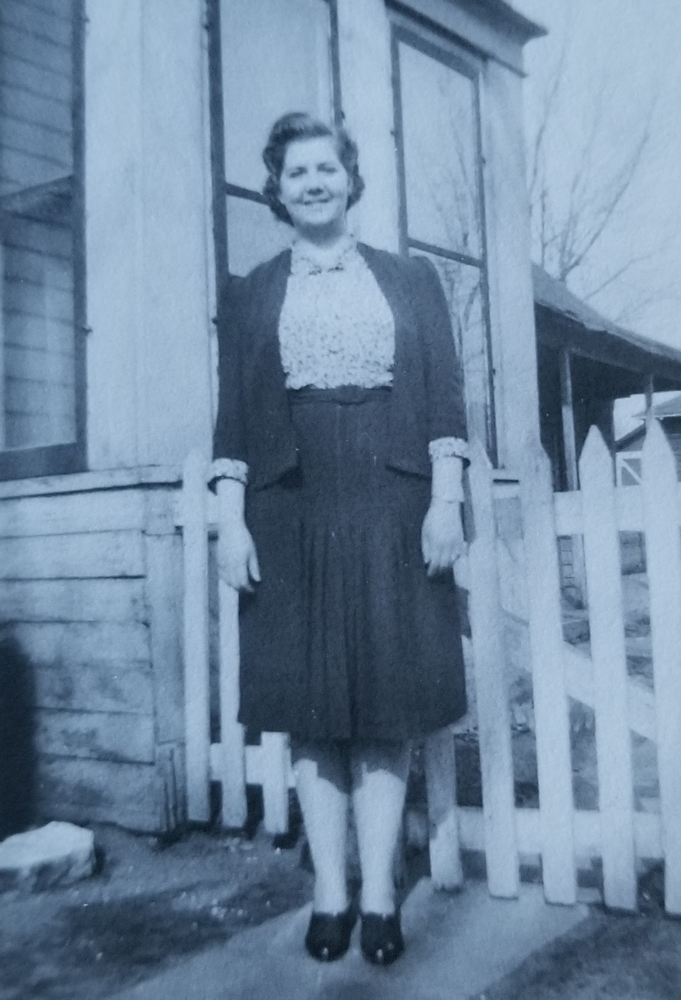

Lila as a young working woman, circa 1943

Chapter Twenty-Nine

The manager at Carroll’s was thrilled when Lila returned and announced that she was available to work again. Two of the waitresses had decided to join the WAVES[2] and they had been short-staffed. In very little time, Lila was back to her usual routine. There was no end in sight to the stream of soldiers moving through La Crosse. Lila had stopped trying to remember the names of her customers; even the ‘regulars’ would be gone after a few weeks.

The price for a movie was reduced on Tuesday evenings; one week Lila asked Myrtle if she would like to go. (“My treat,” she said when Myrtle objected to the cost). They decided to watch the latest movie with Claudette Colbert, *So Proudly We Hail!* Lila assumed that it would be another comedy, but it was not. It was about women serving in the army as nurses and falling in love with the soldiers. Myrtle cried when one of the nurses was killed and said that the movie was ‘so romantic.’ On the way home she said that Carl was stationed in California; she wanted to take the train and go visit him, but women weren’t allowed on the base. Lila wondered if that was the truth or if Carl had reasons for wanting Myrtle to stay home in Wisconsin. Working at Carroll’s, she had observed that there was little difference in behavior between the soldiers who were married and those who were not. She wondered if she should tell Myrtle that she was being naïve, but decided against it. She didn’t want to hurt her feelings.

The soldiers mostly went to the bars in groups. Every weekend, the city of La Crosse was like a giant party. They played darts and card games, smoked and drank, told jokes, and bragged about their exploits. One of the waitresses, a tall, glamorous blonde, openly relished having sex with them. Lila had never known a woman who was so open about it; she was like a movie star. Claire received more tips than anyone, but then one day she simply disappeared. Where had she gone? When Lila asked the manager, he brusquely told her “Don’t ask questions.”

Lila tried to memorize some of the jokes to share with Lloyd. One night, she noticed a soldier who was sitting by himself in the corner. He was older than usual and seemed to be lost in thought. When he nursed a single beer for more than two hours, Lila took him a fresh one and said, “There’s plenty more where that came from.” He smiled a bit and said, ‘Thanks… I don’t know what I’m doing here.’ Lila had met plenty of soldiers who were homesick or nervous or just plain scared (not that they wanted to admit it), but this one… it was like he had come to the bar from a funeral. “You mean, you don’t know why you came to Carroll’s?” she said. The man chuckled. “No, I know why I came to this bar… I just don’t know what I’m doing so far from California, getting ready to head off to war. This is not how I imagined my life would turn out.” Lila sat down beside him; it couldn’t hurt to give him a little extra attention. He had sandy hair and smelled like cigarettes and Old Spice.

He started telling a story. “A few nights ago, it was time for lights out and the sergeant said, ‘Men, I want you to look up into the sky and tell me what you see.’ One person spoke up right away and said, ‘Sir, I see millions of stars.’ The sergeant replied, ‘Alright. Now what do the stars tell you?’ Someone on the other side of the room said, ‘They tell me that I can always find my way home as long as I look for the north star.’ Another said, ‘They tell me that God exists and everything else is insignificant.’ My bunkmate added, ‘The stars tell me that the sky is clear tonight and the weather will be good tomorrow.’ It was a very somber mood. Then the sergeant barked, ‘You’re all wrong. If you can see the stars when you’re in bed, then somebody stole your damn tent.’” Lila laughed out loud. He had told the joke with such a dry sense of humor; Lila didn’t think it was a joke until the punchline. “You really got me there. My name is Lila, by the way.” The man smiled and held out his hand, “Private Daniel Oxnard.” A feeling like electricity rippled through her body when they touched. Lila said, “Well I need to go back to work now, Daniel, but I’ll bring you another drink. Compliments of the house.”

Daniel stayed for most of the night, but he slipped out before they had another chance to talk. It was a busy night and Lila had made over fifteen dollars in tips. Before leaving work, she slipped the five-dollar bills into her brassiere. (One of the other waitresses had told her, “A thief might take your purse, but the money will be safe if you keep it close.”) By the time she returned to the neighborhood, the sun was peeking over the horizon. A few nights later, Daniel was back. As soon as she noticed him, Lila made a beeline for his table. “Welcome back, soldier. I wasn’t expecting to see you again.” Daniel replied, “Well, a bad penny always turns back up.” Lila laughed, “I wouldn’t say you’re a bad penny. I’m glad you came back.” He sat in the corner again and ordered a beer, but when Lila brought the drink to his table he asked when her shift would be done. “3:00,” she said, thinking how long it had been since someone offered to walk her home. Her shift flew by. She found Daniel standing in the parking lot, waiting and smoking a cigarette. He smiled and said, “Where to?” Carroll’s was on French Island. There were many islands in the Mississippi, but this was the largest one in the area. Lila smiled back and said, “This way,” pointing in the direction of the Clinton Street bridge.

That day the weather was unusually warm for September. The cicadas were buzzing; it felt more like summer than fall. After they crossed the bridge, Daniel asked, “Can we walk by the river for a little while? I’ve never seen the Mississippi up close before. I feel like I’m in a Mark Twain novel.” “Sure,” said Lila. It was no special thrill for her to see the river, but she didn’t mind taking a detour. When they got to the shoreline, she took off her shoes and put them in her handbag; it would be impossible to walk along the sand in heels.

The moon was full that night and the air was thick with humidity. Daniel said, “I was a truck driver back home… my family is in the sugar business.” “Oh?” said Lila. “My oldest brother is a truck driver too. My family is in the plastering business.” “Plastering like… the walls? Or getting plastered?” Lila laughed, “A little of both, I guess.” How had he guessed about the drinking problems in her family? It was like he could read her mind. Soberly, Daniel said, “I’m a tank driver now. We got our marching orders this week; we’re heading to Europe in a few days.” Lila put her hand on his bicep. “I don’t know what to say, but I hope you make it back.” Daniel put his hands on her waist. “I want to make love to you Lila. You’re so beautiful and I miss being with a woman.” His hands were warm and gentle. It had been over a year since Lloyd was arrested. She leaned over and kissed Daniel. He untied the front of her dress and they sank down into the sand. It was like being in a movie. Lila wanted to give him a happy memory; one last enjoyment before going off to war. It was so passionate and romantic. They could have been spotted by anyone passing by, but Lila did not care.

II *In a Family Way*

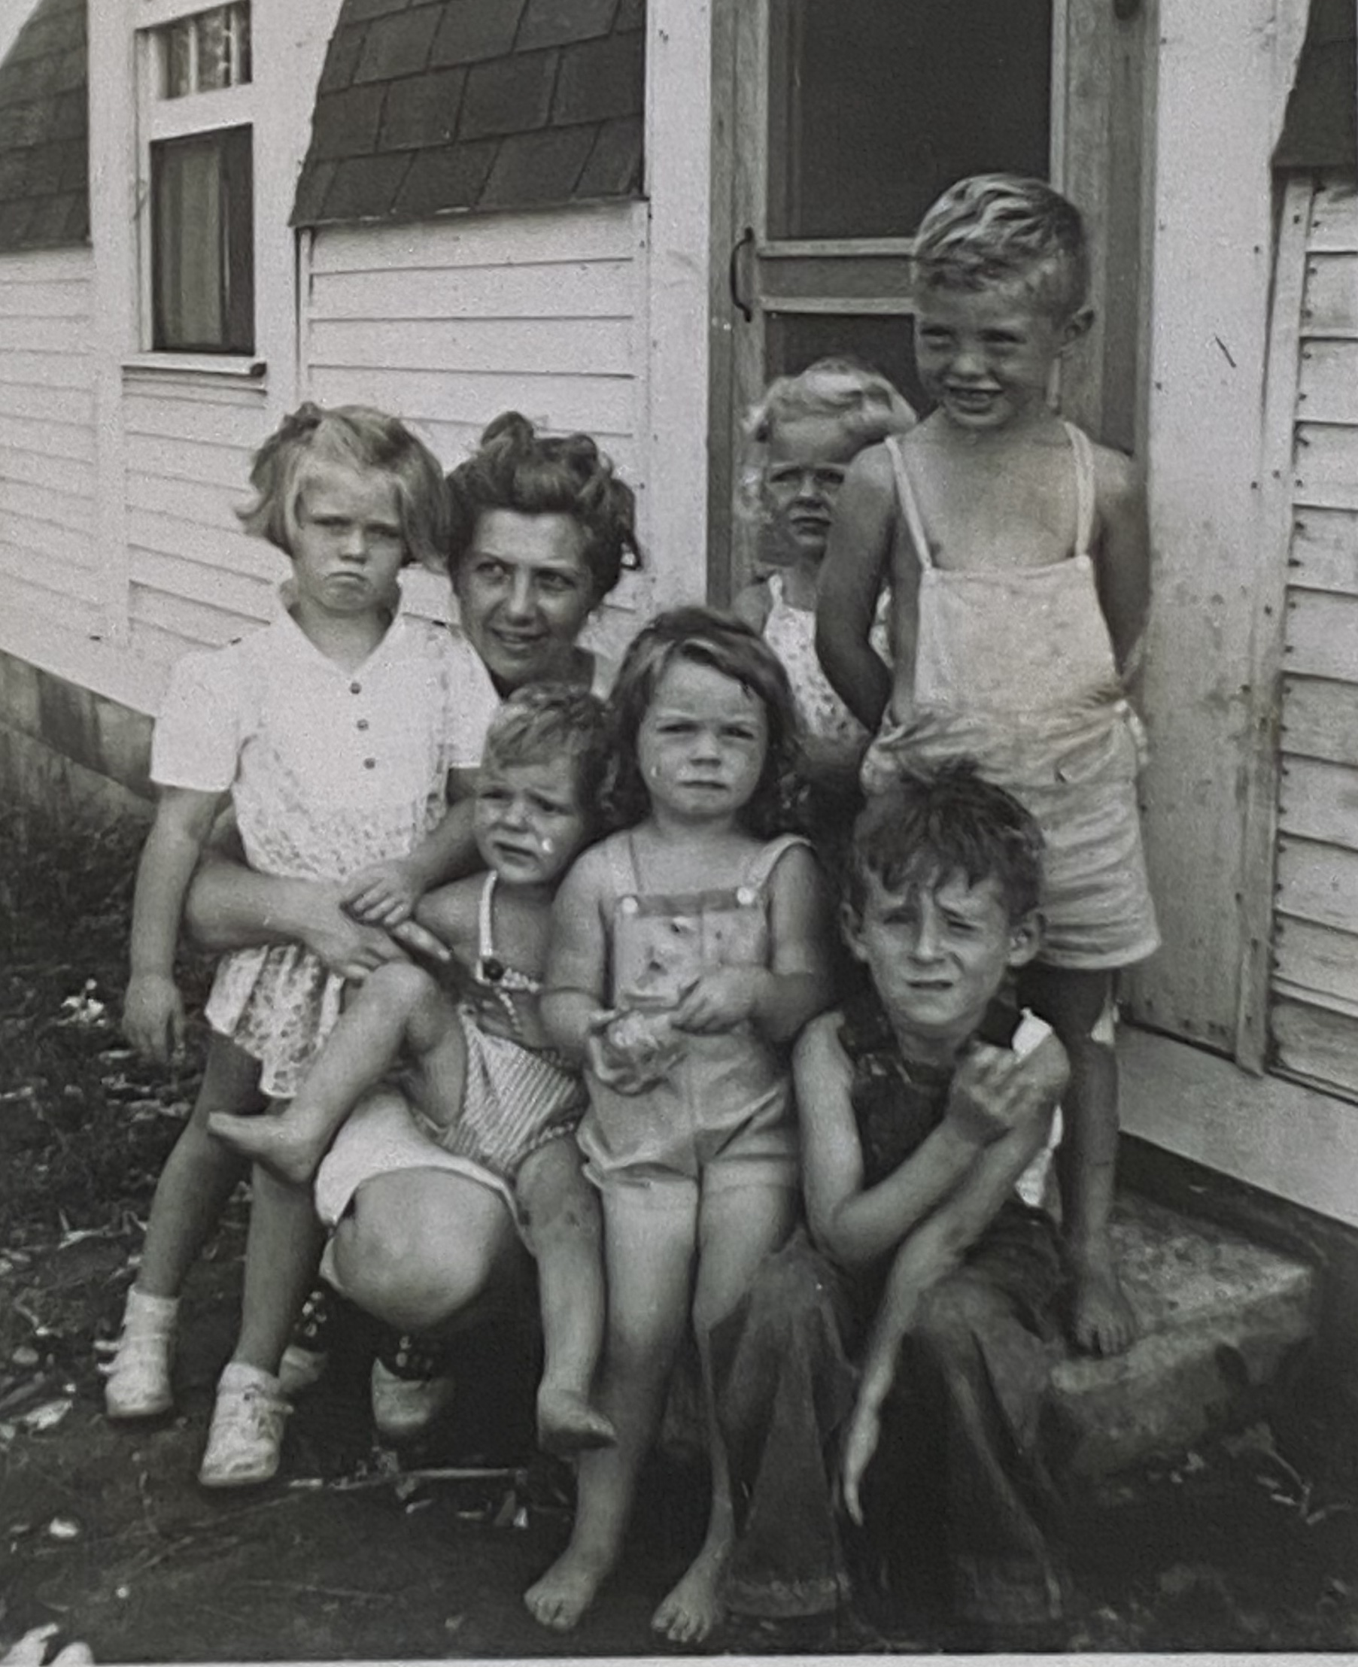

Lila, circa 1948. In the center is her oldest daughter, Myrtle Joyce. Her son, John, is sitting in her lap. Standing on her left are Veda’s children, Patty and David.

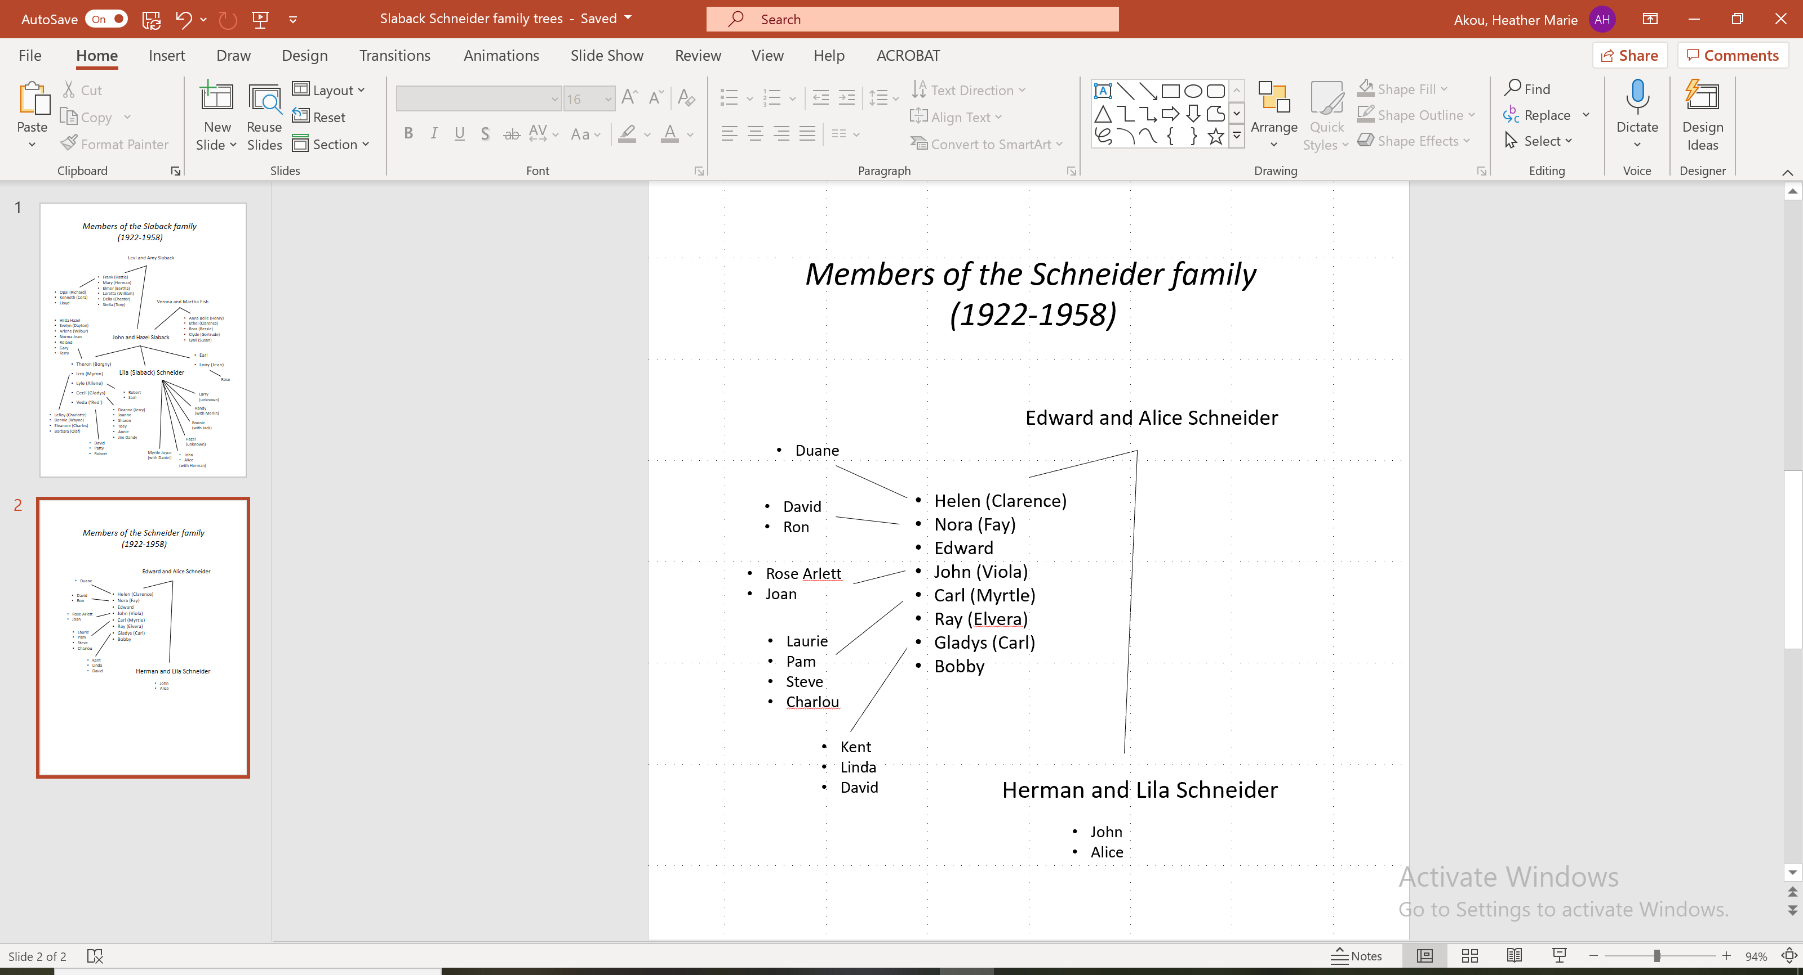

Chapter Thirty

Within two weeks, Lila knew something was different. Her first clue was that her clothes suddenly felt like sandpaper on her skin. One evening during her shift at the bar, she felt sick to her stomach and had to excuse herself for some fresh air. Maybe it was food poisoning. On the way to work she had been so hungry that she stopped at White Castle to purchase a hamburger. She kicked herself for stopping there when she could have eaten as much food as she wanted at Carroll’s. What was she thinking? A few weeks later she realized that her time of the month had not happened yet. She tried not to think about it. Lila was hungry all the time, especially for beef, baked potatoes, and ice cream. Her uniform was getting tight and she thought (regretfully) that she would have to stop eating so much. For a little while she was successful at eating less, but around Christmas she realized that it was no use; she would have to buy a larger uniform after the holidays. If Veda noticed, she didn’t say anything.

One night at the end of January Lila fainted at work. She had been feeling a little sick but didn’t want to admit it. Carroll’s was always busy. If she took time off, she would have to find someone to cover her shift; the manager, wouldn’t like it. He was even less thrilled when Lila fainted, but he was the one who drove her to the hospital. She woke up hours later in a bed at St. Francis. A nurse had been sitting in the room; as soon as Lila opened her eyes, she left to fetch the doctor. Dr. Olson was a tall man with dark hair, horn-rimmed glasses, and a severe expression. His stout belly stuck out from his white jacket, which was open in the front. He sat down next to the bed and said, “Do you know why you’re here, Miss Slaback?” Lila had never been in the hospital before. She felt very tired and silently shook her head. The doctor looked down at his clipboard and said, “Miss Slaback, are you engaged or married?” This again. Why did everyone care so much? When she didn’t answer, he said, “Do you have a family member that we can call? Someone will need to pick you up later today.” Her head was swimming. It was like being in a dream; she could hear the doctor speaking, but nothing was making sense. She managed to give him Veda’s name and address before she fell asleep again.

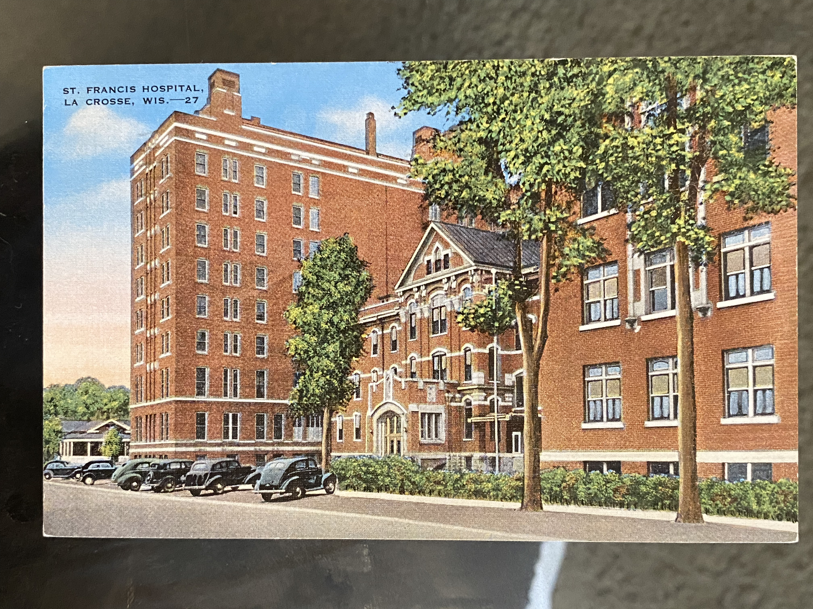

A postcard of St. Francis Hospital from the 1920s; it was the first major hospital in La Crosse, established by the Catholic Church in 1883

When she woke up the next time, Veda was sitting next to her. She looked so worried that Lila immediately felt terrible. Veda said, “Lila… the doctor says you’re pregnant.” Her words were like a lasso that jerked her consciousness back to the surface. “I don’t understand. What are you doing here?” She sensed that Veda was angry. “I’m here because someone came to our house and informed me that you were taken to the hospital.” Lila responded, “I’m sorry, I didn’t mean to cause you any trouble. I don’t understand what’s going on.” Lila ran her fingers over the white sheets of the hospital bed. The sheets were cool and stiff. Veda’s eyes narrowed. “The reason you’re at the hospital, Lila, is because you’re pregnant. You’re anemic from a lack of iron and that’s the reason why you fainted.” “Oh,” said Lila. They sat together in silence until the nurse returned to give Lila an injection.

Veda had left her son with a neighbor before rushing to the hospital. Red picked them up as soon as he was done with work. He gave Veda a kiss on the cheek and she pulled him off to the side for a hushed conversation When Lila had checked out from the hospital, the nurse gave her instructions to eat liver at least twice per week and to get some rest. Lila hated liver; it tasted like meat, but the texture was like peanut butter. It made her gag to think about eating it. She was thinking about it when Red and Veda returned to the truck. Red opened the door for Lila without saying a word. The ride back to Kane Street was completely silent.

For the next two days, Lila slept. She had rambling dreams about car accidents and about being chased. Her legs were so heavy that she couldn’t run away from whatever was chasing her, but she was never able to see what the ‘thing’ was. In one dream, it was chasing her along a cliff and she fell off the edge. It jolted her awake with her heart racing. Someone had placed a chair next to the bed. It was holding a glass of water and a sandwich on a plate. She reached out and touched the top of the bread, but it was stale. Too tired to complain or to make something fresh, she forced down the sandwich, which turned out to be peanut butter. The water wasn’t enough to wash away the dryness. She fell asleep thinking how thirsty she was.

On the third morning, Lila was violently awakened by a splash of ice-cold water. Her mother was standing near the window holding a bucket. “You good-for-nothing whore,” she snapped. “I thought I raised you better than this.” Lila was shocked. It felt like her heart had stopped beating for a few seconds. “Well, what do you have to say for yourself? I’m waiting here until you answer.” Was there anything she could say to make this go away? “I’m sorry,” Lila stammered. “I don’t know what you want me to say.”

Hazel was so enraged that her face was nearly purple. She threw the bucket against the wall and it fell to the floor. Clang-clang. She stomped to the door and slammed it behind her. Lila decided to dry herself off and to get dressed. She needed to use the bathroom and was feeling very hungry and thirsty. As soon as she left the bedroom, she noticed that Veda and Red, her parents, and Aunt Hattie were all sitting around the dining room table—like cats getting ready to pounce on a bird. With an innocent tone, Lila said, “I need to use the bathroom… be right back.” Aunt Hattie hissed, “Be quick about it, we’re all waiting for you.”

Lila looked at herself in the mirror. Her eyelids were puffy and her hair was a mess. The back of her nightgown was soaked. Her thoughts flashed back to the hospital and Veda saying, “You’re pregnant, Lila.” She closed her eyes and wished that she could be magically transported somewhere else—like Dorothy in *The Wizard of Oz*. She stood at the sink and clicked her heels together, but when she opened her eyes, everything was exactly the same.

After changing her clothes and combing her hair as slowly as possible, Lila went to the table and sat down. The table was covered with crumbs and plates and half-empty cups of coffee. She reached out for a piece of bread and Aunt Hattie cleared her throat. “Lila… you should be ashamed of yourself. Your actions have brought disgrace to this entire family.” Lila pulled her hand back and looked down at the table. Hattie continued. “Who is the father of this child? I assume it’s Earl Bright?” Veda said, “Earl married someone else. He wrote a letter to Lila and told her.” Hazel snorted. “I knew it.” (Later, Lila wondered why Veda had not told anyone.) “Well,” Aunt Hattie demanded, “Who is the father then?” Lila was silent. She thought about that night by the river with Daniel and wondered if he was still alive. They had not written letters to one another; he had no idea that she was pregnant.

Everyone was staring at her. She resolved that she would not give them the satisfaction of watching her cry. After what felt like an hour, Aunt Hattie said, “You have two choices: you can either get married or you can give the baby up for adoption.” Lila looked around the table. Veda was as white as a ghost and looked like she wanted to sink under the table. Hazel’s face was beet red and there were veins standing out on her neck that Lila had never noticed before. Her father and Red were staring into their cups of coffee. Aunt Hattie’s lips were tightly pinched, and she was waiting for an answer—she was staring right at Lila without blinking. Her mother spoke up and said, “She should go to that home for unwed mothers… the one that Jean’s parents sent her to.” Aunt Hattie said sharply, “That is certainly one option, unless the father in planning to step forward and make Lila an honest woman.”

An honest woman? It was terrifying to feel so angry and ashamed, worse than anything Lila had experienced before. When she finally managed to speak, her response surprised her: “I guess I’ll be getting married then, because I am not a child and I am not giving this baby away.” She was not sure if that was true, but the words just poured out of her. Hazel stood up and said, “I want to leave now. I’m going to Cecil’s house.” Veda started to cry.

Chapter Thirty-One

That afternoon when the house was quiet again, Veda told Lila that she would have to stop working. What if she fainted again? It wasn’t safe for her or the baby. She said it with a gentleness that had been absent from the conversation with Aunt Hattie and their mother. Lila wanted to push back and tell her to mind her own business, but Veda had a point. She would have to take better care of herself if she was going to keep this baby. She had never thought much about becoming a mother, but she was beginning to feel a deep longing for the child growing inside of her. A child of her own. Nobody was going to make her give it up.

For the rest of the month Lila mostly kept to herself. After a few awkward dinners, she decided to eat alone in her room; it was better than facing the look of rejection on Red’s face. She missed going to work though. She missed earning money and flirting with men at the bar. She missed hearing their jokes and laughter. Most of all, she missed leaving the house. There was a cloud of shame hanging over all of them. Lila couldn’t go to church in her ‘condition.’ Going outside for any reason was risky; the neighbors were sure to notice.

One cloudy day in February, Lila decided that she needed some fresh air. She slipped out of the house while Veda was shopping for groceries. She didn’t have any destination in mind. It was just good to be outside. After walking for a few blocks, she decided to head in the direction of Myrtle’s house. When she rang the doorbell, Myrtle answered right away and invited her in for cookies and tea. It was such a relief to see a friendly face. Myrtle didn’t know anything yet about the pregnancy. It was warm and cozy inside. Myrtle was barefoot and wearing a house dress and a white apron; she was in the middle of making a coffee cake for a luncheon at the church. “Take your coat off and stay a while,” she said.

When Myrtle turned her back to check on the cake, Lila took off her coat and hung it in the little closet by the front door. By the time Myrtle had turned back around, Lila was sitting at the table. “I haven’t seen you in ages!” she said gleefully. “I have so much news to tell you.” Her sister, Viola, had given birth to a baby girl in November, her parents’ second grandchild. Myrtle had crocheted a blanket for the christening and was making her a layette. There was a tiny sweater laying on the sofa. As Myrtle rattled on about Viola’s two precious little girls, Lila thought about her own impending ‘miracle.’ The hot tea was making her feel a bit dizzy.

After an hour Lila said, “Thanks for the tea; I guess I should be going.” Myrtle replied, “Why don’t you stay for dinner? If you don’t, I’ll just end up eating cheese and crackers and reading a trashy romance until midnight. You have to save me.” They both laughed. “I guess I could,” said Lila. “Great! I’ll get some sausages from downstairs, and you can peel the potatoes. They’re in the cabinet near the door.” Feeling relaxed, Lila got up to look for a paring knife. She could hear Myrtle coming back up the stairs. She flipped the switch at the top of the stairs and said, “These sausages are really good.” Lila was standing at the sink washing the potatoes when Myrtle put her hand on her shoulder. With a tone of astonishment, she said, “Lila… are you… pregnant?” Lila didn’t answer, so Myrtle continued. “Why didn’t you say anything? Who is the father?” A tear rolled down Lila’s cheek and Myrtle gave her a hug. “I’m so sorry that I didn’t notice before. Bring a chair from the table and I’ll peel the potatoes.”

As they made dinner, Lila told her about Daniel. It felt good to talk. Being with Daniel that night had been a moment of beautiful pleasure, except—now here she was, pregnant and unmarried. Myrtle usually did most of the talking, but this time she was quiet. By the time Lila finished telling the story (including how her family had reacted) Myrtle was at the stove frying the sausages and hash browns. She said, “You’re really in a pickle, Lila. What are you planning to do now?” It was a question and not a demand. “I told them I would get married and keep the baby, but I don’t know how to pull it off. How can I find a man who will marry me like this?”

As they ate dinner Myrtle said, “I have an idea. Carl has an older brother who never got married. His name is Herman and he works as a hired man on a farm. He’s shy, but he’s nice.” Lila said, “A farmer? No thanks.” Myrtle swallowed her bite of sausage and said, “Beggars can’t be choosers. You should at least give Herman a chance. I’m going out to West Salem next weekend for lunch with the Schneider family. Herman will be there and you can go with me as my friend. Maybe it will turn out to be nothing, but it will get you out of the house. Viola and her husband John are picking me up. I’m sure they won’t mind if we pick you up too.” As they said their goodbyes with another hug, Lila promised that she would go with them.

Chapter Thirty-Two

Lila had not seen Viola since she dropped out of school to get married. Myrtle was in the car with them, holding the baby in the back seat. “Get in!” she said. “You can hold Joan.” John was driving. He was tall with dark hair and a ruddy complexion. Lila wondered if he looked like his brother, Herman. She was feeling nervous about meeting him.

Earlier that week, Lila had gone shopping downtown. Her clothes were getting so tight, but she had never been handy with a sewing machine. Viola had purchased a new one and said that Lila could use it, but when she sat in front of the machine her head was filled with echoes of her mother’s voice: “You’re going to break it! Don’t do it that way. What did I tell you?! You couldn’t sew a straight line if your life depended on it.” She had the money from waitressing, so why not spend a little? After combing through the racks at Woolworths for a while—wondering what size dress she would need in her ‘state’ and working up the courage to try some things on—she stumbled into a small section of maternity clothing. It didn’t look that different from the rest of the clothing on the floor, but when she tried on a dress she realized that it had extra buttons on the inside that would allow her to adjust the size as her belly grew. She bought four dresses in a flattering wrap style. The cotton fabric would be chilly for the rest of the winter, but her skin was too sensitive for wool.

Her dress for the trip to West Salem was brown with tiny yellow and orange daisies. It wasn’t glamorous, but it was presentable. Lila had giggled in the mirror that morning thinking about what ‘knocked-up cocktail waitress in need of a husband’ would look like, but this wasn’t the day for truth-in-advertising. Her feet were starting to swell and felt pinched inside her shoes. She had purchased a pair of brown wool stockings—a concession to wholesomeness—and they were making her legs itch. The only thing she was happy about was her hair. She didn’t love the color, but it was thick and shiny and beautifully curled. She had pinned it back on one side with an elegant gold-colored barrette. As Viola, Myrtle, and John chatted about the latest gossip from West Salem, the baby fell asleep in Lila’s arms. Her eyelashes were so long and delicate and she smelled heavenly. Her tiny fist was wrapped tightly around Lila’s finger.

The drive to West Salem did not take long. It was cold and sunny and the trees glittered like diamonds. The Schneiders lived in a tiny house on the edge of town. The front stairs were crumbling and the house was overshadowed by an enormous pine tree. Gladys, John’s younger sister, was at the front door waiting to welcome them in. There was no turning back now. The house smelled like naptha soap and roast beef. John’s mother, Alice, gave Viola and Myrtle a hug and then she turned and said, “Welcome, you must be Lila” with a slight German accent. She was wearing a long dress and a beautiful shawl that she had knitted herself using different shades of brown wool. She gave Lila a hug like they had known one another for years. It made Lila feel better about being there.

A few minutes later John’s older sister, Nora, walked through the door with a small boy. Her dress was shorter and more fashionable. She kissed her mother on the cheek and put on an apron to help with the cooking. Where was everyone else? Lila sat down at the table and looked around the main living area. There wasn’t much to see. There were two doors leading to the bedrooms. A cast iron stove provided heat and doubled as an extra place to cook. On the wall next to the table was a calendar from 1935 with a bouquet of flowers. It was the only colorful thing in the room. There was no radio and—Lila realized with horror—no indoor plumbing. She dreaded trudging through the snow and using the outhouse, which was sure to be unheated.

As she listened to the family’s chatter, she learned that John had another older sister, Helen, who lived in La Crosse. Her husband had died in a tragic hunting accident not long after their son was born. She was raising him alone and worked in the Trane factory on the south side of the city. (Lila had heard of it, but was not familiar with any of the neighborhoods south of douwtown.) Nora’s son, David, was the third grandchild. Viola’s children, Rose and Joan, were the second and fourth. Alice clearly loved visiting with all of her grandchildren. Rose and David took turns bouncing on her knees; they were gleeful as she performed little rhymes that Lila did not understand. Gladys and Nora were finishing up the meal. As they distributed the tin plates and well-used silverware, Herman, his father Edward, and the youngest brother, Bobby, arrived. They had been milking cows and smelled faintly like hay and manure.

Herman washed his hands in a basin by the front door and sat across the table from Lila, He was very quiet. They didn’t speak to one another during the meal. Lila wasn’t sure that he even noticed her. He was very tall and slim and ate his boiled carrots, salted potatoes, and slice of roast beef in silence. His flannel shirt was heavily patched. He had dirt under his fingernails and sad-looking eyes. Nora asked Lila if she would like another cup of tea and said, “Tell us a little about your family, Lila. What are they like?” Everyone stopped talking and turned their heads. Lila blushed. “Well, I’m not sure what to tell you.” In her mind she was thinking of her life in the city—the streetcars, the bustle of people going about their business, the movie theater where Veda had met Red, working at Carroll’s—it was different from West Salem, which was a much smaller town. She didn’t want to offend them or reveal too much about her situation.

After a few moments she said, “My parents used to be farmers. We moved to La Crosse when I was five years old, so I don’t really remember it, although we sometimes went out into the country to see relatives and pick apples. My parents recently left the city, so I’m living with my sister. I have two sisters and five brothers; well… four brothers, since one of them died in a car accident.” Myrtle blurted out, “I didn’t know that your parents were farmers.” They had been friends for a while at that point, but Lila was not surprised. Myrtle was not a very good listener. For the benefit of everyone in the room Myrtle cheerfully added, “Lila and I went to grade school and high school together.” She beamed as Lila smiled awkwardly.

After the meal, Nora suggested that they should go for a walk. Herman joined them, but as they approached the stockyard by the railroad tracks, he said, “See you later… I have some errands to run before I head back to the farm.” It was the only thing Lila heard him say that afternoon. Once he was gone, Gladys leaned in and said, “Lila! You have to tell us what it’s really like to be in the city. There must be so many handsome men there.” For a second, Lila imagined what it would be like to have Gladys as a sister-in-law. It was an appealing thought. Gladys was not married and they were close in age. “You should come visit,” said Lila. “That would be so much fun!” Gladys replied. “I’ve known all the men in this town since they were little boys and I’m bored to death with them.”

The village of West Salem was only a few blocks wide and a few blocks long. As they walked, Gladys pointed out Christ Lutheran (which the family faithfully attended every Sunday morning), the creamery, the high school, and the photography studio where Nora worked. There was one block of shops along Leonard Avenue with a hardware store and a small movie theater. When they returned the children were sleeping and the house was very quiet. Viola said that she would stay there while John drove Myrtle and Lila back home. Nora and Gladys gave everyone a hug. As Lila was buttoning her coat, Alice said, “I hope we will see you again, dear.” She put her hand on Lila’s belly and smiled. Lila had said nothing about the pregnancy or her reasons for visiting, but it was clear that Alice understood.

Chapter Thirty-Three

It wasn’t long after that when Veda announced that she was pregnant again. They were sitting at the dinner table and Lila had been thinking about the trip to West Salem. She wondered whether Herman was interested in her. Red said, “That’s so wonderful, Veda!” He leaned over and they kissed. Lila felt invisible. There was no joy for her pregnancy. Looy stood up with his plate and said, “I’m heading to Rob’s house.” They had never talked about Looy’s child; Lila reflected later that the Slabacks handled the worst things by pretending they never happened. They heard the back door swing open and shut. Lila felt a strong kick from the baby. What was she doing still living here with Veda and Red? She should be married by now, living her own life. Veda looked happy for the first time in weeks.

A few days later, Lila decided to pay another visit to Myrtle. As soon as she opened the door Myrtle squealed, “Lila! You’re just the person I wanted to see!” She walked in and saw that Myrtle had been baking again. The table was filled with pies and cookies. Myrtle said, “Why don’t you go sit in the living room? The church is raising funds for the school and I’m making some treats for the cake walk… I’ll be there in just a minute.” Lila sat down without taking off her coat. She suddenly felt very tired from the walk to Myrtle’s house. She was starting to doze off when Myrtle walked in with a tray of coffee and sugar cookies shaped like rabbits. “It looks like you could use a little coffee,” she laughed. As she poured a cup and added cream and sugar, she said “I have the best news for you, Lila… Herman is interested, and the family thinks you’re adorable.” “Really?” said Lila. “How do you know? Herman didn’t say so much as two words to me.” “He’s just quiet like that,” said Myrtle. “He told John, who told Viola, that he doesn’t mind you being pregnant. He would consider the baby his own. He thinks you’re beautiful and his mother and sisters think you would be a good match. I do too.” Lila wasn’t sure about it being a good match—he was much older, had never lived in the city, and seemed even more boring than Earl—but where else was she going find someone to marry?

The family wanted her to visit again for Easter. This time, Herman drove to La Crosse to pick her up. Veda and Red were getting ready for church when he knocked on their door. From the bathroom, Lila heard Red say, “Can I help you?” “Yes, I’m here to pick up Lila.” Lila had not told them about Herman or even about her first visit to West Salem. She had told them she was visiting with Myrtle that day. Red stood at the door in shock. Lila popped her head out of the bathroom and said, “I’ll be with you in a minute.” Veda stepped out of the bedroom with David in her arms. They stared as Lila put on her shoes and coat. “I’ll be back this evening,” she said as she walked to the door. Herman was wearing gray trousers, a light blue button-down shirt, and a gray sweater vest. He had shaved and his hair was neatly combed. He smiled shyly when he saw Lila. This time, he smelled like Ivory soap. They walked to the truck and Herman opened the passenger door. Lila did not look back; she would deal with Veda and Red later.

The drive to West Salem was very quiet. Lila tried to get a conversation going. The snow was starting to melt. “It looks like spring is finally starting.” “Yes,” said Herman. “Soon it will be calving season.” “That must be a busy time of the year for you.” He nodded his head and said, “Yes, indeed.” She wanted to know so many things… what did Herman like to do for fun? Who were his friends? What did he think about getting married? She could keep a conversation going with another person, but was never very good at being the one who asked questions. Not knowing what else to say, she decided to be silent and look out the window. The trees were bare and there were patches of mud showing through the snow.

As they approached his parents’ house, Herman said, “I need to do some things before dinner. I’ll drop you off at the house, but I’ll be back in a bit.” “That’s fine,” said Lila, even though her stomach was churning. Gladys answered when she knocked on the door. The only other person at home was Alice, who was checking the oven. “Where is everyone?” said Lila. “Viola and John are picking up Myrtle, Helen, and Duane. Nora is doing something at church, and I think Dad, Ray, and Bobby are checking on the cows. Don’t worry though! I guarantee that everyone will be here in time for the Easter ham.” She helped Lila take off her coat and hung it on a peg by the front door. Alice said, “Willkommen! I’m so happy to see you again, dear. I have a present for you on the table… why don’t you have a seat?” Lila noticed a small package wrapped in brown paper and Gladys said, “Open it!” It was a tiny sweater and booties. “I’m so touched,” said Lila softly. “Did you make these?” “Yes!” replied Alice. “I spin the wool and make clothes for all of my babies and grandbabies.”

As promised, the house was full by the time the meal was ready. The kids and some of the adults had to sit on the floor, but nobody seemed to mind. Herman pretended to be a horse, giving the kids little rides around the living room. He had changed his clothes to a heavily-worn pair of jeans and a flannel shirt. The adults talked in small groups while they drank tea and ate the delicious apple streusel that Alice and Gladys had made. Lila learned that Helen was the same age as her older sister, Izro. She asked Lila what kind of work she did in the city; she and Gladys listened attentively as Lila described working at Carroll’s. There was no drinking and no yelling… nobody stormed out in tears. It was a peaceful day.

As Herman gave her a ride home that evening, Lila felt very content. As they reached the door on Kane Street, he leaned over and gave her a kiss on the forehead. “Goodnight,” he said, and immediately turned to get in the truck. “Goodnight,” said Lila quietly to his back.

Veda was in the kitchen cleaning up from dinner. “Who is that man?” she asked with a flat tone. Lila hesitated for a moment. “His name is Herman. Myrtle introduced us... he’s the older brother of her husband, Carl.” “Is he your baby’s father?” “No,” said Lila. Veda sighed. “How long have you known him?” “Why does that matter? He wants to marry me.” Veda was scrubbing a large pan beside the sink. They stood there in silence for what seemed like an hour. “You have made so many bad choices, Lila. I know I’m not your mother, but I have to tell you that I disapprove. That man is old enough to be your father. You hardly know him.” Raising her voice, Lila said, “You were there when Aunt Hattie told me that I either had to get married or give the baby up for adoption, remember? I am not giving this baby away.” Veda turned to look her in the eye. “So, you’re going to make yet another bad decision? Two wrongs don’t make a right.” She paused, then said, “If you’re going to get married, then you should let Aunt Hattie make a match. Find a man who lives in the city and will let you work outside the home if that’s what you’re so determined to do.” Lila hissed in disgust and left the kitchen. She would rather die than have another conversation with Aunt Hattie.

She walked to her bedroom and started piling her meager possessions on the bed: a stack of letters, the scarf from Lloyd, the cookie tin full of cash, a hairbrush, an apron, and the dresses she had purchased a few weeks earlier. There was a little more in her dresser, but she wouldn’t be able to carry everything. She ripped her pillow out of its case and began stuffing it with the items she had selected.

“What do you think you’re doing?” Veda was standing in the doorway. “I’m going to Myrtle’s house.” “No you’re not,” she demanded. “You need to stay here and talk about this.” Harshly, Lila said, “Don’t get in my way, Veda. I’m leaving. Nothing I do is ever good enough for this family.” She walked to the closet by the front door and grabbed her coat and shoes. “Red, I need your help right now!” yelled Veda. He had fallen asleep putting David to bed and seemed confused. “What’s going on?” he said with a yawn. “Lila is trying to leave. You need to stop her!” Gently, he put his hands on Veda’s shoulders and said, “Let her go.” As Veda started sobbing, Lila finished putting on her coat and shoes. She picked up the pillowcase and walked out the front door, letting the screen door slam behind her.

Chapter Thirty-Four

By the time Lila arrived at Myrtle’s house she had already gone to bed. Lila knocked on the front door several times with no answer. Just when she was starting to think she might have to go back to Veda’s house, the light flipped on. “Lila, what are you doing here at this time of the night?” Lila blurted out, “I had a big fight with Veda and stormed off. Can I stay with you?” “Of course,” Myrtle said. “You must be freezing. Come in and I’ll make you a cup of tea.”

For the rest of the week, Lila slept on Myrtle’s sofa. Although she had told Veda where she was going, nobody came looking for her. Lila kept expecting a knock on the door. When it finally happened, it was just the milkman. She didn’t want to have another fight, but the lack of concern was making her feel sick to her stomach. Didn’t the family care about her? On Friday, Myrtle said that Viola would be coming for a visit. “What kind of pie do you think we should make?” “Um… apple, I guess?” said Lila. Her heart was not in it.

When Viola walked in the next morning, she said, “Lila! I’m surprised to see you here.” Unsure how to explain she just said, “Good to see you, Viola.” Myrtle had been getting dressed when Viola drove up. As she walked into the kitchen she said, “We have so many things to talk about! Let me make the coffee and then we’ll go into the living room.” As Lila ate two slices of pie and considered taking a third, Myrtle told Viola about her fight with Veda in a way that was very sympathetic to Lila’s position. She was touched that Myrtle was being such a good friend. Viola was wearing a necklace with a tiny gold cross. As she listened, she rubbed the cross between her thumb and index finger. When Myrtle finished, Viola turned to Lila and said, “I understand what Veda is saying, but marrying Herman is the right thing to do.. With the war going on, it’s so hard to find young men to marry right now. You wouldn’t have been able to forgive yourself if that baby grew up without you.” They decided that Lila should live in West Salem with the Schneiders until she gave birth.

Lila was worried that they would get to West Salem and the Schneiders would refuse to take her in, but Viola had correctly predicted how her mother- and father-in-law would respond. They not only accepted Lila but welcomed her to stay. Alice immediately made a place for her to sleep in the childrens’ bedroom with Gladys. Lila thought that after a few days they would start asking questions. Why was she unmarried? Who was the baby’s father? Wasn’t there someone else in La Crosse who could take care of her? She kept waiting for the other shoe to drop, but it never did. Edward and Alice treated her like one of their own beloved daughters.

By the first week of June, Lila had loosened her dresses as far as they could go. It was getting difficult to sleep through the night. Her hips and back felt like they were on fire, but the dreams were the worst part, especially a recurring nightmare about giving birth to a monster that ripped its way out of her body. She kept waking up drenched in sweat even though it was still cold at night. West Salem was so quiet compared to La Crosse; it magnified the sounds of her own breathing and heartbeat. Then the questions would start. Was Herman really going to marry her? Did she want him to? Where was Lloyd? Where was Daniel? In the daytime she could distract herself with chores and talking to Alice and Gladys, but the nighttime was lonely. She spent many hours laying on her mattress, listening to the chorus frogs and trying to forget about everything. It was maddening to be so tired, yet unable to sleep.

One humid afternoon, she was hanging laundry on the clothesline when her water broke. The liquid ran down her legs and made streaks on her dusty, bare feet. Gladys was with her and noticed her standing by the basket in shock. “I think it’s time!” she said with excitement. She ran inside to get her mother, who came outside and gave Lila a little hug. “Don’t worry, dear!” she said. “Edward will get the midwife and I’ll take you inside to get cleaned up.” A tear ran down Lila’s cheek and Alice put her arm around her.

The midwife was a tiny, old woman. She was older than Alice and had delivered Gladys, Bobby, and Nora’s son, David. She gently examined Lila and said, “This is going to take some time, dear.” She announced that she would be back the next day. Lila was relieved. She was in no hurry to deliver the baby. As it turned out, the baby was in no hurry either. Thursday passed, then Friday… and finally, on Saturday it was time. The pain was so much worse than anything Lila had experienced before. For several months afterwards, just thinking about it made her cry. How did women do this? Nora took over the household chores so Alice and Gladys could stay with her. As the baby was coming out, they held her legs and gave her words of encouragement.

At last, the midwife said, “One final big push!” The midwife placed the baby on Lila’s belly. Iit was so tiny and perfect. A baby girl. Alice said a prayer and Gladys left the room to tell everyone the good news. The midwife said, “Good work, mama! While I’m cleaning you up that beautiful girl is going to want some milk.” The baby had stopped crying and turned to look at Lila’s face. “Hello sweet angel.” She could hardly believe that she was a mother now.

Lila decided to name her Myrtle Joyce. She wanted to give her the Schneider name, but two months later when she went to La Crosse to register the birth, the clerk pinched her lips and said, “Since you’re not married, the baby should have your name.” Lila felt like she wanted to disappear through the floor. She did not list a father on the birth certificate.

Herman had dropped her off with Myrtle for the day. When she told her what the clerk had said, Myrtle replied, “Don’t worry about it. You’ll be married soon enough.” She put her finger on the tip of the baby’s nose. “Isn’t that right, little Myrtle Joyce?” She was thrilled that Lila had named the baby after her. To celebrate the birth, they had lunch in a cafe across from the courthouse. “So,” said Myrtle. “What are you planning for the wedding?” Lila looked out the window. “I don’t know. I haven’t thought much about it.” Myrtle said, “Why don’t we look for a wedding dress today?” “I guess,” said Lila. She was wearing one of the maternity dresses and suddenly realized that it would be a challenge to shop. She had gained a lot of weight.

Myrtle had seen advertisements in the newspaper for a new bridal store that was only one block away from the courthouse. Before Lila could object, they were standing in front of Fields. She pushed open the door and a saleswoman immediately walked over. “Welcome! Which one of you lovely young ladies is the bride-to-be?” The room smelled like lilacs and the walls were covered with photographs of brides in elegant dresses. Myrtle took the baby from her arms and nudged her forward. Lila blushed and quietly said, “That’s me.” Without pausing, the woman cheerfully continued. “How marvelous! Follow me to a dressing room and we can get started.” When the saleswoman left the room, Myrtle whispered, “This is so fancy!” Lila was nervously eyeing the enormous three-way mirror in the corner.

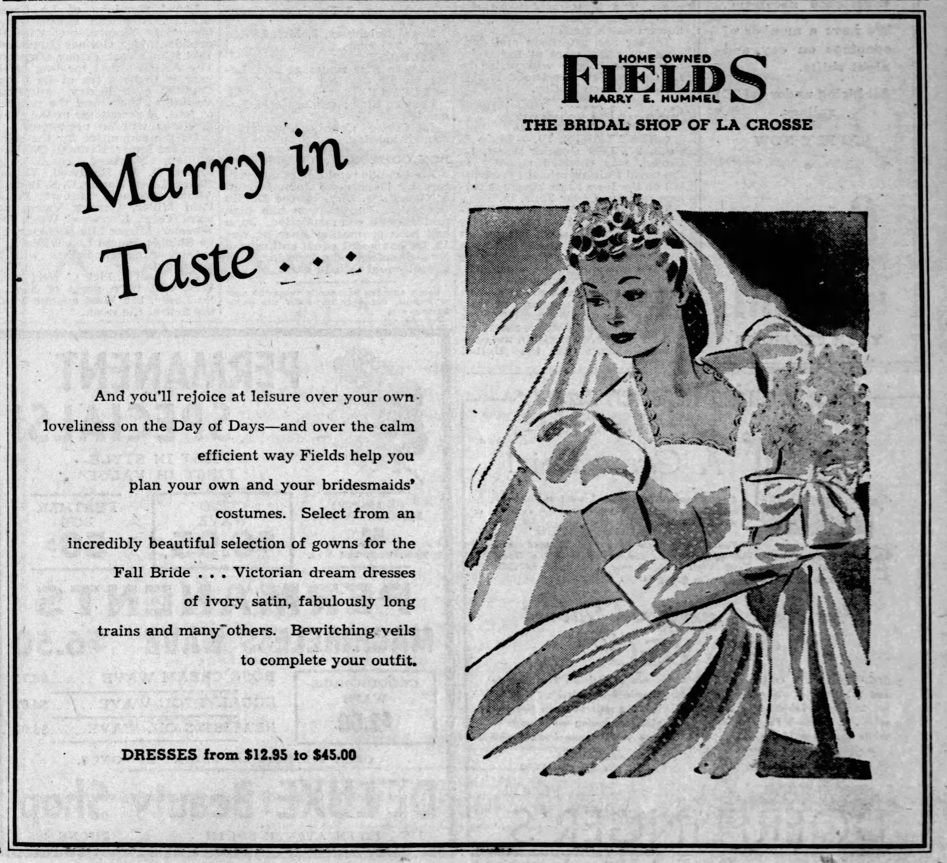

Advertisement for Fields on page 3 of *The La Crosse Tribune*, September 10th, 1944

When the saleswoman returned, she had a tray of tea and cookies and a measuring tape around her neck. There was a stack of books on a table by the door and she handed one of them to Lila. Embossed in gold letters the cover said, *Wedding Embassy Yearbook*. “This is for you to keep,” said the saleswoman. “It’s filled with good advice for planning your wedding and honeymoon. Do you know what kind of budget you’re going to have?” As she was talking, she directed Lila to raise her arms slightly so she could string the tape measure around her chest, waist, and hips. Lila was starting to panic about undressing. She felt so embarrassed about the size of her body and the ugly stretchmarks that now covered her belly. “Well,” Lila stammered, “I’m not really sure.” The saleswoman was being polite, but Lila thought she must be judging her. “That’s alright dear,” she replied in a cheerful tone. “Many brides need time to speak with their parents and fiancé about what they can afford. I’ll finish taking your measurements and then I’ll show you some of the styles for dresses. Do you have a date for the wedding?”

When they left the store an hour later, Lila was exhausted. The saleswoman, whose name was Katherine, was like a human windstorm. She had never stopped moving; she barely stopped talking long enough to hear Lila’s responses. Mercifully, she had not asked Lila to undress. She explained that the dresses were just samples; once they received a deposit, they would make her dress to order. (Unless she was in a hurry? The saleswoman looked relieved that Lila was not.) It was hot that afternoon and the baby was getting fussy. Myrtle suggested that they hire a taxi and go back to the house to wait for Herman. Lila agreed and handed her a dollar for the fare.

Lila had mixed feelings about being in her old neighborhood. She missed the bustle and excitement of the city, but she had not seen anyone from her family in more than three months. Veda had mailed several letters to Myrtle’s house, but Lila couldn’t bear to open them. She was still overwhelmed with anger and shame. Did the Slabacks have any idea that she was in West Salem? Probably not. She wondered if any of them would attend her wedding.

Chapter Thirty-Five

Since Myrtle was the one who told Veda about the baby and the date for the wedding, Lila was surprised to see Veda and Red as she walked down the aisle at Christ Lutheran. It was a sunny day in October and the small church was bathed in a rainbow of light. Veda was holding a tiny baby and Red was holding David. He had grown so much in the last few months. Myrtle was sitting next to them holding her namesake. She smiled as Lila walked past, arm-in-arm with Herman’s father, Edward. Herman was wearing a three-piece suit that he had borrowed from John, the same suit John had worn for his own wedding.

While Lila was living with his parents, Herman had stopped by many times. Everyone said that he adored her, but he was so quiet… Lila still felt like she barely knew him. He was working on a farm near Hamilton, just outside of West Salem. The farmer knew that Herman was getting married but didn’t want to lose such a reliable and hard worker, so he had offered him a small house on the property. Herman had given it a fresh coat of white paint and built some furniture; the Schneiders had added a mattress and some linens. Like the house in West Salem, it did not have running water or electricity. She would have to do everything herself—hauling water for the laundry and heating it over the wood-fired stove, lighting the kerosene lamps (which could explode and start a fire), canning vegetables without a second pair of hands—it was more work than she had ever done before, plus now she had a child. Was this really going to be her new life? Alice had patiently taught her some skills for living in the country, like how to kill and pluck a chicken, but she wasn’t sure it would be enough.

Lila had gone back to Fields twice to order a dress and have it fitted, riding with Viola as she drove into the city to visit with Myrtle. She was grateful for the money she had earned as a waitress. Iit was the only reason she could afford the dress. She was sure that Alice would have offered to make her one, but she had already been so kind and generous. Lila didn’t want to add to her burden. The dress was soft pink, with short sleeves and a long hemline. Everyone knew that white was for virgins. It did not have a train or a veil; the thought of having fabric over her face made Lila feel claustrophobic. The last fitting had been just two weeks before the wedding, but the dress was already a little loose. Her hair was falling out at an alarming rate; it felt thin when she brushed it on the morning of the wedding. Gladys had picked some white roses and pinned them to her dress. Herman also had one on his suit.

During the ceremony, Lila was in a haze. She followed the pastor’s instructions (“With this ring, I thee wed…”), but it was like she was watching someone else get married, not going through it herself. Herman had purchased the ring. It was a simple gold band, and it was warm from being in his pocket. As Herman kissed her and took her arm so they could walk down the aisle as man and wife, Lila was suddenly grateful for his steady and reassuring presence.

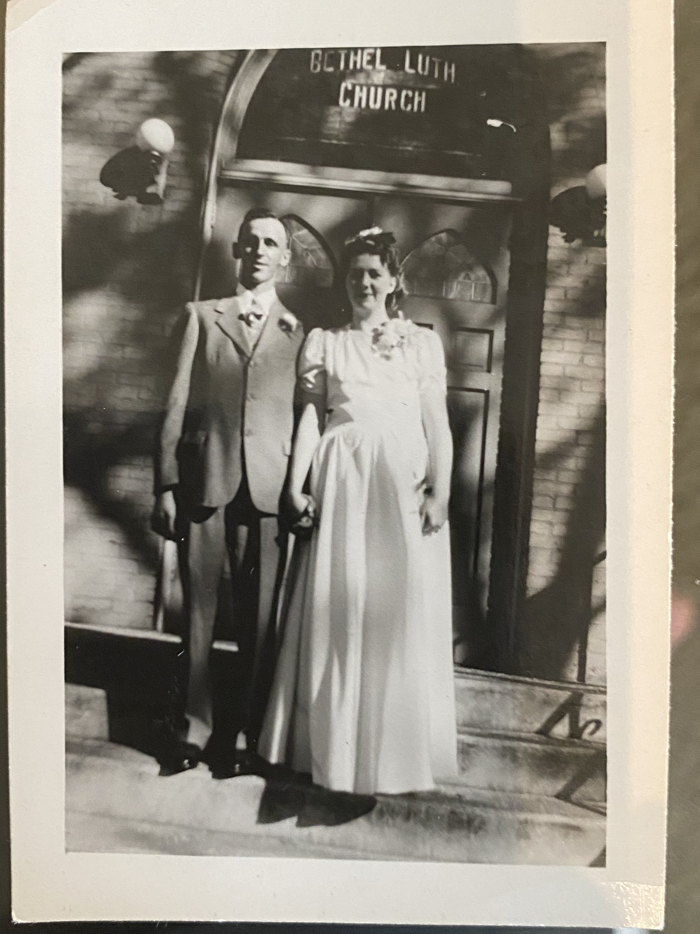

Herman and Lila Schneider on their wedding day, October 14, 1944

They held hands as they greeted everyone outside; it was not a large group. After lunch, they would be driving to their new home. Lila heard, “Let me take your picture!” The request was from Red. He was holding a camera. Lila thought that it must be new; she had not seen it before. Veda walked over and gave Lila a little sideways hug with her right arm. In her left arm she was holding the baby. “Boy or girl?” said Lila pleasantly, as if the fight between them had never happened. “Patricia,” she said with a flat expression on her face. “Patty for short. Myrtle introduced us to your little girl.” Gladys was standing next to them and Lila said, “This is my sister.” “Oh,” said Gladys, “Pleased to meet you,” but then immediately walked away. (Months later, Gladys confessed that she had not been pleased. “Where was she when you were pregnant and needed help? If I were her, I wouldn’t have shown my face at your wedding.”)

Veda said, “Red and I have decided to sell the house. He has a new job as a fireman… we’re moving to a neighborhood closer to the station.” Lila was stunned. It was the house her father had built. The house where they had grown up. How could they just walk away like that? It felt like a rejection. Veda continued, “We have a crate in the car with the rest of your things. Where would you like us to put it?” Herman had been listening to the conversation and said, “I’ll put it in my truck.” He let go of Lila’s hand and disappeared with Red.

The day was supposed to be happy, but Lila suddenly felt sick to her stomach, “I need to feed Myrtle and then I think it’s time for lunch.” Why did Veda have to tell her this news at her wedding? It could have waited. “We’re not going to stay,” said Veda as Lila walked away. Nora was holding Myrtle Joyce and asked Lila what was wrong, but by then Lila was so upset that she was unable speak. Nora handed Lila a handkerchief and said quietly, “The pastor has an office next to the sanctuary. I’ll let you in and then give you a little privacy. I’ll let Gladys know where to find you when it’s time for lunch.”

As promised, Veda and Red did not stay. Lila’s out-of-wedlock birth had caused such a rift in the Slaback family that Veda was the only one who attended her wedding. Lila had done the right thing and found someone to marry, but it didn’t erase the shame. When Lila realized later what had happened, she wondered if her parents and siblings would ever forgive her.

A friend of the Schneider family had made the wedding cake. It had many thin layers and was soaked with honey. It looked like the rings of a tree when it was cut open. Gladys leaned over and said, “This is a called a Baumkuchen and it’s a special thing for weddings… it’s for sweetness and good luck.” There was no music and no dancing, but the Schneiders gave her a warm welcome to their family. Lila Schneider. Her new name.

When they arrived at the little white house, Lila was exhausted. It only had two rooms. In the front was the kitchen, which had a table and chairs, some shelves, and a wood-fired stove. In the corner was a tub for washing; the outhouse was in the back. There was a yellow curtain in the doorway to the bedroom. Lila pushed it aside and put the baby in the crib; she had fallen asleep during the drive. Herman set the crate on the table and turned to give her a hug. He was solidly built. Lila softened into his chest and sighed. For a little while, they just stood there embracing, not saying or doing anything.

Finally Herman said, “I need to milk the cows. Why don’t you take a little nap?” “That sounds good,” Lila said. They walked into the bedroom and she sat on the bed. He took off the suit and carefully folded the jacket and pants. He would have to return them to John. He also took off the shirt and shoes that were his ‘Sunday best.’ For a moment he stood there in his undergarments. Lila wished that he would lie down with her. His warmth was comforting, and she wanted to know him better; she wanted him to know her too. A husband and wife should be intimate. Instead, he put on a flannel shirt and a pair of overalls. “I won’t be long,” he said as he got dressed. He smiled at her and left the house without saying another word.

When he was gone, Lila went to the kitchen and looked in the crate. On top was her doll, Elizabeth. She had been put away for several years… Lila remembered holding her in her lap as they rode the train to La Crosse. She smiled and set the doll aside. She would give it to Myrtle when she was ready for toys. Under the doll was her uniform for the Girl Reserves. She rolled her eyes and wondered why she had kept it. Then she realized that she could re-use the cloth… she would make more diapers for the baby. Aunt Hattie would be horrified. Her rubber boots would be useful on the farm… so would the undergarments and dish towels. For a moment she was grateful that Veda had delivered the crate. Then she noticed the red uniform from Carroll’s. She held the dress up to her body and realized there was no way it would fit. For a moment she thought of cutting it up, but then she carefully tucked the shoes, the dress, and the shrug into the bottom drawer of the dresser. She wasn’t ready to give that memory up. Feeling tired again, she put the empty crate by the stove. She took off her shoes. They were beautiful satin slippers that she would wear as house shoes until they fell apart. She took off her wedding dress and draped it over Herman’s suit on the dresser. She would have to wash it before putting it away. Dressed in only her slip and camisole, she laid down on the bed and fell asleep.

Herman returned not long after she woke up. He was carrying a large pan with a lid. The farmer’s wife, Evelyn, had roasted a whole chicken with potatoes and carrots as a gift. It smelled delicious. Herman lit the kerosene lamp that was sitting on the table. He went outside again and Lila wondered what on earth he was doing. He returned with some wood, which he used to start a fire in the stove. The day had been warm, but the night would be cold. He pulled two plates, two forks, and a large knife from the shelves and set them on the table next to the roasting pan. Lila was feeding the baby. “Would you bring me a glass of water?” “Sure, said Herman. “Just a moment.” He grabbed a pail and went outside. The water was ice cold. “Why is it so cold?” she asked. “There’s a pump in the yard, but the water is from an underground spring.” It was like drinking water straight from an icebox.

The next day, Herman did not work. Although it was harvest season, Vilas had hired a local boy to help so Herman and Lila could have a little time together as a new couple. If Lila had realized what a hard worker Herman was, she would have savored that day so much more. Before going to bed, he had stoked the fire and put a pot of water on the stove. After spending the morning in bed, they ate the rest of the chicken and Lila washed the pan with a little of the hot water. Herman had purchased some basics for the house—flour, sugar, salt, coffee—but he said that Evelyn would send some smoked ham and jars of fruit and vegetables for the winter. He proposed that they go fishing and pick a squash from the garden on the way back.

Lila had never been fishing before. She knew people fished along the river in La Crosse, but it was not something her family did. It was another beautiful day. The trees were brilliant shades of red, yellow, and orange; soon they would be bare again. Lila bounced Myrtle on her knee as she sat on a boulder by the creek and watched Herman fish. He quickly caught four trout and they walked back to the house. Lila watched as he gutted and scaled the fish; he made it look so easy. He told her to wait until the pan was blazing hot before adding the butter and the fish. It made the fish so crispy and good that she ate every morsel and sucked the bones and tail.

Herman was always quiet, but when they made love again (after the baby went to sleep), he was completely silent. He fell soundly asleep without saying another word. By the time Lila woke up the next morning, he had already left to milk the cows.

Chapter Thirty-Six

Although Lila was never much of a reader, a few months later she was cleaning the house and noticed the *Wedding Embassy Yearbook* from Fields. As she leafed through it, she read the author’s advice about ‘honeymoons.’

If your honeymoon is to be spent inside U.S. borders, you will probably be driving or taking a train. Remember food and lodging if you drive. Railroad diners are not cheap. Figure such costs ahead of time. If you’re lucky enough to be honeymooning on a cruise ship or a trip to foreign shores, you must figure in transportation for two from your hometown to New York or San Francisco and back. Things like that are easy to overlook.

It was ridiculous advice. Nobody she knew had ever been to New York or San Francisco. She wasn’t even sure what state San Francisco was in.

For most of her life, Lila had been a listener. At school she listened to her teachers; at dinner she listened to her parents and older brothers. At work, her listening skills made her an excellent waitress. She never forgot an order. Living with Herman was different because he said so little. Lila found it unnerving. Desperate for someone to communicate with, she tried making friends with Evelyn. To her disappointment, she found that Evelyn was always on the go. As the president of the La Crosse County Homemakers Association (and mother of only one child) she was constantly gardening, sewing quilts, and making pies. A wall in their house was filled with ribbons that she had won at the county fair. Lila found Evelyn intimidating.

She begged Herman to show her how to drive the truck. If she could drive, she could visit Alice and Gladys or go shopping with Myrtle in La Crosse. He promised that he would as soon as the snow was gone. That winter was one of the longest she had ever known. It should have been a happy time with a new baby and a new husband. Instead, she felt isolated, bored, and sad. Every day was basically the same. Herman would be gone by the time she woke up. He would come back with a fresh canister of milk, which they would drink with slices of bread from the day before. Sometimes there would be eggs, but the chickens did not lay as much in the winter. At first, she marveled over the different colors of the shells—white, light brown, darker brown with speckles, and pale green (the flock belonged to Evelyn and she had many different breeds of chickens)—but after a few weeks the novelty wore off. For lunch she made grilled cheese. For dinner, she might open one of the jars. They had many dinners of oatmeal with fruit, milk, and blackstrap molasses. Myrtle Joyce was crawling all over the house. Lila missed listening to the radio and taking walks around La Crosse. She could walk down the road as much as she liked (and often did), but there was so little to see… just endless farmhouses and empty fields.

On Sundays, they went to church with Vilas and Evelyn. It was a one-room Lutheran church on Gills Coulee Road. Most of the congregants had grown up together. As Lila later confessed to Myrtle, she stood out like a sore thumb. She didn’t know the words to the service. She didn’t know any of the songs. Some churches had books to help people follow along with the service, but this one did not. There was no need since they knew what to do.

After the first week, the pastor had told her that if she wanted to join everyone for Holy Communion, she would need to take confirmation classes. The thought filled Lila with dread. She had never been a good student. So every two weeks when it was time for communion, she stayed in her pew and held the baby and tried to make herself inconspicuous. She noticed that the other mothers with small children would pass them around so everyone could take turns going up to the altar, but nobody offered to hold Myrtle Joyce. Was it because she was not Lutheran or because they questioned whether Herman was the father? Lila had no idea.

Since it was easily her best outfit, she wore her wedding dress every Sunday to church. Other young women did the same thing, but it was making Lila feel extra self-conscious. She was losing weight from the pregnancy and the dress was growing more and more loose every week. Lila did her best to take it in without a sewing machine, but she was hardly a professional seamstress. She was sure that everyone could tell and was silently evaluating her. In February, Lila stopped losing weight; she was pregnant again.. Her first thought was how glad she was that she could stop fussing with the dress.

Herman was thrilled by the news that she was expecting. One muddy day in April she took a walk with Myrtle Joyce. Evelyn was outside feeding the chickens and asked where Lila was planning to deliver the baby. “I suppose with Herman’s mother in West Salem. That’s where Myrtle Joyce was born.” Evelyn paused with her hand in the pail of grain. “It’s not safe to give birth at home… do you know how many women die of infections? You really should go to the hospital.” Lila quickly put the conversation out of her mind, but Evelyn did not.

A few weeks later, Herman asked Lila if she wanted to stay in La Crosse until the baby was born. Evelyn had pressured her husband into talking with Herman. “I could stay with Myrtle if she’s willing.” Herman paused to think. “Carl is coming home from Europe soon. What about your family?” Lila relished the thought of spending a little time in La Crosse, but her heart sank when he mentioned her family. Who was she supposed to stay with? Veda and Red? Lyle and Allene? For days, the possibilities tumbled through her mind. She was so distracted that one evening she accidentally burned the potatoes. She burst into tears, but Herman said nothing. His silence confused her. Did he not care about dinner? Did he not care about her? She wished that he would yell or slam the door. Anything would be better than silence.

It was calving season and Herman was even busier than usual. Myrtle was pulling herself up on the furniture and shuffling around the room. The trees had come back to life, but Lila was feeling increasingly lifeless. One day blended into another. There was no friendship, no laughter, no radio, no movies. It was just endless work. Endless boredom. What was the point of washing the dishes or making another loaf of bread when she would just do the same thing the next day and the day after that? There was no end in sight. She was so tired of drawing water and waiting for it to boil.. She was tired of cooking food that she barely felt like eating.

Chapter Thirty-Seven

One day, Lila was outside drawing water to wash diapers when she noticed a green truck turning by the barn and heading in her direction. As it came closer, she could see Gladys waving to her. She hadn’t realized how much she had been drowning in a sea of loneliness until she saw her face. Her heart leapt as she watched Gladys park the truck and step out. “I could hardly wait for the roads to dry up so I could come visit you!” Lila had already set down the bucket of water and walked over to the truck. She hugged Gladys and said, “I’m so relieved to see you!” Gladys laughed and said, “That’s quite a hug! I guess you really did miss me.”

They were sitting at the kitchen table when Herman came home for lunch. He poured a cup of coffee and took one of the sandwiches. “Hi Gladys. When did you get here?” “A little while ago,” she replied. “Lila and I are just catching up.” When he finished chewing his first bite of the sandwich, he said, “You should give Lila a driving lesson. I told her that I would do it, but I’ve been busy with the calves.”

When Herman left and they had finished eating, Gladys said, “Well… are you ready for the lesson?” Lila could hardly believe it. It was such a treat just having Gladys for a visit; now she was teaching her to drive. Gladys picked up Myrtle Joyce and Lila cautiously opened the driver’s side door and stepped into the cab. She sat down and Gladys handed her the key. “Put this in the ignition right here and then press the button on the dash.” Lila followed her directions and the truck roared to life. Speaking louder, Gladys pointed out the clutch, the brake, and the gas pedal. “We probably won’t go far today… the first thing is to learn how to shift and use the clutch.” The truck rolled forward a bit and then lurched to a stop. Lila was horrified, but Gladys was laughing. “Everyone does that the first few times. It takes a little practice to get it right.” It wasn’t long until they were out on the road. When they finished the lesson, Gladys opened the door of the glove box and pulled out an envelope. “This is for you,” she said. “It’s an application for a driver’s license, You just have to fill it out and give them fifty cents.”

That Sunday, Herman said he wanted to go to West Salem for church. As they walked to the truck, he handed the key to Lila. “You can be the driver this time.” Lila blushed as he took Myrtle Joyce and opened the passenger door. Herman gave her directions to Christ Lutheran; she was proud of herself for only stalling the truck once. Alice, Nora, and Gladys were happy to see her again. Since her wedding dress no longer fit, she had worn her favorite blue maternity dress. It was obvious that she was expecting again. During lunch she told Nora and Gladys that Herman was encouraging her to go to La Crosse for the birth. Nora said, “You could come here, but I’ll ask Viola for ideas.” A few weeks later, Nora said, “I have good news for you! Viola’s parents offered to let you stay at their house… you can go to St. Ann’s for the birth.” St. Ann’s was the maternity hospital for St. Francis, where Lila had learned of her first pregnancy.

It was a hot day in August when Herman drove her to the Johnson house. It was strange (but also a relief) to be away from Myrtle. Joyce They had taken her to West Salem to stay with Alice until Lila was home with the baby. Since the day she was born, Lila and Myrtle Joyce had never been apart for more than a few hours; now they would be apart for a few weeks.

When Herman and Lila arrived in La Crosse, Viola’s mother, Bertha, was at home with her three youngest daughters. Evelyn and Rosemary were teenagers; Ruth was only four years old. Bertha showed Lila where she would sleep, then said she needed to go. She and her husband had opened a bar and she needed to help with the evening rush. Rosemary turned on the radio and suggested that they play a game of cards. ‘It takes four people for euchre, so let’s play gin rummy.’ Evelyn agreed and pulled a deck of cards and a notepad from a drawer in the kitchen.

The next day, Myrtle dropped by. Carl had been home for almost two months and she was still giddy about it. They decided to take a streetcar downtown to see the new Abbott and Costello movie. On the way she talked non-stop; it made Lila giggle. She missed being close to Herman, but she had also missed La Crosse—hearing the traffic, smelling the river, feeling dwarfed by the tall buildings, and imagining the stories behind the snippets of conversation she overheard (‘If you don’t tell your mother, Margaret, I will.’) Growing up she had taken the city for granted, but now it was calling to her like the sirens of Greek mythology. Her time with the Johnson family passed by too quickly.

Chapter Thirty-Eight

When the baby was born, Lila decided to name him after both of his grandfathers—John Edward Schneider. Herman was so proud when he held his son for the first time. He embraced Lila and told her that he couldn’t wait to have everyone back home. After a week in the hospital, Carl and Myrtle drove her back to the farm.

John was such an easy and sweet baby. Edward and Alice were overjoyed about their oldest son’s growing family. Herman and Lila began spending almost every Sunday in West Salem. Gladys said it was too bad they didn’t live a bit closer. Although Herman had to get back to the farm to help with milking, Lila often stayed behind for the rest of the day. Alice enjoyed spending time with her grandchildren and Lila enjoyed spending time with Gladys. She was going to parties at Camp McCoy and dating a veteran named Carl Schliebe. He had been married before the war, but returned to find that his wife had run off to Minnesota with another man. Lila and Gladys laughed and talked like they had been close friends for their entire lives.

One weekend that summer, Gladys said that they should plan a trip to La Crosse. Lila almost objected that she had nothing to wear, but then she thought about the red uniform at the bottom of her dresser. When she tried on the dress the next day, she could hardly believe that it fit. John was in the crib and Myrtle Joyce was standing on the bed. Lila twirled around and said (not expecting an answer), ‘What do you think?’ Myrtle Joyce clapped and Lila laughed. Two weeks later she was with Gladys driving to La Crosse in the green truck. ‘This is so exciting!’ said Gladys. Lila was excited too. The children were spending the night with Aunt Nora.

Gladys and Lila had decided to go dancing at the Trocadero, one of the new nightclubs downtown. It was 35 cents to hear the band and dance from 8pm to midnight. The dance floor was already packed by the time they arrived. It was an ocean of khaki, button-down shirts, and swirling dresses. As they paid for admission, the band started playing a new song and the crowd formed a circle to watch two dancers in the middle. Shockingly, the male dancer was black. His movements were so fluid and powerful… it was like nothing Lila had ever seen before. He lifted and spun his partner around like she was weightless. “Wow, they can really dance!” said Gladys. Lila had forgotten where she was for a second; she was so captivated by the dance and the dancers. A young man asked Gladys to join him and pulled her into the crowd.

Lila was just starting to think about getting a drink when a man came up behind her and said, “Lila Slaback.” She turned and it was Lloyd. A shock ran through her body—joy, horror, longing, excitement—she had never expected to see him again. He obviously didn’t know that she was married now. “Dance with me, beautiful.” He held out his right hand and Lila took it. Without another word they started dancing. To Lila, it felt like time had stopped and she was eighteen again—no husband, no children—just her and Lloyd. His collar was unbuttoned, and he smelled like cigarettes. His hair was turning gray. His left hand was on her hip and Lila wanted him to pull her closer. They danced for two songs and Lloyd whispered in her ear, “I’ve missed you so much.” Then he smiled and melted into the crowd, like he had been a mirage. She didn’t see him again for the rest of the night.

Two days later, while Herman was working and the children were napping, Lila pulled out the letters from Lloyd that she had kept hidden for years. She should have destroyed them or thrown them away… why couldn’t she just be happy with her life? It was embarrassing that she could not forget her first love and move on. She unfolded one of the last letters she had received from Lloyd before her engagement to Herman.

February 5, 1944

Dear Lila,

The days have been so cold, but I keep myself warm by thinking about you. I want to share a bed with you. I want to tell you dirty jokes and watch your face blush. I want to lick your tits and feel the shiver of pleasure in your body.

Love, Lloyd

At the bottom of the letter was a picture of two snails. One was holding a gun and telling the other snail, “I’ll give you just two days to say your prayers, buddy!” She didn’t want to miss Lloyd, but she did.

Chapter Thirty-Nine

By January, the snow was so deep that they could no longer drive Herman’s truck. By February, Lila could tell that she was pregnant again. Veda was sending letters.

February 4, 1947

Dear Lila,

This is quite a snowy year, isn’t it? When you can drive again you should visit our new house. Red built a porch. It’s such a nice place for the children to play when the weather is nice. Most of the yard was a garden when we first moved in, but I’ve had my fill of weeding and watering! We planted an oak tree in the middle.

Looy married Jean Shuda last year. Do you remember her? They now have a baby girl named Rose. Such a pretty name. David will start school in the fall. It’s hard to believe how big the children are getting. Myrtle Joyce must be getting big too. We should plan a visit to mom and dad’s house so they can see their grandchildren.

Hugs and kisses, Veda

Lila sometimes wondered why she kept writing. To brag about her house and family? To make her feel guilty for not visiting more often? Was it possible that she missed her? Lila hardly ever responded, but Veda kept writing.

Herman and Lila didn’t receive much mail. Since they didn’t have a mailbox, the driver had to knock on their door to make deliveries. He was an older man who always had a red nose, so Lila thought of him as Rudolph. She had no idea what his real name was. It made her laugh inside every time ‘Rudolph’ came to the house. Lila decided to write to Gladys and tell her that she was expecting another baby. It took her a few weeks to respond with bad news: Alice had suffered a stroke and Gladys was taking care of her. It was a shock to everyone. Alice had been fine—doing her usual activities—and then one morning she fell trying to get out of bed. When she talked, nobody could understand what she was saying. It made Lila feel sick to her stomach. Alice had become more dear to her than her own mother. Herman borrowed a horse from Vilas to visit his parents; it was the only way to travel in the deep snow.

Lila did not really miss the Slabacks, but Alice’s condition made her think she should give them another chance before it was too late. She wrote to Veda and said she would visit as soon as the roads were clear. As she thought about going to La Crosse, she decided that she also wanted to visit Myrtle and buy some new clothes. If she replaced her dresses, she could cut up the material and make clothing for the children. When she told Herman about her plans, he said that he could use a new pair of rubber boots and gave her forty dollars. It was a lot of money—enough to buy the clothes, the boots, some additional fabric, and even to restock the coffee, flour, and sugar. She put the money in their dresser for safe keeping.

Myrtle and Carl had wasted no time in starting their family. Their first daughter, Laurie, was born in 1946. By the time Lila was finally able to drive into the city that spring, they were both visibly pregnant. They laughed as they hugged over their bellies. Carl was working at the Trane factory. They were hoping to buy a house in West Salem and raise the children closer to their cousins. Her younger sister, Rosemary, would be done with high school soon. Evelyn had married a man from Iowa and moved to be with him. The Johnson family was shrinking.

As they tried on dresses, Myrtle told her that Viola and John were getting divorced. Lila was shocked. Divorces happened in the movies, not in La Crosse. Herman had not said a word about it. “What happened?” she said with astonishment. Myrtle replied, “Well… I’m not really sure. I think Viola was not very supportive when John lost his job. She’s not the easiest person to live with.” Lila nodded and changed the topic, but for weeks she thought about all of the married couples she knew. She wasn’t naïve enough to think that all adults were nice or that all marriages were fairy tales. One of the other waitresses at Carroll’s had been living alone (even though she was still married) because her husband had run off with another woman. But getting divorced in real life? That was nearly unthinkable. Once you got married, it was supposed to be forever. “In sickness and health, ‘til death do us part.”

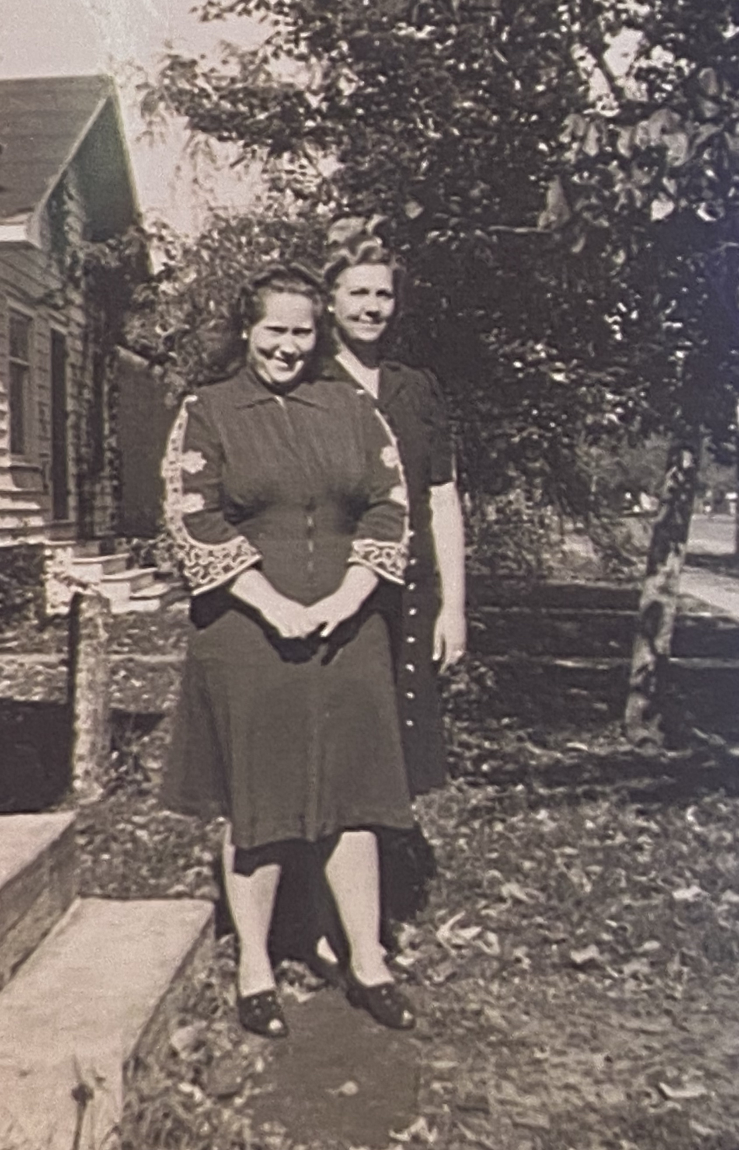

Lila (back) and Myrtle Schneider (front) circa 1946; used by permission of June Lewis

Chapter Forty

Independence Day was on a Friday that year, so Nora and Gladys had decided to hold a gathering in Veterans Park. It was close to the farm, which would make it easy for Herman to drive back and forth. Lila had never slept in a tent and wasn’t sure what to expect, but she was looking forward to spending some time with Myrtle and Gladys. It had been a tough year. Alice was not getting better. Myrtle had lost the baby. When Gladys asked Lila how she was feeling, she said “exhausted,” but when Myrtle and Carl arrived, she felt ashamed. Why couldn’t she just be satisfied with her life? The baby inside of her was still alive.

When nightfall finally arrived, the men took the older children to the riverside to shoot bottle rockets. Nora, Gladys, Lila, and Myrtle sat around the fire. Nora’s baby (her second and last) was just a few weeks old. Gladys told them that Carl had proposed. It was wonderful news! They tried to be lighthearted, but then the conversation took a dark turn. They talked about Alice and about Viola and John. Their children were living with their grandparents in La Crosse until Viola could remarry. Lila was surprised and said, “Why?” Myrtle had been lost in her thoughts, but she looked up and said, “My parents don’t want them to be raised by a single mother. Viola should have stayed with John.” The conversation turned back to Gladys, but the news about the divorce and about Viola’s forced separation from her children haunted Lila for months. Would the Slabacks do the same to her if she left Herman?

On Saturday, Carl drove to La Crosse to pick up Helen. Her son, Duane, was ten years old and growing fast. Wistfully Helen said, “He’s going to be tall like his father.” As they made lunch (grilled bratwurst and blueberry streusel for dessert) she asked Lila if she had a place to stay before the birth; if not, she could stay with her. Lila was relieved. She had been thinking of asking Veda but wasn’t sure that she would agree. The contrast between Viola and Helen was striking. They were both single mothers, but as far as she knew the Schneider family was not pressuring Helen to marry again. Was it because she was widowed and not divorced?

Herman drove Lila to La Crosse on the last weekend in July. Although her last delivery had been at St. Ann’s, La Crosse Hospital was much closer to Helen’s house. Lila thought she knew what to expect, but she was wrong. As soon as she arrived in the labor and delivery ward, the doctor said he was going to ‘medicate’ her. That was the last thing she remembered. As soon as she woke up, she vomited. Once the bed was cleaned up and she had regained her senses, the nurse explained that the baby was turned sideways so the doctor had put her under and given her a ‘c-section.’ Cheerfully, she added, “Isn’t it better than going through labor?”

Lila was speechless. How was this better? The room was spinning and it hurt to cough. When they finally brought the baby into her room, she was sleepy and difficult to feed. Was there something wrong with her? Lila started to cry out of worry and frustration and the nurse scolded her for disturbing the rest of the mothers. She had never had surgery or stitches before. The nurse who came to change her bandages every morning would not allow her to touch her belly or see what the stitches looked like. It was almost a week before they allowed Herman to visit his wife and newborn daughter.

Lila was so disoriented from the birth that she didn’t name the baby right away. Herman suggested ‘Alice’ after his mother. Alice was also the middle name of Lyle’s wife, Allene, so on the application for the birth certificate she wrote ‘Alice Allene Schneider.’ As they drove out to West Salem to pick up Myrtle Joyce and John, Lila wondered how she was going to handle three small children along with the rest of the chores. Myrtle Joyce had recently turned three and John was not quite two. It was daunting.

By the end of September, Lila felt like she was losing her mind. Her life had become an endless stream of cooking and cleaning, snot, vomit, dirty diapers, crying, and begging. Myrtle Joyce had responded to the baby’s arrival by refusing to take naps. John had learned to say NO and MINE. Do you want a cookie? MINE. Share that with your sister. MINE. Time for bed. NO. Herman was so good and patient with them. He loved the children and they loved him. She knew it wasn’t a contest, but it made her feel like a bad parent. Herman was busy with the cows and the harvest, so most of the time it was just her and the children. They were always getting into trouble with something: the stove, the pump, the baby, the farm animals. Once she fell asleep from exhaustion and woke up just in time to prevent John from falling through the hole in the outhouse. That would have been a disaster.

One day, Lila was so desperate for relief that she piled the children in the truck and drove to Veda’s house. “Why are they so dirty?” Veda asked. Myrtle Joyce and John were playing in the yard with David and Patty. They were all laughing and throwing acorns, so they took the baby inside to clean her up. When hot water came out of the tap, Lila started crying over the ease of Veda’s life. She suddenly realized that living in a house with no running water was making her own life much more difficult. Sternly, Veda said, “You’re the parent, Lila, not a child. You need to pull yourself together.” She left the bathroom to check on the oven; they were having pot roast for dinner, cooked with an electric oven. When she returned, she had clean outfits for the children. “David and Patty have outgrown these so you can keep them.” Mercifully, she held Alice while Lila gave Myrtle Joyce and Johnny a bath. They didn’t fuss like usual; they were so fascinated by the indoor bath and the bar of pink soap. Myrtle Joyce even let her wash and comb her hair. Lila caught a glimpse of herself in the mirror, but it was like looking at a stranger. There were dark circles under her eyes. Her hair was a mess and there was dried vomit on her shoulder; she had barely even noticed when the baby spit up earlier that day. When dinner was done and it was time to go, the younger children wailed, and Myrtle Joyce begged to stay with her cousins.

When they got back to the house, Herman asked where they had been all day. He wasn’t angry, but Lila realized (with horror) that she had forgotten to prepare something for dinner. He had been working hard and deserved to have a hot meal. Lila said, “I’m sorry… I lost track of the time. I’ll cook you something right away.” “That’s alright,” he replied. “I’ll have a peanut butter sandwich and a glass of milk.” The next day as she was making more bread, she decided that she would ask Herman to put a lock on the door. If she could keep the older children clean and safe indoors, maybe she could get a little bit of sleep while Alice was napping.

Chapter Forty-One

Winter started early that year. Myrtle Joyce was the first one to notice the snow falling. “What is that mom?” The flakes were so small that they were barely visible, but by November there was enough snow on the ground to make a snowman. Just when Lila was starting to feel like she couldn’t take being a mother for one more day, the winter gave her relief. Fall had been rainy and muddy; the colder temperatures froze the ground. It was cold going to the outhouse, but it was easier to keep the house clean now that they were no longer tracking mud all over the floors. During her last trip to La Crosse, she had purchased coats and boots for the two older children. Alice was already big enough to wear Myrtle’s coat from the year before. Evelyn had given her some handspun yarn. Although Lila had not done any knitting for years, she managed to make some basic scarves, hats, and mittens. They were ugly, but warm.

Once the silage and hay were safely stored away for the long winter, Herman had more time to spend at home. He started taking the children out for walks—to climb on the bales of hay, to see what it was like in the barn (Myrtle Joyce had been worried that the animals would freeze), to see how the ice was forming on the creek, and to go sledding once there was enough snow. He made snowshoes using strips of hide and wood from an old barrel. Lila watched from the window as he taught the children how to use them; it was funny to watch them tripping over their own feet, but John was competitive with his older sister and determined to be the first one to figure it out. The look on his face when he did was pure delight.

Lila had stopped going to church after Alice was born. Herman went from time to time, but the children couldn’t go with dirty clothes. They couldn’t go if they had refused to eat that morning or if they didn’t get enough sleep the night before. They might cry in church, which would be embarrassing to the whole family. Lila might have been able to manage it with help, but with Alice needing so much support there was nothing left for Gladys and Nora to give. It was heartbreaking to watch her mother-in-law’s decline. She could no longer hold or even talk with her beloved grandchildren. Myrtle Joyce was too young to remember what she was like before the stroke. During one visit, she asked, “Who is that scary woman in the corner?” Lila was mortified. Gladys gently took Myrtle Joyce and Johnny by the hand and said, “Why don’t we go play outside for a little while?” The Schneiders were always kind, but remembering the incident made Lila feel like she wanted to disappear.

Carl and Gladys got married in December, but there was already too much snow to drive the truck. Lila was sad to miss it. She had hoped they could visit West Salem for Easter, which was at the end of March. The snow had started to melt, but then there was a blizzard. “In like a lamb, out like a lion,” said Herman as the children watched through the kitchen window. Lila cooked a ham for the occasion, but it didn’t feel like much of a celebration. A week later, Alice died at home in West Salem.

That spring there was a new postman. He was younger than ‘Rudolph’ and had striking white-blonde hair. The first time he came to the house, he smiled and said, “I’m Fred Hicks and you… must be very busy!” Lila had taken the children outside for some fresh air and they had discovered the mud around the water pump. She took the letter (which had Veda’s handwriting) and dashed into the house without saying a word; by the time she returned, he was already gone. A few days later, he delivered a letter from Gladys. When Lila answered the door, she said “Hi, “I’m Lila.” Replaying the moment in her mind that night, she kicked herself for being so stupid. He knew her name already; it was on the letters. Two weeks went by before Fred returned for another delivery. Surprisingly, he said, “Do you like jokes? I have a joke for you.”

One Sunday at church, the pastor was giving a sermon about forgiving your enemies. He said, “Raise your hand if you can forgive *your* enemies.” Only half of the men and women raised their hands. Undeterred, he kept speaking. After ten minutes, he asked the same question. This time, three-quarters of the congregation raised their hands. Another ten minutes went by, and he was really getting into it! He asked the question again and everyone raised their hands except for one person. “Mr. Olson,” he said with obvious frustration, “Why are you so unwilling to forgive your enemies? Surely, after living for eighty-six years, you should be able to do this with ease!” “I can forgive,” replied Mr. Olson, “but at this point… all my enemies are dead!”

The joke was not that funny, but Lila laughed. She had not heard a joke in such a long time. It felt good to laugh again.

Fred’s joke got her thinking about jokes she had heard from Lloyd and from the soldiers. Many of them were not appropriate to tell around the children, but by the time Fred returned she had thought of one that was not too bad.

A man walks into a courthouse and tells the clerk that he wants to change his name. The clerk is busy with filing, so he says impatiently, “Alright, what is your current name?” “Adolf Cockburn,” the man replies. In shock, the clerk stops filing. Feeling more sympathetic, he pulls a form out of a drawer and says, “What name would you prefer to have?” With a smile, the man replies, “James Cockburn.”

Fred turned red in the face. Just when Lila thought that she had really offended him, he started laughing so hard that he couldn’t speak.

That spring, Alice and John started teething at the same time. A less experienced mother might have thought it was just a cold, but John was sucking him thumb again. Alice was starting to pull herself up and was gnawing on the edges of the bed frame. They were feverish, cranky, and hardly sleeping. Somehow, Myrtle Joyce was able to sleep through it, but Lila and Herman were not. After a week of losing sleep Herman said, “We really need to slow down on having children.” Lila agreed, but when they were not intimate, she felt like he was slipping away; it was the only way she felt truly connected to him.

It was calving season and Herman was spending longer days in the barn. She was never alone, but there were many times when she felt lonely. She yearned for some real conversation with another adult. Even when they were together, Herman still didn’t talk much.

Fred and Lila continued trading jokes. One day he said, “I’m allowed to have some time off for lunch. Would you mind if I sat here and ate with you?” When Lila didn’t respond right away, he added “I don’t mean to impose… I have a sandwich in my bag.” Lila smiled and said, “Sure, let me make you some coffee to go with that.” For several weeks they ate lunch together outside. The children enjoyed having ‘picnics’ with Fred. Myrtle was just big enough to help by setting the plates on the blanket. It was something to do in the mornings. And then one day, he arrived during a thunderstorm. Fred knocked on the door to deliver the mail and said, “I guess I better go. It’s too wet to eat outside today.” Lila felt like her heart was falling into her stomach and quickly said, “No, don’t go… you can come inside.”

The wind had picked up and it was rattling the windows. Alice was giggling as her older brother jumped on the bed, but storms always made Myrtle Joyce nervous. As soon as Lila was done making the coffee and sat down at the table, Myrtle Joyce climbed into her lap. Fred didn’t seem to mind the chaos. He swallowed a bit of his sandwich and said, “So… you told me that you grew up in La Crosse. Where did you go to school? What kinds of things did you do for fun?” Herman was not interested in the past or the future, only in the present. He had never made Lila feel guilty for her bad choices, but he had also never asked what her life was like before they got married. At times, his silence felt uncaring. Being with Fred was different. It reminded her of being with Lloyd. She told him about going to the movies for the first time to see *The Wizard of Oz*. He had never seen it. As she described the film, he listened with rapt attention and laughed at her imitation of the Wicked Witch.

Myrtle Joyce had fallen asleep in her lap. Fred said, “I guess I should get back to work now… the mail won’t deliver itself.” Lila began to push her chair back from the table, but he said, “No need, I can let myself out.” He leaned over and kissed her on the forehead. It was so quick and unexpected. Before she could say anything, he was halfway out the door. She knew the kiss was wrong, but she wanted more of them.

Chapter Forty-Two

Lila wasn’t trying to push Herman away. If someone had asked her why she let Fred into the house, she would have said that she was just being polite. He needed a place to eat lunch, so why not? It was nice to have a conversation with another adult.

Many of the houses in that area were set close to the woods. It was very hilly, so the flat parts needed to be reserved for the fields, which were mostly corn, oats, and hay. Vilas and Evelyn’s house was at the edge of their largest field, but the little house where Lila and Herman lived was tucked into the edge of the bluff. Although the front yard got plenty of sun, the back yard was always in the shade and the ground was covered with a thick layer of fallen oak leaves and pine needles. It attracted mice and snakes, so Lila preferred to stay in the front.



Farmland and bluffs in La Crosse County, Wisconsin; Library of Congress Prints and Photographs Division, # LC-DIG-highsm-40479

One day when Fred arrived for lunch, they were still inside the house. The children were playing with a kitten that Herman had rescued from the barn. Fred said, “Could you come with me for a second? There’s something I want to show you.” Lila followed him to the back of the house, thinking he had seen a snake or maybe a deer. Instead, he cradled her head in his hands and passionately kissed her on the mouth. After a few moments he let go and said, “I’ve been wanting to do that for so long.” With a whisper, Lila replied, “Don’t stop.” Fred put his arms around her and they leaned against the house, quietly making love.

It was challenging to find time alone. Lila constantly worried that Herman would come home or that the children would see them, but she craved being with Fred. It felt so good to be in his embrace. He said the most gentle and loving things. “You’re such a beautiful woman, Lila.” “I love being with you.” She knew that it was wrong to have an affair with a man who was not her husband, yet she couldn’t help wanting to be together. Lila loved the Schneider family and felt a deep sense of love and acceptance that was lacking from her own family, but as Veda had predicted, she was not a good match with her husband. Fred was closer to her age and they could talk with an ease that she and Herman had never achieved.

One day when he finished eating lunch he said, “Would you like to hear a song?” Myrtle Joyce clapped her hands and said, “Yes, a song!” He laughed and started singing:

*My young love said to me, “My mother won’t mind,*

*and my father won’t slight you for your lack of kind.”*

*Then she slipped away from me and this, she did say*

*“It will not be long love, ‘till our wedding day.”*

Lila had not heard any music for months. Fred’s voice was breathtaking, but the song sent chills up her spine. The ‘young love’ turned out to be a ghost, calling for her love to join her. “Where did you learn that?” she gasped. He grinned and said, “My mother is Irish. I think she learned it as a child. Did you like it?” Johnny chimed in with his sweet little voice and said, “More!” The next song was more upbeat, but it was also about two lovers.

*Come won’t you walk with me Griselda,*

*wearing the dress that moonlight shines through.*

*I am a sad and lonely boy since your mother said I couldn’t see you.*

*Slip into the woods in the dark of the night*

*Call to the moon out yonder,*

*Oh, lady moon won’t you shine a silver light and lead me to my Griselda.*

Lila blushed. What if someone heard what he was singing? He was practically advertising their love affair. Lila turned to look for Alice and there was Herman, standing at the edge of the front yard. Fred stood up from where he had been sitting and said, “You must be Mr. Schneider.” He held out his hand, but Herman refused to shake it. “I guess I better be going now,” he said with a strained cheerfulness. Herman’s face was darker than usual. He stared at Fred as he walked down the path. When he was out of sight, Herman said, “I’ll be back for dinner.”

The tension was thick that night in the house. Lila was not hungry and the children were unusually quiet. When he finished eating, Herman said, “Fred Hicks will not be coming back to this house. If you want to mail a letter, give it to Evelyn.” Lila’s heart was thumping hard in her chest. How much did Herman know? Did Evelyn tell him something? When they went to bed, Herman slept facing the wall. He didn’t raise his voice or make any other demands, but he was clearly angry. For weeks he said almost nothing. On the outside, Lila was calm. On the inside, she was screaming, “Yes, I had an affair! Say something about it! Get angry! Was it so wrong wanting to be held and loved?” Lila wanted to be more than just a mother and a housewife. For a brief time, she had that with Fred. Now he was gone, and the silence was deafening.

Chapter Forty-Three

When Lila moved to West Salem, she had more than three hundred dollars in small bills stashed away from working. She had used some of it to purchase her wedding dress. Since the wedding, she had used a trickle of the money to stretch the household budget. Stationery and postage stamps. Her driver’s license. A new pair of boots for Johnny after he lost one playing outside. (They never did find it.) A bit of lace to make a pretty dress that Myrtle Joyce could wear to church. Two pounds of coffee for the picnics. Nothing extravagant. Herman never said a word about it; she wasn’t sure that he even noticed. By the time her affair with Fred Hicks was over, the stash was small enough to fit into an empty can of baking powder.

Lila had fantasized many times about leaving the farm, but as the days of silence turned into weeks, her fantasies became more urgent. Should she take the truck and just drive to La Crosse? Would Herman follow her? Did she want him to? Where would she live? Should she take the children along? For a few days she seriously considered just walking away—taking a train and getting out of Wisconsin. Starting a whole new life. It was an appealing thought. She was only 26 years old. But then doubts crept in. What would happen to their children? Who would raise them? Would she miss spending time with the Schneiders? Would she miss Veda or the rest of the Slabacks or even just La Crosse? She felt like she was standing on the edge of a powerful river; she could get in and let the current carry her away to an unknown destination or she could turn and walk back to solid land. Stay on the farm or move to La Crosse. Stay with the Schneiders or go back to Veda. For days, she wracked her brain for other options. She fantasized about standing on the bridge to French Island, steeling herself to jump into the river. It was such a dark fantasy that it made her shudder. She forced the thought out of her mind; it was a sin to think about ending your life. The children needed her. If she was gone, where on earth would Herman find another wife to take care of them?

Lila was waiting for some kind of sign that it was time to make a decision. August was hot and dry, but in early September the weather suddenly turned gloomy. After several days of rain, Lila woke up to see a brilliant beam of light piercing the clouds. The light poured through the bedroom window and filled her with a sense of strength and purpose. It was the sign she had been waiting for—the day to take the next step. Herman had left to do the milking, so she went to the pump to draw a bucket of water. By the time she was heating the water on the stove to make coffee and give everyone a quick wash, she was humming a song that she remembered from long ago on the radio.

They couldn’t take much without arousing suspicion. It had to look like they were just leaving for the day to visit La Crosse. Lila filled a small bag with a change of clothes and some diapers for the baby. She put her hairbrush, a packet of letters, and the baking powder can of money in her purse. As they walked out the door Myrtle Joyce sobbed, “We can’t leave Kitty!” Her sense of panic almost made Lila turn back. Gathering her composure, she knelt down and said, “Don’t worry, Kitty will be fine. You’ll see her again later.” Johnny was more excited. When they got into the truck he said, “Go mommy!” “Well alright then,” she replied as she pushed the button to start the truck’s engine.

Lila knew that there was a train station in West Salem. She had decided that she would drive to the station, buy tickets to La Crosse and leave the truck there. Somebody would figure out who the truck belonged to and let Herman know. What would happen next? Would he just go back home? Would he drive to La Crosse to look for her? She wasn’t sure what she wanted him to do. She just knew that something had to change. Veda and Red’s house was only three blocks away from the train station in La Crosse. When the train arrived, they would walk from the station to Veda’s house and then she would figure out her next move.

When Veda opened the door she said, “Oh, Lila. I wasn’t expecting you. Come on in.” Myrtle Joyce and Johnny darted into the house to look for their cousins. “David is still at school, but the bus will drop him off in a couple of hours. I was just getting ready to make lunch.” Lila stepped inside and said, “I can help if you like.” Veda tilted her head to the side. Did she suspect that something was wrong? She straightened back up and smiled faintly. “It’s kind of you to offer, but I can handle it. Have a seat.” Lila put Alice on the floor. She had just started walking and immediately pulled herself up on the sofa. Lila took off her sweater and put it in the diaper bag. In the corner there was a new television set. Lila had never seen one before. At first, she thought it was a radio. Veda returned to the living room and saw her staring at it. “We got that a couple of months ago. Sometimes we make popcorn and invite the neighbors over to watch with us like our house is a miniature movie theater.” “Oh, that’s nice,” said Lila. She suddenly felt like she had taken more than just a trip to La Crosse; she had stumbled into a new century.

After lunch, Veda made tea. “I looked out the window, but I didn’t see the truck. Did Herman drop you off?” Lila hesitated. Now the truth was going to come out, ready or not. “No, we took the train this time.” “Oh?” said Veda. “Are you planning to stay for dinner?” “If that’s alright with you,” Lila replied. She took a sip of the tea. It was hot and burned the roof of her mouth. “Yes, of course that’s fine.” Veda put her hand out. “Lila… is everything alright?”

Lila was starting to sweat. “Um… well, you see… we’ve moving to La Crosse. Just me and the children… without Herman.” Veda’s mouth fell open in shock. “What happened? Did he hit you?” “No, nothing like that,” said Lila. “Then what? Did he have an affair?” Veda had set down her cup of tea and her eyes were open wide. Lila’s stomach twisted into a knot. For a few seconds she was silent. They could hear the children running around and laughing upstairs. Quietly, Lila said, “I just couldn’t keep living there.” Veda stared at her. “I don’t understand. Herman is your husband. You can’t leave him for no reason.” Lila looked down into her lap. Had she been wrong to leave? How was she going to explain this? Summoning her last bit of courage, she looked at Veda and said, “Could we stay here for a few nights? I can find a job and a place to live… it won’t be for long.” Veda’s lips were tightly pinched. She looked both angry and concerned. “The children can stay here for a few nights. You need to take the train back to West Salem and straighten this out right away.”

Suddenly they heard footsteps on the front porch. It was David, returning from school. By the time the door opened, Veda had flipped to ‘loving mother.’ “How was your day, dear?” “It was good, mom,” said David. Before Veda could say anything more, he turned and said, “Hi, Aunt Lila.” Lila raised her hand to say hello, but he was already heading upstairs to look for his cousins. When he was out of earshot, Veda turned back to Lila. “You should leave now. I don’t know what you need to do to make this right, but your children will be fine. Just go.”

Lila picked up her purse. Without saying another word or looking back, she went out the door, down the steps, and started walking back to the train station. Her mind was blank. In the distance she could hear a whistle; a train was coming into the station. Should she buy a ticket and go back to West Salem? Instead of going to the ticket window, she decided to sit on one of the benches by the tracks. A train was getting ready to leave. An agent in a dark blue suit leaned out of the one of the middle doors and said, “Last call for Rochester with service to Winona.” Where would the train go after that? She sat on the bench for what felt like hours, watching the trains. Eventually, someone came out of the station to ask, “Ma’am, are you alright?” “Yes, I’m fine, thank you. I was waiting for someone, but it appears that they’re not going to show today.” She was astonished at how easily the lie tumbled out. She stood up and started walking in the other direction, away from Veda’s house and toward the river.

By then it was late afternoon. It was getting chilly, and the sun was low on the horizon. Maybe the children were eating dinner. Without even thinking about where she was going, she had reached Copeland Park. She walked past the playground—there were only a few children playing on the swings and the merry-go-round—and headed right down to the river. In a few minutes, she could see the Clinton Street bridge. Her darkest fantasy was coming to life.

As she walked closer, she thought about an accident that had happened when she was a child. This bridge could only handle small cars, but there was a larger bridge on the south side of La Crosse. One day, a man driving a car passed out as he was crossing and collided with one of the support beams. It caused a big section of the bridge to collapse and fall into water and his car fell with it. He managed to get out and swim to safety, but two of his passengers drowned. Lila heard the story at the dinner table—one of her brothers (maybe Lyle?) had read the newspaper article out loud. It gave her nightmares for months. The crash. Plunging into the river. Drowning while trapped in the back seat. Lila had walked over the replacement bridge many times, but she had never really trusted it. The water below was always dark and churning.

Lila sat on a boulder near the pilings. How long did she stare at the river? Her body was numb with the cold. The moon was nearly full. She could see its swirling reflection in the water. Subconsciously, she had hoped that a brilliant solution to her problems would spring to mind, but nothing came. Her mind was as numb as her body. She could hear cars going back and forth over the bridge, but nobody walked by. She was completely alone.

Eventually, the sun crawled back over the horizon. With a sigh, she climbed up the bank and crossed over the bridge to French Island. Everything looked golden in the early morning light. She caught a glimpse of herself in a window. Her dress was dirty and wrinkled and her hair was a mess. She laughed out loud thinking, “I look like a banshee.” Then she sat on the curb and her laughter turned into sobs.

Chapter Forty-Four

An older woman tapped Lila on the shoulder. “Are you alright dear?” Lila looked up and a tear dripped off the end of her nose. “Why don’t you come with me? My house is just a few blocks away… you look like you could use a cup of coffee.”

The woman introduced herself as Emma as they walked to her house. It was extremely small, but the kitchen was cozy and warm. Emma took a frying pan off the shelf and set it on the stove. “How do you like your eggs, dear?” Lila took a seat at the table. “Oh… fried, I guess?” With a warm smile, Emma replied, “Fried eggs and toast, coming right up.” Lila’s stomach rumbled. Her last meal had been lunch at Veda’s house. It was very quiet. For a few minutes, they listened to the sound of the eggs frying and a train whistle blowing in the distance. Lila was the one who broke the silence. “Do you live here by yourself?” “Oh no,” chuckled Emma. “The girls are married now, but my husband, Edward, is at work and the boys are at school.” “How many children do you have?” said Lila. “Three girls and three boys. The oldest, Margaret, is probably the same age as you.” Quietly, Lila said, “I have three children. Myrtle Joyce, John, and Alice.” “Oh, that’s lovely,” said Emma. “Children are such a gift.”

As Lila finished eating, Emma put her hand on Lila’s arm and said very gently, “You seem to be having some trouble, dear. Is there anything I can do to help?” Lila’s eyes welled with tears and Emma offered her a handkerchief. When her throat stopped clenching, she said, “I don’t know… I guess the first thing I need to do is find a job.” She was staring at a smear of egg yolk left on her plate. Lila expected Emma to start asking questions and making demands, but Emma just said, “Well now that your belly is full, let’s get you cleaned up. I think I have a dress you can borrow. I’ll wash the one you’re wearing, and you can pick it up when you come back. Emma put a pail of water on the stove and showed her to a room with a sink and a mirror. “You can change your clothes here. I’ll bring you soap and a washcloth as soon as the water is ready.” Lila had a comb in her purse and started fixing her hair, avoiding her reflection in the mirror. The dress from Emma was not stylish, but it was clean. By the time she had washed up, the sun was bright overhead. Emma gave her a hug and Lila walked back in the direction of the bridge. She had noticed that there was a new tavern on Bainbridge Street.

When Lila pushed open the door, there were just a few locals sitting at the bar for lunch. It was dark and there was already a cloud of smoke in the air. She immediately wanted to leave, but the bartender said, “Is there something you need?” Swallowing, she replied, “I’m looking for a job as a cocktail waitress… I worked at Carroll’s during the war.” The bartender looked her up and down in a way that made her skin crawl. “Is that so? I might have a job for you if you come back tonight.” One of the men at the bar laughed. Without saying another word, she turned and left. She might be desperate, but not that desperate.

Carroll’s was only two blocks away, but Lila resisted going in. She worried there would be nobody left who remembered her; worse, that somebody would remember exactly why and how she had left. Summoning her last bit of courage, she walked into the supper club across the street from Carroll’s. She had never been inside before. The restaurant was on the edge of the water and the entire back wall was filled with windows… the view of the water was impressive. “Would you like a seat at the bar?” Lila snapped back to attention and said, “Actually, I came to see if you were hiring.” The hostess was older than Lila, but well put together. She was wearing a pearl necklace and a black dress with a sharply-tailored white collar. She said, “I’ll take you to the kitchen so you can talk with the owner. I’m his wife, Stella.” To Lila’s relief, he asked how quickly she could start working.

When Lila returned to Emma’s house, her sons were home from school. She hugged Lila like they were old friends and invited her to stay for dinner. “That’s so kind of you, but now that I’ve found a place to work, I need to find a place to live.”

“You can stay here for one night,” Emma said. “Why don’t you look for a place to live tomorrow when you’ve had some rest?” She had a point. Lila felt tears welling up again, but Emma put her hand on her shoulder and said, “It’s no trouble, dear. Whatever problems you’re having will work themselves out.” Lila fell asleep on her sofa not long after dinner and Emma covered her with a quilt. She slept heavily without dreaming.

She left Emma’s house early the next day, hoping to find and apartment and buy some new clothing before starting her shift at 4:00. It was easier than she had expected to find a place to live. It wasn’t much, but she could afford the deposit of one hundred dollars. It was on Rose Street, not far from the boarding house where Lloyd had lived. The rent included water, heat, and electricity. The restaurant did not require uniforms, but Lila realized that she would need to be more stylish if she was going to work her way up from washing dishes to being a waitress again. She purchased a long, gray skirt, two white blouses, and a cheap pair of black pumps that caused terrible blisters until she could afford to replace them.

Her next goal was to bring the children back to the apartment, but when she went to pick them up Veda asked sternly, “Who exactly is going to watch them while you’re working?” Lila had hoped that Veda might offer to help. It was crushing to leave her house (alone) for a second time. As she walked out the door, Johnny screamed “Mommy… mommy don’t go!”

Emma had invited her back for dinner that week. Lila offered her two dollars, but she refused to take it. “You’re going to need that for your children dear.” As they worked together on preparing the meal, Lila decided to ask Emma for advice. It felt strange; she had been able to confide in Lloyd, but his problems were always so much worse than hers. Lila worried that she was asking too much. Emma turned from the stove and said, “You could put an ad in the paper for a child minder, but why don’t you bring the children here while you’re working?” “Really?” said Lila. She could hardly believe the depth of Emma’s kindness. “That would be so helpful and the restuarant is nearby.” “That settles it then,” said Emma. I’ll cover the first two weeks. After that, you can hire someone or pay me whatever you think is fair.”

Chapter Forty-Five

Cleaning did not pay as well as being a cocktail waitress, but it was just enough. Myrtle Joyce had started school, so on weekdays Lila arranged to work from 4:00 to 11:00. It was brutal walking home from Emma’s house late at night (especially with Alice getting so big and heavy), but the children loved her. Lila decided not to advertise in the newspaper. The first three months in La Crosse felt like a dream. Lila was making her own money and her own choices. Although she had not made a conscious decision to hide, her life was more simple without the Slabacks and the Schneiders; they had no idea where she was living.

In mid-November, the bars and restaurants on French Island started putting up lights for Christmas. It gave the long nights a more festive and hopeful feeling. There were not as many soldiers at Camp McCoy now that the war was over, but there were still some; Carroll’s was as busy as ever, especially on the weekends. One night, a soldier noticed Lila as she was leaving work and whistled to her from across the street. “Hey there, gorgeous! Why don’t you come over here for a minute?” Against her better judgement she walked across the street.

There were three soldiers standing together in the parking lot, smoking cigarettes. Lila asked where they were from and they offered her a cigarette, but when she turned to leave one of them grabbed her by the wrist and whispered into her ear, “The fun is just getting started.” He pulled her into a dark corner between the building and the dumpster and one of the men put his hand over her mouth. “Just be quiet and this will be quick.” She tried to get away, but they were too strong. While two of the men held her arms and legs against the wall, the other one raped her. Then they switched places. The struggle and the rough texture of the bricks ripped her coat in the back. The last one grabbed her hair and pushed her lower to the ground so he could force himself into her mouth. She tried to bite him, but one of them slapped her so hard that she nearly blacked out. How long was she trapped there? In her memories it would seem like an eternity, but it must have been only a few minutes. It was the most violent thing she had ever experienced.

As she walked to Emma’s house after the attack, Lila was shaking. Emma noticed the rip, her messy hair, and the wet spots where her knees had touched her skirt, but Lila brushed her off. “It’s fine… I’m just cold and tired. I’ll be fine once I get the children home.” It was snowing as they passed Carroll’s. The soldiers were gone, but Lila urged the children to walk faster. When they got home, she tucked them into bed and said, “I’ll be back in a few minutes.” She locked herself in the bathroom and wept silently for hours, hoping the children would not notice.

For a few weeks Lila managed to perform most of her usual routine: taking Myrtle Joyce to school, work, Emma’s house, cleaning, feeding the children and putting them to bed at night. But for her, sleep was elusive. Even when she fell asleep (which was not guaranteed) she often woke up in the middle of the night in a sweat with her heart racing. By early February, she was living in a constant fog. One day when she dropped the children off at Emma house she said, “You look so tired dear. Why don’t you take a day or two off from work?” Lila looked down at her shoes. “I can’t really afford to.” Emma gave her a hug and she felt so solid and warm. Lila reluctantly let go and waved goodbye to the children, who were looking out the front window.

At the supper club, Lila had begun to work part of the time as a waitress. She found that her memory was not as sharp as it used to be. Even though she was writing the orders down, she sometimes forgot the extra little requests that customers made (“Could you bring me another cup of salad dressing, please?”). It was embarrassing. One day, the owner’s wife asked if they could talk for a minute after the dinner rush. Lila said, “Sure, no problem,” but her heart sank.

Stella had grown her hair long and was pulling it back into a new style that she called a ‘French twist.’ Lila wished that she could be even half as elegant; Stella looked like a movie star. They were standing in the back hallway near the kitchen and Stella leaned in. “Lila, I’m sorry to ask this, but are you pregnant?” Lila was stunned. She didn’t cry or protest, she just froze. Why would Stella think that? She had been separated from Herman for months. “I don’t think you should be working in this condition, Lila. If you can’t work a little faster, I’ll have to let you go.” Lila nodded. The word ‘pregnant’ rattled in her head for the rest of the shift.

When she picked the children up from Emma’s house that night she said, “You were right about needing some rest. I’m going to take the day off tomorrow.” Emma smiled and said, “I’m so glad to hear that. You can bring the children over here if you want some time to yourself.” “I might,” said Lila with a chuckle. The next day after Myrtle Joyce left for school, she took Johnny and Alice to the playground at Copeland Park. She sat on a bench and watched them play—first on the swings and then the slide. Johnny looked like her, but Alice looked more like her father. For the first time since leaving West Salem, Lila wondered how Herman was doing. What would he say if he knew she was pregnant again? Although she didn’t think she wanted to go back to him, having another baby that was clearly not his would make it impossible. After the affair with Fred, he would never believe that she had been raped. She never told anyone about the attack; it was so traumatizing and shameful that she could barely admit to herself it had happened.

Chapter Forty-Six

For weeks, Lila managed to avoid thinking about her waistline. But by the summer there was no denying it; she was pregnant again. She could feel the baby kicking. The first week of May, Stella handed her an envelope and said, “This is your pay plus an extra week. I’m sorry to do this, but you can’t keep working here in this condition.” Stella glanced down at the growing bulge in Lila’s dress. “I worry too much about you… goodbye, Lila.” And with that, she turned and left. It was only 4:30 in the afternoon. The dinner rush had not even begun. Lila gathered her sweater and purse and exited through the door marked ‘Employees Only.’

Her feet knew the way back to Emma house, but her mind was elsewhere. What was she supposed to do now? Without a job she would lose the apartment. Without the apartment, she would not be able to live on her own. Who would take her in? Veda? Herman? Her parents? Emma wouldn’t have enough room for four more people. She was next to the gas station when another idea popped into her head. For a dime she bought a cup of coffee and a newspaper and sat on the curb to look at the Help Wanted section.

**WANTED**

Girl or woman for clerking and

waitress work. Hours 11am –

7pm. Steady Employment.

JUSTINGER’S FOOD STORE

700 West Ave. South

It was the kind of work she was looking for, but the job was too far from Emma’s house and the apartment. Also, the hours would require Myrtle Joyce to walk home alone from school; it was too risky. “Girl for general housework.” Lila was no longer a girl, but she also knew the job would never pay enough. “General office worker. Must have some knowledge of bookkeeping, State age, experience, and salary expected.” Lila had never considered working in an office. She assumed it was the kind of work that required a high school diploma. Some of the ads made her wonder what the job was even about. “LADIES—Work in your spare time, realize big profits having fun.” It made her laugh. She might have called out of curiosity if she had a phone.There was only one advertisement in the ‘Help—Men or Women’ section:

**CLOTHES** presser in our dry cleaning

department. The Modern Laundry

and Dry Cleaning Co.

Lila had no idea what ‘dry cleaning’ was, but she had seen the building on Caledonia Street; it was near Myrtle Joyce’s school. Lila decided to go investigate. If she went to Emma’s house before 10pm, Emma would know immediately that something was wrong.

When she opened the door, a bell chimed and a man dressed in white came out of the back room. “Picking up or dropping off?” Lila felt sick to her stomach. “Neither.” Nervously, she twisted the handles of her purse. “I’m here about the ad in the newspaper.” Like Stella, the man glanced at her waistline. “Do you have experience with dry cleaning?” “No, but I’ve done plenty of laundry. I’m willing to learn.” The man paused, clearly thinking it over. “All right,” he said. “I need someone to press and help with customers. We’re a little behind and the complaints are killing me. Can you work evenings?” “Sure,” said Lila. “Great… come back tomorrow at 3:00 and I’ll start training you.” “Would 4:00 work?” Lila held her breath; she needed this job. “Yeah, sure… whatever.” Lila was so relieved that she didn’t ask about the salary or what the job would involve.

There were five other people who worked at the Modern Laundry, three men and two women. Howard, the manager who had offered her the job, was constantly in motion—taking orders, moving bins of laundry from one area to the next, conferring about difficult stains and difficult customers—doing anything that needed to be done. No matter how hard he worked, his clothes were always immaculate. He said, “Nobody would trust a sloppy dry cleaner.” Patrick and Charles had been in prison. Patrick was gaunt and his face was always red. Sometimes, he came to work drunk, but he was such a wizard at dry cleaning that Howard let it go. Rebecca was older than Lila and had never been married. She was as strong as the men and always wore pants to work, which Lila found astonishing. It wasn’t normal for grown women to wear pants outside of the home. Mary’s husband had been in the war. A few months after returning home, he was sent to prison for killing someone during a bar fight. When customers yelled about stains and missing garments, Mary never yelled back. Sometimes, she would ask Howard or Lila for help so she could go compose herself in the back room.

Lila’s main job was to iron and get the clothes ready for pick-up. Ironing was hot, but at least she was working with clean clothes. Mary and Patrick had to figure out the stains. Mud or chocolate? Wine or urine? Lipstick or blood? It was a horrible game. Lila’s starting wage was 40 cents per hour. It was more than her pay as a waitress, but there were no tips. By the end of the month, she realized that she would have to tell Emma; she wasn’t paying her much to take care of the children, but it was more than she could afford. What would she do without Emma?

Sometimes while she was ironing her thoughts drifted to her recent choices. Was it really so bad on the farm with Herman? Was Veda right to be so harsh? Why did she cross the street and talk to those soldiers when she could have walked away? Was there any way that Herman would take her back? One day she was so lost in her thoughts that she dropped the iron on her foot. As Howard helped her put a dressing on the burn, he said, “You should buy some work boots. I should have told you that before.” Lila knew he was right, but there was no way she could afford them. She could barely afford to pay the rent or the school fees for Myrtle Joyce. She picked up the iron and continued working.

Chapter Forty-Seven

There was an unofficial code of silence at Modern Laundry: don’t ask personal questions. Lila felt like her belly was ready to pop, especially around the scar from the c-section, but none of her co-workers said anything about her appearance, not even Howard. They all needed their jobs. It was better not to ruffle feathers.

When she finally told Emma about the job at the laundry, Emma asked what she was planning to do about the baby. Lila closed her eyes. She didn’t want to think or talk about it. Emma said nothing more and just waited, holding Lila’s hand. The children were sleeping, and they sat on her sofa until Lila was able to squeeze out, “The doctor at La Crosse Hospital told me I need to go back there.” “I guess the doctors know best,” said Emma. “My babies were born at home, but my daughter Margaret says the hospital is better. She’s also having a baby.”

By August, work felt like torture. Everything hurt—her ankles, her belly, and especially her lower back. It was so hard to stand at the ironing board for six or seven hours and then walk across the bridge to pick up the children. Lila would fall asleep as soon as they got home, but often woke up after two or three hours. She used the time to bake until one night she fell back asleep and almost burned down the apartment with a loaf of bread. After that, she stuck with cleaning. There was nothing else to do. She never liked reading and didn’t have a radio.

One evening at work, she felt even more uncomfortable than usual. It was like the baby was deliberately ramming its head into her bladder. When she went to the bathroom there was blood in her panties. It was time to go to the hospital. The children were safe with Emma, but she had done nothing else to prepare. Mary noticed her look of panic and asked if she needed any help. “Can you call me a cab to La Crosse Hospital? I think I have enough money in my purse.” “Don’t worry about it,” said Grace. “I’ll take care of it.”

When she arrived at the hospital, the nurse asked if she had given birth before. Lila told her that she had, and the nurse left the room to get her chart. When she returned, she said with a scolding tone, “You should have come earlier, Mrs. Schneider. You could have died if you went fully into labor. We need to prep you for surgery immediately.” Two orderlies were already in the hallway with a gurney. She was scared to have another c-section, but there was no time to argue. When she woke up, a different nurse was standing by the bed looking at her chart. “You have a healthy baby girl, Mrs. Schneider!” Lila closed her eyes again. She just wanted to sleep and forget about everything.

That stay at the hospital was her longest one yet. She named the baby Hazel, after her mother. It seemed appropriate after naming Alice for Herman’s mother. Since Herman didn’t have a phone (and had begun working at a different farm, although Lila didn’t know that yet), the hospital had reached out to his sister Helen. It was obvious that the baby was not Herman’s. They had not been together; the baby looked nothing like him. When Helen came to her room in the hospital it was like seeing a ghost. They had not talked for almost two years.

Helen pulled a chair next to the bed and sat down. When she finally spoke, it was with a soft tone. “I don’t know what happened between you and Herman, but I know how hard it is to raise a child on your own. You’ve been managing with three and now you have four.” It wasn’t a question. Lila wasn’t sure where the conversation was heading. “I don’t think you can do this by yourself, Lila. It’s just too much.” She looked down at the floor, like there might be answers to Lila’s problems hidden in the linoleum. Lila didn’t know what to say. For a little while they sat there in silence, listening to the sounds of the ward—the phone ringing, babies screaming, patients being rolled down the hall. “I talked to your sister, Veda. She can take Myrtle for a while and Herman can take John and Alice.” Lila was stunned. Give her children away? For how long? Sensing her thoughts, Helen added, “It won’t be forever… just until you can work things out. I’ll make all the arrangements if you tell me where the children are.” “Do I have a choice?” Lila said in a whisper. Helen gave her a compassionate look and said, “Not really.” Was this how Viola felt when her children were taken away? Lila was terrified that she would never get her children back. Who would want to marry her now?

When she was finally released from the hospital, she took a taxi to the apartment. There was a note on the door: your rent is overdue, pay now or leave by September 30th. That was in three days. As Lila stood in the hallway staring at the note, Hazel started crying. After being in the hospital for two weeks, Lila knew she couldn’t afford the rent. Would she still have a job? Doubtful. Once Charles had missed two *days* of work (for reasons that he never divulged) and Howard had nearly fired him. She unlocked the door and rocked Hazel as she walked around the apartment. The only piece of furniture besides the mattress was an upholstered chair that she had found sitting on the curb one day. There was a big hole on the side, but it was comfortable. She sat down to nurse the baby and thought about what she wanted to keep—her clothes, the bundle of letters and photographs, and a nice pot and saucepan that she had purchased at Woolworths. The plates and silverware had been left by a previous tenant and the glasses were just jelly jars. She noticed a doll that belonged to Myrtle Joyce and burst into tears. The children didn’t have much, but it took her hours to pack their things. She fell asleep hugging a sweater that had been passed down from Myrtle Joyce to Johnny to Alice. Herman’s mother had made it.

She wrapped everything into two bundles using the bedsheets. Unable to carry the baby and the bundles at the same time, Lila had taken another taxi to Emma’s house. Emma said, “I’m so relieved to see you, dear. I was worried about you.” She gave Lila a hug and Lila melted into her arms, sobbing for everything that had happened to her and for everything she had lost—not just her apartment and the children, but her hopes of making a better life, a life where she could be free to make her own choices. Emma made a private place for her to sleep on the porch. She sunk into the little bed with Hazel and quickly fell asleep.

A few days later at breakfast, Emma said, “Your cheeks are flushed. Let me check to see if you’re running a fever.” She put her hand on Lila’s forehead and said, “I think you better see the doctor again. As soon as Laverne gets home, he can borrow a car from a neighbor.” When they were out of the house, Lila asked him to take her to St. Francis. “Sure thing,” he responded. She couldn’t bear the thought of going back to La Crosse Hospital. The doctor at St. Francis was a tall, skinny man with enormous glasses. He gave her a prescription and told her to return in ten days. “It’s a good thing you came in. You don’t want to let an infection get out of control.”

The antibiotics worked, but Lila was exhausted. How was she going to look for another job? The days had become a strange jumble—both too fast and too slow. She felt guilty about living in Emma’s house and not contributing to the chores. She felt even more guilty that other people were taking care of her children. “Veda must hate me.” The thought rumbled around in her head like a pinball. She felt like she was running through deep snow; struggling so hard but making very little progress. When she returned to St. Francis and the doctor asked how she was doing, she said tearfully,. “I’m so tired. I don’t know how I’m going to do this.” “I can give you another prescription,” he said. “This one will give you energy, improve your mood, and help you lose the weight you gained during your pregnancy.” The pills were for her thyroid, but the doctor didn’t explain how they were supposed to work. The effect was so subtle that Lila decided it was not worth the expense. When the prescription ran out, she didn’t refill it.

Chapter Forty-Eight

By the end of October, Lila had regained some strength and decided to look for a job as a waitress; it was her best chance to earn enough money for another apartment.. Emma told her that she could stay a little longer to save money. With a sprinkle of cornstarch, Lila wrestled her belly into a girdle; she felt enormous and very unglamorous. With some lipstick and her hair pulled back in her best attempt at making a French twist, she looked in the mirror and said to her reflection, “Well… here goes nothing.”

She steeled herself to go back to Carroll’s. The tips had been good. If she could make enough money, maybe her family would decide that it wasn’t so bad to be a single mother. To her surprise, when she went in the staff was completely new. Even the manager was new; there was nobody who remembered her. When she asked if they were hiring, one of the waitresses smiled and said, “I’m sorry, but we don’t have anything right now.” It was starting to drizzle when Lila walked across the street to the supper club. Maybe she could get her old job back. Stella saw her as soon as she entered and said, “Lila! I’m so glad to see you again.” She gave her a hug, but then looked at her belly. Even with the girdle, Lila looked at least four months pregnant. In a more serious tone Stella said, “f you’re looking for a job, I’m afraid I can’t help. Things have been a bit slow.” “That’s alright,” said Lila. “I’m sure I’ll find something.” As she turned to head out the door, Stella said, “Good luck dear. Take care of yourself.”

Reluctantly, Lila walked across the Clinton Street bridge. She wished that she could stay on French Island, but there were more jobs on the other side of the river. It took her three days to find a place that was hiring. It wasn’t much, not like Carroll’s during the war. It was a place for working men to get dinner and a beer. The most popular thing on the menu was a hamburger with deep-fried cheese curds. The owner’s name was Hank. He loved to talk and could make friends with anyone. He knew everyone’s name and favorite drink. Lila was starting to enjoy working there, but then one day she had to go behind the bar and Hank pinched her on the rear. When Lila flinched, he winked and said, “Tight squeeze back here.” After that she tried to avoid being around him. It was difficult in such a small place.

As the snow began to fall, Lila’s thoughts returned to Myrtle Joyce, Johnny, and Alice. How was she going to get them back? She had decided that she would start by visiting Myrtle Joyce and introducing the new baby. But when she arrived at Veda’s house, she was shocked to find that Myrtle Joyce was not there. Veda was blocking the doorway and wouldn’t let Lila inside. “What do you mean, she’s not here? I need to see my daughter!” There was a tone of panic in her voice. Red emerged behind Veda and said firmly, “We took her to St. Michael’s orphanage. She was too wild for Veda to handle with the rest of the children… you’re not the only one with a new baby.” Lila stood on the porch, stunned into silence. Veda’s arms were crossed in a feeble gesture of protection against the cold.

Looking past her, Veda said, “St. Michael’s is on Market Street. Red will get the car and drive you there… take care of yourself, Lila.” She gently closed the door. Although Lila didn't know it, Red was the one who had suggested taking Myrtle Joyce to the orphanage. Veda had reluctantly agreed; she knew it would break Lila’s heart, but she really was overwhelmed with the baby. She also felt like she couldn’t go against her husband’s wishes.

As Red and Lila rode in silence to the orphanage, Lila’s mind was reeling. How could Veda do something so awful? Would she be able to see Myrtle Joyce? To keep her warm, she was holding Hazel inside of her coat. She had been asleep during the confrontation on Veda’s porch, but now she was squirming.

The orphanage was run by the Franciscan Sisters of Perpetual Adoration; Lila noticed a sign when Red dropped her off at the main entrance. A bell rang when she opened the door and a tall nun wearing a black and white outfit stepped into the hallway. Lila had seen nuns when she went to church with Veda and Red, but she had never spoken with one. “Can I help you?” The nun’s tone was more efficient than welcoming. “I believe you have my daughter, Myrtle Joyce.” “Oh, I see.” The nun looked her up and down. “Come with me. You can sit in the office and I’ll get one of the priests to speak with you.” While she waited, she fed Hazel. Shortly before the priest opened the door, she felt a trickle of warm liquid from Hazel’s diaper flowing down the front of her dress. She hoped the priest would not notice the smell.

Father James was a young man, not much older than Lila. “What brings you here today, Miss…” he paused so Lila could answer. “Mrs. Schneider” she replied, thinking that he might listen to a married woman. “I came to find my daughter, Myrtle Joyce, who was brought here by my sister, Veda Metcalf.” “I see,” he said, turning towards the wall. “Give me just a moment to find her papers.” Lila was not religious, but for a moment she prayed that Veda had listed her as ‘Myrtle Schneider’ and not ‘Myrtle Slaback,’ even though that was her legal name. She held her breath until Father James said, “Ah, here’s the folder.” He spread the handful of papers on the desk and started reading. “It says here that your sister brought Myrtle to us because you were unable to care for her.” He looked up from the desk and for a moment, Lila froze; it felt like he was staring into her soul. “I was,” she said with her voice wavering. But then she took a breath and added, “It was supposed to be temporary… I came to La Crosse to give birth, but I ended up staying in the hospital longer than expected. I guess it was too much for my sister. She recently had a baby too.” The priest looked down again. “So where is your husband, Mrs. Schneider?” Lila felt like she could barely breathe. “Herman is a farm laborer. He kept the younger children on the farm, but we thought it would be easier for Myrtle to stay with her cousins so he wouldn’t have to drive her back and forth to school.”

She had no idea what Veda might have told the orphanage when she dropped Myrtle Joyce off. Feeling pressure to fill the silence, Lila said, “Now that I’m out of the hospital, I’m very anxious to get our daughter back… I’m sure Herman would like to have us home for the holidays.” Father James pushed his chair back from the desk. “Well, I’m glad you’re here, Mrs. Schneider. Many of the children at St. Michael’s have been abandoned by their parents. It’s very sad at this time of the year. I’ll ask Sister Jerome to find Myrtle straight away.”

Lila pulled a handkerchief out of her pocket. She had stretched the truth, but her tears of relief were genuine.

Chapter Forty-Nine

By the time the snow melted, Lila was thinner than she had ever been as an adult. When Hank hired another waitress and decided that they should all wear uniforms (a short black dress with a zipper up the front), Lila was shocked to be a size eight. Her hair—which always fell out after giving birth—was thick and lush again. On a whim she decided to dye it dark brown. One of the regulars at the bar wolf-whistled when he saw her. “You look like a celebrity.” The real star was the other waitress, Betty. With a tiny waist and curves for days, she could double her tips by letting the zipper on her dress ‘accidentally’ slide down a few inches.

There was a new regular at the bar named Jack, who worked at the Trane factory. When he started flirting with Lila, she flirted back. He had a good sense of humor, brilliant blue eyes, and cowlicks that made his brown hair stand up in adorable, messy ways. He started showing up with little presents—a flower, a box of tea, a package of candy for the children. Lila enjoyed his attention; it was nice to be noticed in a positive way. He started spending longer hours at the bar; not just to eat dinner, but to socialize with the regulars and to trade jokes with Lila. One night he asked what she was doing after work. “I need to pick up my children from the babysitter.” “Oh,” he responded. “I was hoping we could spend a little time together.” His look of disappointment made her reconsider. “The children always go to sleep as soon as we get home. I guess you could walk with us and then stay for a little while.” She wasn’t sure what she wanted from Jack, but the thought of losing his friendship was unnerving; she enjoyed being with him.

The new apartment had come with a table and chairs. After Lila put the children to bed, they sat at the table sharing a bottle of beer. Jack leaned over and kissed her. It was dangerous to get involved with another man, but part of her longed for the intimacy. Noticing her hesitation, Jack said, “Is something wrong?” Lila blushed and said, “No, it’s nothing. Don’t worry about it.” He paused and said, “Oh wait… I have a rubber.” He pulled a small package out of his pocket and opened it. Lila had never seen one before. She felt awkward watching him put it on, but then they made love silently right there in the kitchen. The ecstasy made her feel better than she had in months. When she showed Jack to the door, he smiled and said, “See you soon, beautiful.” That night she went to sleep easily with a feeling of calm satisfaction.

Jack never discussed what he wanted from the relationship, but that summer he was at the bar nearly every night. Every month that went by with no signs of pregnancy, she relaxed a little more. He was a surprisingly good lover, showing her positions that she had never imagined. It was the best sex she had ever had. Lila wondered why Jack was not married and why he was so knowledgeable about sex, but she didn’t dare to ask.

Eventually, the system failed. Lila kicked herself for giving in. Being pregnant again was the very last thing she wanted. She allowed herself to hope that Jack might want to be more than just a lover, but when she told him, the first thing out of his mouth was, “Are you sure?” It was infuriating. Of course, she was sure. She had two children that he knew about and two more that he didn’t; she knew the signs. Then he said, “You should go to the doctor and get that taken care of.” He reached into his wallet and pulled out fifty dollars, which he pressed into her hand. “I’m not interested in being a father.” After that, he disappeared from the bar. Lila asked some of the other regulars about him, but they had nothing to say. It was like Jack had never existed.

The thought of going to the doctor filled her with dread, but she made an appointment at St. Francis to see what her options might be. It was the first time she thought about adoption; she just wasn’t sure she could really go through with it. One night as they were walking back to the apartment, Myrtle Joyce looked up and said, “I hope the new baby is a girl.” Lila was exhausted, but the words slapped her awake. She had not said anything about being pregnant. How did she know? As they continued walking, Lila reflected how helpful her oldest daughter had been with Hazel. Maybe the two of them together could make it work. Lila took the fifty dollars out of her purse and tucked it into an empty jelly jar.

Since she had left Herman, the only member of his family that she had spoken with was Helen. She missed the Schneiders—especially Gladys and Myrtle—but she worried what they thought about her. Did they blame her for leaving? Did they think she was a terrible mother? When she decided to keep the baby, she knew she would need help; clearly, she couldn’t trust her children with Veda. During a slow night at the bar, she picked up the phone directory and discovered that Myrtle and Carl had moved. Carl was still working in La Crosse, but they had always wanted to raise their children in West Salem with their cousins.

Lila was desperate for news about Johnny and Alice, but had resisted reaching out to the Schneiders. That night, she decided that it was time to push through her fears and pay a visit to West Salem. She purchased new outfits for the children and set Myrtle Joyce’s hair into rag curls using strips of fabric from an old bedsheet; if they were going to make a good impression, they couldn’t show up looking like street urchins.

Lila had written down the addresses for Carl Schliebe and Carl Schneider (reflecting how funny it was Gladys and Myrtle both married a ‘Carl’), but when the train arrived in West Salem she realized that she wasn’t sure how to get to their houses. Thankfully, she remembered Nora’s house. Nora and her family had just returned from church from Lila rang the doorbell. As Nora opened the door she said, “Oh, my goodness, Lila… is that you?” She gave Lila a hug and said, “Please come in and join us for lunch. There’s plenty.” If she was angry at Lila, it didn’t show. Her husband, Fay, was also welcoming. “It’s good to see you again, Lila.” Their older son, David, had grown nearly as tall as Nora. Their younger son, Ron, was the same age as Alice. With a lump in her throat, Lila wondered how much her own children had grown. They had been apart for nearly a year. During lunch, Nora said, “We need to let Gladys and Myrtle know that you’re in town. I’m sure they would love to see you.”

After lunch they walked to Myrtle and Carl’s house, which was just a few blocks away. Myrtle answered the door with a dark-haired little boy clinging to her leg. After hugging Lila, she said breathlessly, “Is that my namesake, Myrtle Joyce? You’re such a big girl now!” She pinched Myrtle Joyce on the cheek and said, “Why don’t you go play with your cousins, Laurie and Pam?” As they stepped inside, she gently touched Hazel’s nose with her finger. “And who is this little cutie?” Lila wasn’t sure how to respond. Was it an innocent question or was Myrtle judging her for having another baby? “Her name is Hazel, after my mother.” “That’s lovely,” Myrtle replied. “I guess I never knew what your mother’s name was.”

Lila tried to relax. When she was pregnant the first time, the Schneiders had been her saving grace. As they ate dinner (sausages and sauerkraut, which she had never enjoyed) they talked about Camp McCoy. For a few years it had been used for German prisoners of war, but now the prisoners were gone, and a new war had just started; the base was filling up again with soldiers and their families. After the meal, when Hazel was napping and Lila was helping with the dishes, Myrtle said, “Herman wants you to come back. Johnny and Alice need you. I don’t know why you went to La Crosse when you have a home right here. You should be here with Herman and your children.” She meant well. But the thought of going back to the farm—to chores and no hot water and no jokes and no flirting—it made Lila feel exhausted, deep in her bones. Herman had not tried to find her in La Crosse. Maybe he also recognized that they were never a good match. It just wasn’t enough.

Lila told Myrtle, “I need to get back to the train station. The last train is at 7:45.” She didn’t tell her that she was pregnant again. Myrtle made her promise that she would return to West Salem in two weeks. “I’ll ask Herman to let us have Johnny and Alice for the weekend. They will be so happy to see you and Myrtle Joyce!”

Chapter Fifty

Lila was skeptical about Myrtle’s plans, but she went back to visit as promised. Johnny remembered her immediately and gave her a long hug. Since she had missed his birthday, she gave him a slinky as a gift. The children were fascinated and played with it for hours. Alice was shy; she was more interested in the new baby than in her mother. Myrtle said, “Give her a little time.... she’ll warm up.” By the end of the visit, Alice was sitting in her lap. Until that moment, Lila had not realized just how much she had missed her two other children. It was like part of her soul had been ripped out when Helen sent them to live with Herman.

For the next visit, Myrtle invited Gladys. She gave Lila a big hug and said, “I’m so glad to see you again.” Lila was ashamed that they had fallen out of touch; she could have written her letters. Gladys had a little boy who was the same age as Hazel. After church, they traded funny stories about being mothers. She was such a joy to be around. The children also swirled around her, like honeybees around their queen. “Look at this carrot I dug up, Aunt Gladys… it looks like a little person!” “Watch me do a somersault… now watch me do a cartwheel!” When the older children wanted to play baseball, they asked her to be their pitcher. One visit turned into another, until Lila was taking the train to West Salem nearly every Sunday.

It took weeks for the Schneiders to realize that Lila was pregnant; they just assumed that she was gaining weight. Myrtle was the one who finally confronted her. When Lila responded, “Yes, I am pregnant,” Myrtle had tears in her eyes. “How could you do this? I just want you to be happy and straighten things out with Herman and now you’re having another baby that is not even his.” Lila froze. She had let her guard down, but Myrtle was no better than Veda. She had been such a good friend when she was pregnant with Myrtle Joyce. It was a punch in the gut to realize that she had stopped being a friend as soon as Lila became part of the Schneider family. Family was Myrtle’s whole life; she assumed that Lila felt the same way.

Before the confrontation with Myrtle, Gladys had asked Lila to spend Christmas at her house and Lila had agreed. December was a lonely time of the year in La Crosse. The bar would be closed and Emma would be busy with her own children and grandchildren. Although she tried not to think about it, December also reminded Lila of the rape: Christmas lights, people laughing, clusters of soldiers. Every dumpster felt like a threat. The year before, she had white-knuckled her way through the month. The only way she could sleep was by drinking shots before bed. It made her stomach sour, but it kept the nightmares away.

When Lila took the train for Christmas it was packed with college students gong home for the holidays. It was easy to recognize them with their sweater sets and carefree laughter. She wondered what it would be like to have that kind of life. Watching the other passengers was her favorite thing about riding the train. Since she and the children were staying in West Salem for a few days and going to church, Lila had packed their best outfits in a plaid suitcase that she had found in a secondhand shop. It fit neatly under their seat.

Lila had not considered that Herman would be at church. He entered just a few moments before the service started and sat down next to her without saying a word. She felt like her heart was going to leap out of her throat. Was he angry? Did he want to talk? What would they say? With her mind racing, she barely heard the songs or the sermon. Herman was warm beside her and smelled like soap and hay. He didn’t sing along with the hymns. Lila wanted so badly just to hear his voice, but when the service ended, he left without saying anything. Lila felt crushed. She wanted to be desired. She wanted to be missed.

She was relieved when Herman joined them for dinner. Nora and her family were there too. The house was chaos from all of the children laughing and running around; their glee was infectious. Gladys had made Christmas crackers for the children to open after dinner. The best way to open them was to have two people pull on the ends, which caused the rolls of cardboard covered with shiny paper to open with a bang.

What do you call a cat that lives in the desert?

*Sandy claws!*

Why does Santa have three gardens?

*So he can ho, ho, ho!*

What do Santa’s little helpers learn at school?

*The elf-abet!*

Lila groaned over the first few jokes, but the children were delighted. By the end, everyone was in tears from laughing so hard. They drank hot chocolate (with mint schnapps for the adults) and stayed up late. At the end of the evening, Lila was standing in the kitchen with Gladys and Nora. Herman was already wearing his coat when he gave Lila a kiss on the cheek. He smiled and then walked out the door without saying a word.

Chapter Fifty-One

What did Herman’s kiss mean? The question rattled in Lila’s mind. Did he forgive her? Did he want her to come back? Maybe it just meant ‘goodbye.’ Nora and Gladys had seen the kiss, but they offered no explanations.

There was heavy snow in January. Between the snow, the pregnancy, and carrying Hazel (who was walking, but not old enough to walk by herself in the street), it was getting difficult for Lila to travel more than a few blocks. By the time the blizzards eased up and Lila was able to go back to West Salem, it was already the end of February. Gladys was visibly relieved to see her. She welcomed the children and brewed a pot of tea to warm them up. By the time it was ready, the children were off playing. After some easy conversation, Gladys put her hands over Lila’s. (Oh no, Lila thought… here comes another ‘talk.’) Gladys looked her in the eye and said, “Lila, I truly do care about you. I don’t know what happened between you and Herman and it’s not my place to judge. I love him as my brother, and I love you as my sister.” Lila felt tears welling up. She didn’t want to be a burden or to break down in front of Gladys.

“What can I do to help you, Lila? Myrtle Joyce and Hazel can stay with us while you’re in the hospital. I don’t know what else you might need.” It was like talking with Emma. Unlike Myrtle, Gladys didn’t jump to conclusions or make demands. She just listened. Lila started to cry and Gladys offered her a handkerchief. Eventually, Lila replied, “Maybe I should move back to West Salem.” “Is that what you want?” said Gladys. “Would that make you happy?” A flood of emotions was building in her heart—sadness, anger, grief, anguish—maybe even hope. Gladys didn’t press her for an answer. Lila said, “I just don’t know. I don’t think Herman and I belong together, but how would I find a job if I moved back here?”

With her encouragement, Lila went to La Crosse Hospital to ask for an appointment. It had never occurred to her to see a doctor before going into labor. Gladys said that it was called ‘prenatal care.’ When the doctor opened her file, his eyebrows furrowed in concentration. “I’m glad you came in, Mrs. Schneider. Hopefully, we can make this delivery easier for you than the last time.” He scheduled surgery for April 6th, but told her to return immediately if she noticed any signs of labor. Lila promised that she would.

Lila worked at the bar right until the end. She was grateful to have the income and to be around people, even though the men had stopped flirting with her. A small group of regulars who had known one another since childhood began singing drinking songs at the bar on Friday nights. Some of them were funny and some were tearjerkers. One of her favorite songs was ‘My Bonnie Lies Over the Ocean.”

*My bonnie lies over the ocean,*

*My bonnie lies over the sea,*

*My bonnie lies over the ocean,*

*Oh, bring back my bonnie to me!*

During the chorus, everyone sitting at the bar would sway back and forth to the words. When her fifth child was born—another girl—Lila decided to name her Bonnie. Naming them after friends and family had never done any good. It was time for something new.

Chapter Fifty-Two

Lila had given up her apartment after she found a house to rent on French Island. The owner had been diagnosed with TB and needed some time away to recover. Emma’s sons had helped her move. Less than three weeks after Bonnie arrived, Lila was back at work. It was the first time she had been able to return to the same job after having a baby. Lila was grateful, but she was also exhausted. Some of the regulars cheered when she returned, but Betty (the curvy waitress) pulled her into the storeroom and said, “I’m worried about you, Lila… why are you back to work so soon?” Lila shrugged. “I need this job to support my children.” Betty gave her a hug and vowed to help her as much as she could. After a few weeks, Lila realized that Betty’s ‘help’ consisted mostly of cashing out her tabs and taking the tips.

At the end of the month, Gladys visited with Myrtle Joyce and Hazel. Lila felt ashamed that she had not been able to clean the house or bake any treats. She was just too tired. Gladys said, “Don’t be silly. I’ll wash these dishes and you can enjoy a little time with your children.” Myrtle Joyce was excited that the baby was a girl. “I told you, mom!” After a few minutes she said, “I’m going to Emma’s house to see if she has any cookies.” Before Lila could object, she was already out the door. Her increasing independence made Lila nervous.

Gladys put two cups of tea on the table and said, “Let me hold Bonnie… I’m sure Hazel would like to sit with you for a while.” She was sucking her thumb when Lila pulled her into her lap. She laid her head on Lila’s chest and quickly fell asleep. “I hope the girls haven’t been too much trouble.” “No trouble at all,” said Gladys. “If you don’t mind, I think it would be good for them to stay with us until the school year is finished next month.” “That’s fine,” said Lila. As much as she wanted them back home, she knew that as soon as they returned it would be more work and more expense. She wasn’t sure that she could handle it.

Lila did her best to be attractive and outgoing at work. Her breasts felt enormous in the uniform, even though she had purchased a new bra to keep the ‘girls’ under control. She began curling her hair and wearing dark red lipstick. One of the regulars said she looked like Elizabeth Taylor, but the cook—who everyone called Merlin—was not fooled. One night after the dinner rush he told Lila, “You look like you’ve been through a war… I see the exhaustion in your eyes.” Lila looked down at the floor and said nothing. The next night, he slipped her a package of pills in a tiny envelope. “Try these for a week… take one at the start of your shift. If you like what it does, I can get you more.” After her experience with the thyroid medication, Lila was skeptical that they would do anything.

She had no idea what was in the pills, but she decided to try one the next night. To her surprise, she made it through her shift, picked Bonnie up from Emma’s house, and had enough energy to wash the dishes before falling asleep. The next night was the same, and the night after that. It was like a switch had flipped. She told Merlin that she wanted more. “Five dollars per week,” he replied. It was a lot of money, but she was tired of being so tired. They shook hands and settled the deal.

At the end of May, Lila took the train to West Salem. Gladys asked to hold Bonnie and told her, “You must be a good little sleeper… your mother looks fantastic!” To Lila’s surprise, Alice was there with Myrtle Joyce and Hazel. All of her girls were together. She sat on the floor and they piled around her. For a moment, Lila was filled with joy. When the children left to play again, Lila and Gladys sat down at the kitchen table to have coffee and strawberry pie.

Gladys said casually, “Herman asked me to take Alice. She was having a tough time on the farm.” “Oh?” said Lila. “What kind of trouble?” “Herman didn’t say, just that it would be better if Alice stayed with you.” Lila had mixed feelings. She was thrilled at the idea of having Alice back, but could she really take care of four children? Myrtle Joyce was the only one old enough to be in school. Regardless of her feelings, she felt like she didn’t have a choice. If the Schneider family trusted her enough to have Alice back, she better not disappoint them.

Chapter Fifty-Three

On the first weekend in June, Gladys drove to French Island with Myrtle Joyce, Hazel, and Alice. The sun was brilliant that day; Lila hoped that it was a sign of good things to come. Gladys hugged them all and told Myrtle to “be a good helper.” Emma was delighted to see the children again and made them a cake covered with shredded coconut for decoration. It looked like an enormous dandelion, ready for the wind to carry the seeds away.

That summer, Herman began driving Johnny to Emma’s house so he could see his sisters. Gladys had given him Emma’s address. Lila had hoped that they would get a chance to talk, but he always visited the island while she was working. Was he avoiding her? As usual, Lila found it nearly impossible to know what he was thinking.

As her strength returned from having Bonnie, she found that the pills from Merlin were a little too strong. She had tried to quit taking them, but the sudden lack of energy scared her; she could barely get out of bed. With the pills, she could work and take care of the children, but she was plagued by insomnia, worse than anything she had experienced before. She knew that she needed to sleep. She just could not do it. When she told Merlin about it, he said, “Yes, that can happen sometimes. You might need a drink to unwind before bed.” She purchased a bottle of whiskey and stashed it in the highest cupboard in the kitchen. She hated the thought that she might turn her into a drunk like her mother, but had no idea what else to try.

Merlin’s solution was effective, but tricky. She needed to drink enough to fall asleep, but not so much that it would keep her from waking up when the girls needed her. She couldn’t take the first drink at work—she discovered that it gave her an intense desire for sex—but she didn’t want to drink in front of the children. She decided that she would wait until they were asleep. It took her weeks to find a routine that usually worked.

In the spring, Lila had to find a new place to live; the owner of the little house on French Island had recovered and was eager to move back in. It took Lila nearly a month to find a new apartment. Nobody wanted to rent to a single mother working in a bar, especially when they learned how many children she had. The apartment was in an old house that was falling apart, but the children loved it. It had two stories and long staircases on both sides. For hours they would race one another up the stairs and down the other side. One day Myrtle found a litter of stray kittens and begged to keep them. For a moment, Lila flashed back to being a child. She was not much younger than Myrtle when she begged her mother to let her keep Annabelle; now she was the mother. Lost in her thoughts, she told Myrtle that they could keep just one.

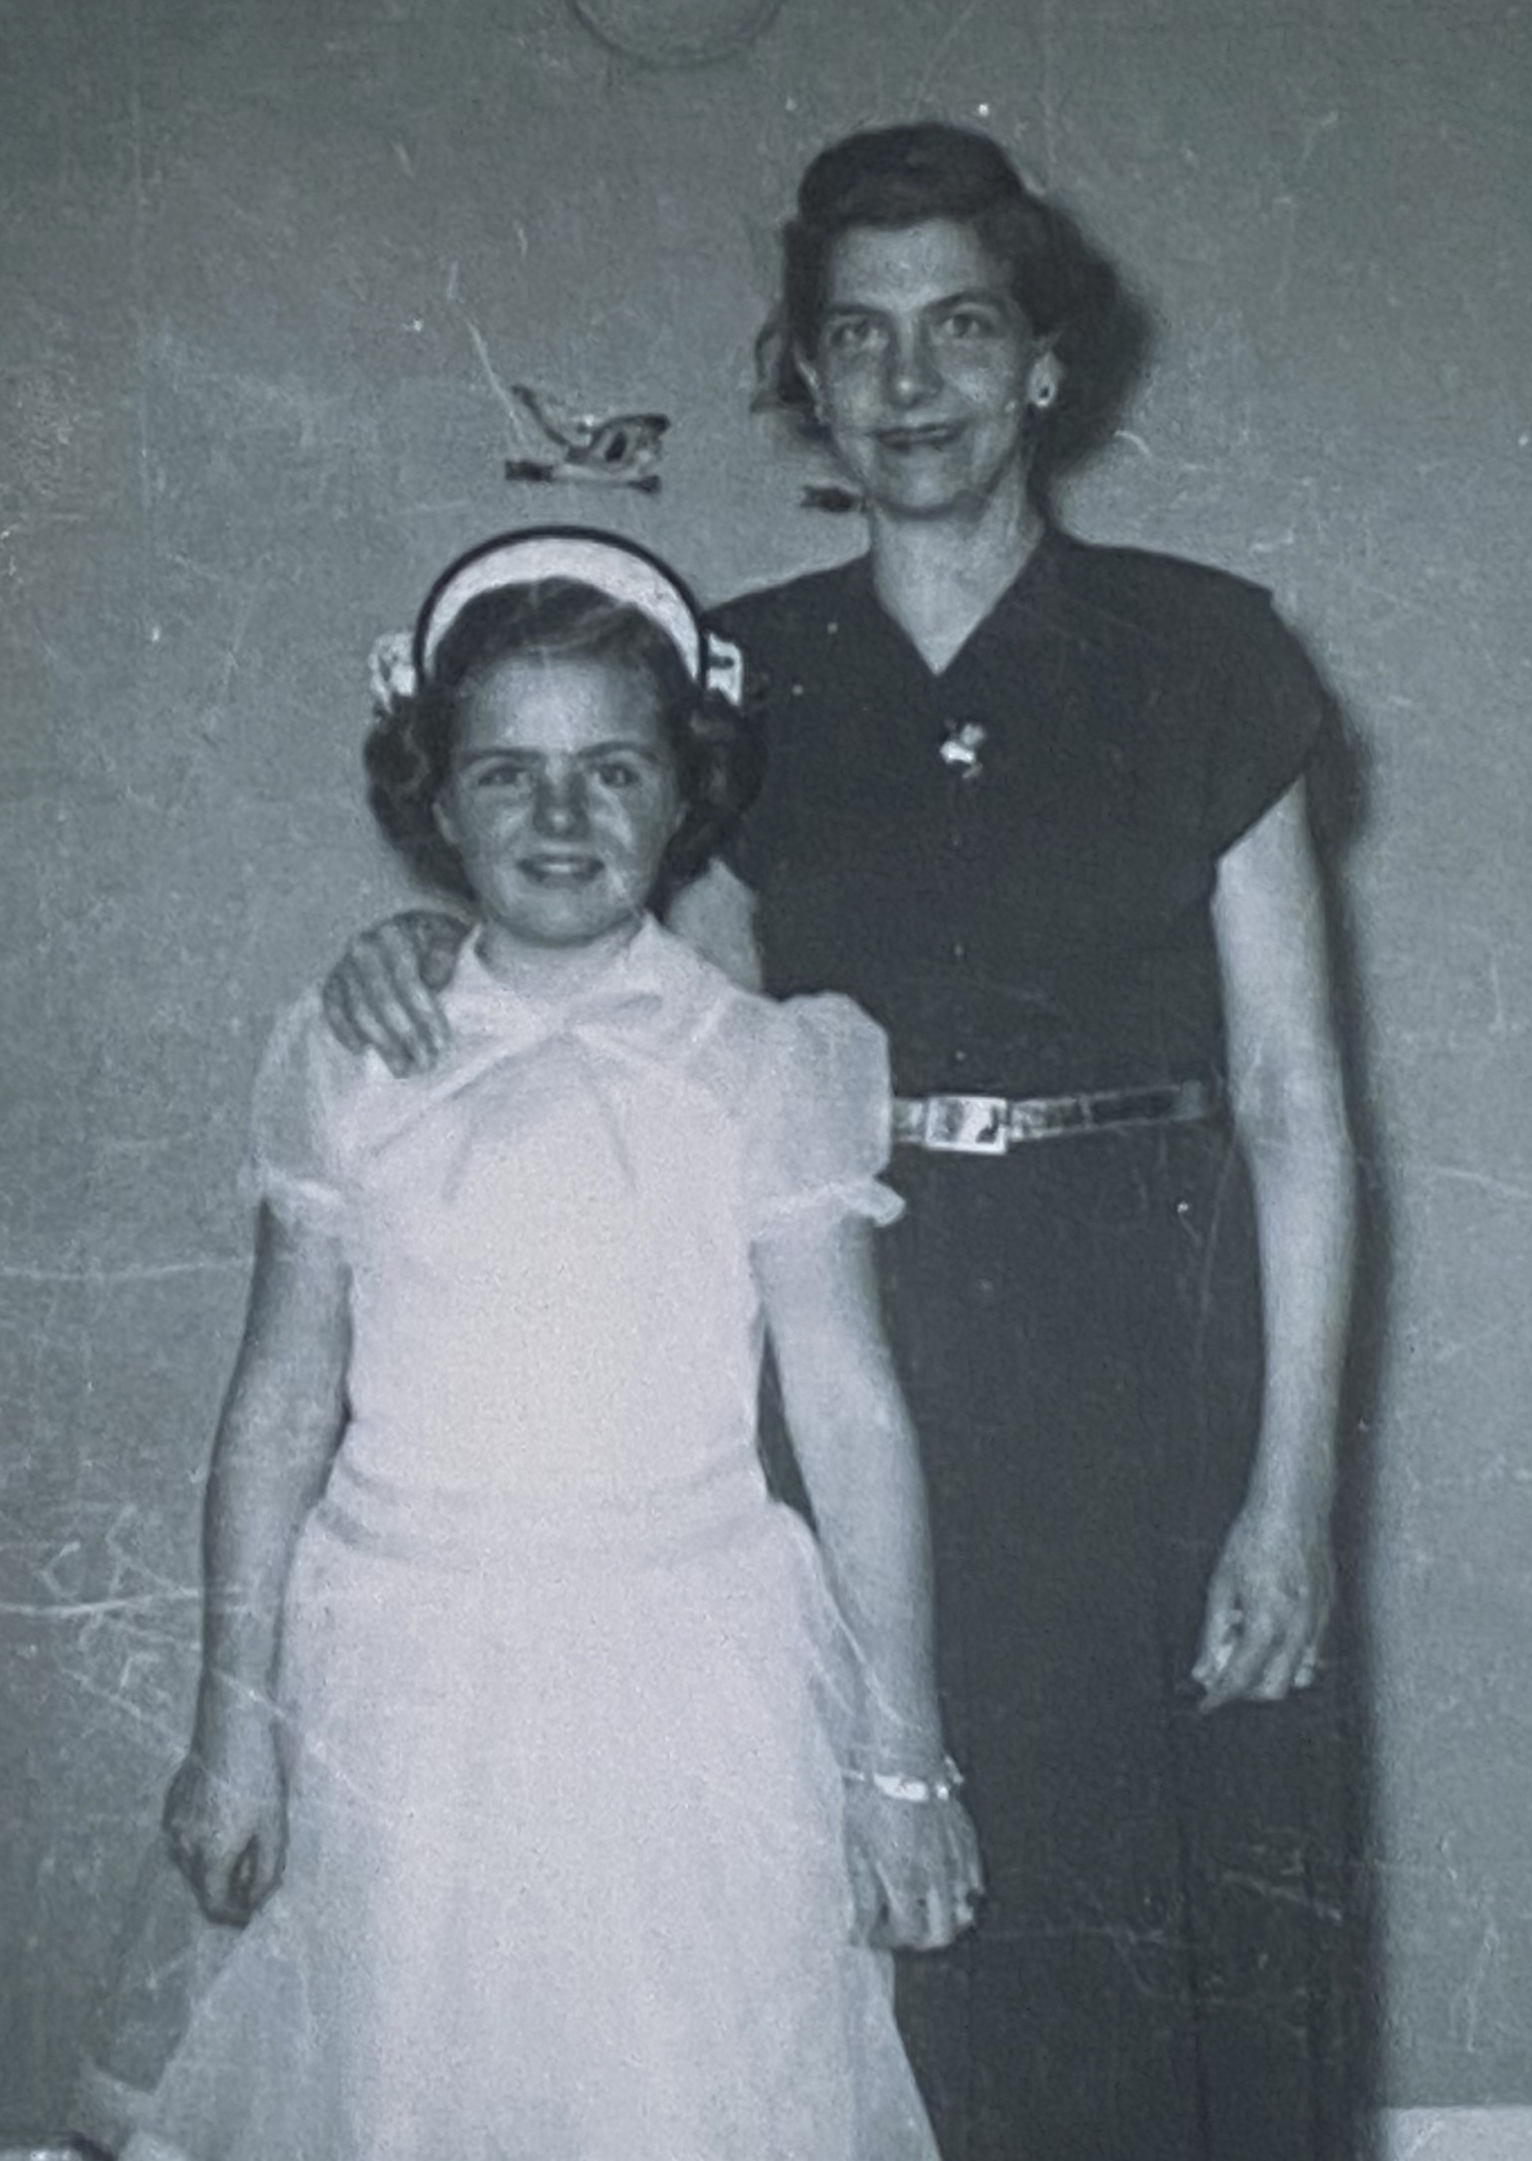

Lila and her niece, Patty Metcalf, circa 1952

Much of that year and the next were a blur. She reconnected with Veda—not because she trusted her, but to prove that Veda was wrong about her as a mother. Myrtle Joyce was thrilled to see her cousins again. Aunt Hattie died that year; Veda was horrified when Lila refused to go to the funeral. She couldn’t afford to miss work, but she enjoyed the look on Veda’s face when she told her she wasn’t going. She didn’t understand why Veda still admired her.

In truth, Lila’s life was just as much of a struggle as ever. There were months when she could barely afford the rent. At work, she snuck half-eaten meals out of the garbage so she could leave the food at home for the children. Emma gave the children baths and made sure they had clothes to wear. Later, she reflected how much Emma had loved all of them; she regretted that she was never able to return her many favors. When Alice turned five, Myrtle Joyce was the one who made their lunches and walked Alice to school.

Some of the regulars at the bar could not keep their hands to themselves. Although Lila had recoiled the first time Hank (the owner) touched her when she was behind the bar, she had grown used to the constant brushing and groping. One night, one of the regulars motioned for her to lean over. She assumed he wanted to order another drink, but he whispered into her ear, “Ten dollars.” Ten dollars for what? She was too busy at the time to think about it, so he was already gone by the time she understood. The next time he offered “ten dollars” she agreed to meet him behind the building after her shift. Unlike Jack, he didn’t wear a rubber.

That time when she got pregnant, it ended with a long and painful night in the bathroom. She didn’t go to the doctor. In fact, she didn’t say anything to anyone about it. The miscarriage was both a relief and a dark shame. The voice in her head was brutal. Slut! Whore! Why did you allow this to happen?! Couldn’t you just keep your legs together? For weeks she worked in a fog of regret and self-loathing. The sex was not rape, but there was no love in the transaction. She had just needed the money to pay the rent.

Chapter Fifty-Four

The next person she had sex with was Merlin. The pills were losing effectiveness; once again, she was tired all the time. He said he could fix that, but it would cost extra. How much? Two dollars per week. She must have looked shocked or desperate because after a few moments he added, “If you can’t afford it, we can set up a trade.”

Merlin had been a soldier. He had lost one of his ears to a sniper’s bullet, but he wore a fake and kept his hair a bit long. Most people didn’t notice. Lila wasn’t sure why he had decided to work in a bar. He didn’t sing or tell jokes. He didn’t even drink. He made the hamburgers and cheese curds and Reuben sandwiches without complaint, but it didn’t take much skill to be that kind of cook. Before he started working, there had been a series of cooks who quit after a few weeks. The job was boredom punctuated by burns from the deep fryer. Later, Merlin told her that he just enjoyed watching people: the regulars, the waitresses, the brawlers, and the criers. He thought they were all fascinating. He admitted that he made more money selling pills than he did as a cook. Everyone at the bar was a potential customer.

The trade with Merlin was a monthly night of sex, but it was never impulsive. He didn’t want to wear rubbers, but told her that if they had sex right after her period ended, she wouldn’t get pregnant. Could it really work? She had never heard of it before. After a few months she started to enjoy their time together. Like Jack, Merlin never gave any indication that he wanted to get married or be a father, yet Lila found herself fantasizing about sharing a life with him— cooking for him, waking up next to him, having someone who could share the burdens and joys of being a parent. Merlin was not fazed by her life as a single mother. He knew that she worked in a bar and didn’t judge her for it; she thought it was the best she could hope for.

There was just one problem with Merlin’s plan: Lila’s cycle was no longer regular. Was it the pills? Was it normal for her age? She had no idea. One time her period returned after just three weeks. Another time it took seven weeks. She wept from relief when she started bleeding again. What was she supposed to do about the bargain? One month she didn’t have her period and decided just to tell Merlin that it was ‘time.’

Late in the summer of 1953, Lila realized that she was pregnant. She didn’t want to say anything to Merlin, but she saw him every time she had to pick up a tray from the kitchen. The secret was eating away at her. It didn’t take him long to ask what was wrong. When she told Merlin that she was pregnant, he froze. After a pause that felt like hours, he said, “How is that possible?” Lila started to cry. She couldn’t cry at work, so she walked out to the back of the building. A few minutes later, Merlin followed her. “You can’t take those pills while you’re pregnant… you need to start tapering down right away.”

By the time she went to the doctor, she was no longer taking them. It had been a hard adjustment. The fatigue came roaring back, and she felt a crushing sense of sadness and doom. She was gaining weight (Merlin told her it was good for the baby) and the apartment was an absolute mess. She had put Myrtle Joyce in charge of washing the dishes, but they often sat in the sink for days. A few times she was so angry that she hit her with the cord from the iron. She felt bad for lashing out; it was terrifying to be so out of control. Alice was wetting the bed and Bonnie was teething. Lila had been through difficult times, but this was a new level of difficult.

At her appointment, the doctor said, “Your blood pressure is higher than I would like. I need to see you again in one week.” What did that mean? The doctor didn’t explain. The next time he said, “Mrs. Schneider… I’m concerned that you’re developing toxemia. Have you ever heard of that?” Lila nodded her head to say ‘no.’ “Since the start of this pregnancy, have you had any dizziness or vomiting?” “A little,” she said, thinking that it was probably because she had stopped taking the pills. In that moment, she wanted them so badly. The doctor asked her to raise her legs and pressed his fingers into her ankles. “Have you had any headaches or blurry vision?” Merlin had warned her that she would ‘feel like crap’ for a while, but he hadn’t been very specific. She had been so focused on getting off the pills that she hadn’t really considered how the pregnancy itself was affecting her.

After the doctor asked a few more questions he said, “Mrs. Schneider… for the health of you and your baby, I want you to go on bed rest. I want you to lay down and not get up for more than one hour per day.” Lila was shocked. What he was asking was impossible. “But how will I work? Who will take care of my children?” Sternly, the doctor said, “You need to figure this out right away. You could have a stroke, you could be damaging your liver and kidneys… you could even die from this.” He underscored his seriousness by gripping her shoulders and staring straight into her eyes.

When she left the hospital, her head was swimming. She went to work in a daze and somehow managed to work her shift, but it would be her last one. The next day she took the children to West Salem. When Myrtle Joyce asked, “Why are we not going to school today?” Lila snapped back: “Don’t ask questions… just do what you’re told.” When Gladys answered the door, she knew immediately that something was wrong. She told the children to go play and ushered Lila to the sofa. As Lila told her what the doctor had said, Gladys’s eyes grew wide with alarm. “I’m so sorry that this is happening to you, Lila. I’m glad you came to me for help.”

By the next day, Gladys and Lila had come up with a plan. Myrtle Joyce would go back to the orphanage in La Crosse. Alice would go with her father. Hazel and Bonnie would go with a family that Gladys knew from church. She reassured Lila that they were kind people who had a lot of experience with children; they lived on a farm a few miles from town. Gladys said that she would drop them off, but Lila said, “No, it’s my responsibility. I want to be with them until the last possible moment.” Gladys gave her the directions and the key to Carl’s truck. They hugged just before she drove off and Lila said, “Don’t cry, Gladys. If you cry… I’m going to cry, and I don’t think I’ll be able to stop.” Her throat was already clenching.

Lila didn’t know if she would ever see her daughters again, but when she left Hazel and Bonnie with the Jostads, she told them, “I’ll be back soon.” Dropping them off took all of Lila’s remaining energy. Gladys took Alice back to Herman. By then, Lila was getting so drowsy that Gladys had to leave Myrtle Joyce and her own children with Nora so she could drive her to La Crosse Hospital. They drove so fast that Gladys was sure she would get a speeding ticket.

Chapter Fifty-Five

Lila was in the hospital for three months. When she entered it was winter, when she left it was spring. Her son was born on March 8th, 1954. She had no idea what to name him. One of the attendants (who struck Lila as being incredibly young in her little pink apron) said, “I’ll help you come up with a name!” They chose Randy, which was a popular new name for boys. Lila was relieved that he seemed to be unharmed by the pills and the toxemia. He had a vigorous cry and was hungry all the time. Concerned that he wasn’t getting enough to eat, the nurses made him extra bottles with evaporated milk and corn syrup.

One day, Myrtle and Carl arrived during visiting hours. Lila was surprised to see them; in the last three years, they had rarely spoken. Myrtle was wearing a striped dress that made her hips look enormous. She was holding her handbag in front of her like a shield. She sat down in the chair next to the bed and Carl went into the hallway to find another one. For a few moments Lila stared at her while she looked at the door, waiting for Carl to return. Finally, Myrtle cleared her throat and said, “I want you to give your son to us.” “But why?” said Lila. “I won’t be in the hospital for much longer.” Myrtle glanced over at Carl, whose face was expressionless. Myrtle said, “You can’t keep living this way, Lila. Carl and I can adopt Randy and raise him as one of our own. It’s not right for your children to grow up with a single mother.”

Lila wanted to scream; the only thing that stopped her was knowing that the nurses would scold her for disturbing the ward and inject her with a sedative. She stared at Myrtle with such intensity that Myrtle shifted her gaze to the floor. After a few moments of silence, she stood up and Carl followed her to the door. Myrtle turned and said, “I know you’re upset, but think about it, Lila. Randy will have a stable home and two parents who love him.” And with that, they left the room. Lila was so enraged that the nurses gave her a sedative anyway.

Within a few days, her anger turned to sorrow. Myrtle was right. She wasn’t doing her children any favors by clinging to them. She had tried so hard to be a good mother, but it just wasn’t enough. The grief of that realization extended her stay in the hospital; the nurses were worried about her fragile state of mind. By the time she was ready to be discharged, she had decided that Myrtle and Carl could have her son. A nurse brought her the adoption papers.

As she held Randy for the last time as his legal mother, the nurse said that they would release him to the Schneiders. With a compassionate tone, she said, “I know this is hard, but you’re doing the right thing. The hospital will take care of the rest.”

Leaving the hospital without a child in her arms was the worst feeling she could have imagined. She had never felt so ashamed and full of grief. Gladys had visited her several times during her stay in the hospital, but she was not there the morning Lila was discharged. A social worker had given her money for a cab. She asked the driver to stop at the apartment, but she was not surprised to find that her key no longer worked. There had not been enough time (or money) to make arrangements with the landlord. Now she had no home, no possessions, no job, and all of her children were gone. Was she even still a mother? In a fog of disbelief, she gave the driver directions to Emma’s house.

Summer arrived early that year, but Lila felt so cold and completely empty. How was she going to get Myrtle Joyce out of the orphanage again when she could barely get out of the house? Emma urged her to go back to the doctor. He was dismissive when she described how tired she was, but when he felt her neck during the exam he said, “Hmm… you do have a goiter. I’ll write you a prescription.” Lila froze and said, “No pills, I don’t want to take anything.” The doctor forced her to take the prescription, but she never went to the pharmacy.

Unable to bear the thought of walking across the bridge, Lila had decided to take the first job on French Island that she was offered. It was at the tavern on Bainbridge Street, the one she had rejected after Hazel was born. Nothing had changed; it was just as dark and creepy as she remembered. “Beggars can’t be choosers,” she thought ruefully. Without an income, she had no hope of renting an apartment. Even Emma wouldn’t tolerate her forever.

Chapter Fifty-Six

The tavern was small with just one other waitress. Mildred never told her how old she was, but Lila thought she must be at least in her 40s. She looked (as Merlin would have said) ‘ridden hard and put away wet’ with streaks of gray hair, sagging breasts, and a tight, leathery face. Most of the men at the bar were older too: working men who had retired from their jobs and moved to French Island for the excellent fishing. The bar didn’t have a full menu, so the owner’s brother doubled as the bartender and cook. It was smaller than the other places Lila had worked and easily the most depressing. The light fixtures were yellow from years of cigarette smoke; it was always dim inside regardless of the weather.

Lila had enough energy to work (barely), but inside she felt like something had broken. Maybe forever. One of the regulars had a son who was a police officer in Prairie du Chien. He often drove up to La Crosse to go fishing and drinking with his father. They both swore like sailors and told horrible, vulgar jokes. He flirted with Lila, but so did most of the other men. Why did she agree to have sex with him? If she was being honest, it wasn’t really about the money (although he offered her more than usual—twenty dollars). She did it just to feel alive; to see if she could still feel something: desire, anger, happiness, grief. Anything.

Emma had always been so kind and supportive, but her face fell when Lila told her that she was pregnant again. At her first doctor’s appointment, her blood pressure was already high. The doctor told her that she would have to stay in the hospital until the pregnancy ended or the baby was born. By the time an orderly arrived with a wheelchair, her mind was as lifeless as a rabbit in the mouth of a fox.

Lila was not the one who named her last child. Larry was taken away immediately by the state of Wisconsin and placed into foster care. Her health had been declining since the pregnancy with Randy, but this time the doctors told her that she *must not* have another child; the stress on her kidneys would kill her. The adoption triggered an investigation. A social worker pressed her for information: where were her other children?

She was shocked when the state charged her with child neglect for leaving Hazel and Bonnie with the Jostads. The social worker pointed out that they were not family and were not registered in the foster care system. Lila said, “How was I supposed to know?” There wasn’t time to investigate before I dropped them off… it was an emergency.” The social worker had given her a handkerchief and it was already soaked. She continued, “I see your point of view, Lila, but we need to sort this out. The state needs to ensure that your children are safe.”

When the state pressed Herman for information, he filed for divorce. He had promised to treat Myrtle Joyce like his own child, but in court he only took responsibility for John and Alice. It was a bitter ending to their marriage. Lila had given up years before on getting back together, but she was stunned to be divorced. Marriage was supposed to be forever.

She was also stunned when the state began giving her welfare; she had never thought to ask for support. Faced with a choice between giving her daughters up for adoption (minus Alice, who had been claimed by Herman) or trying once more to raise them, she decided to give it her best. A social worker helped her find a new apartment near Copeland Park, but being a mother again was rough. Hazel was six years old, and Bonnie was five. They had been away for two years and barely remembered her. Myrtle Joyce was twelve years old and had a hot temper. It reminded Lila of her own mother; sometimes, when Myrtle Joyce yelled, Lila felt like a small child again. She had no idea how to repair the years of damage they had all endured.

Lila eventually found another job in a bar. For the rest of her life, she resisted taking any pills; however, she often drank to numb her feelings, which felt like impossible burdens.

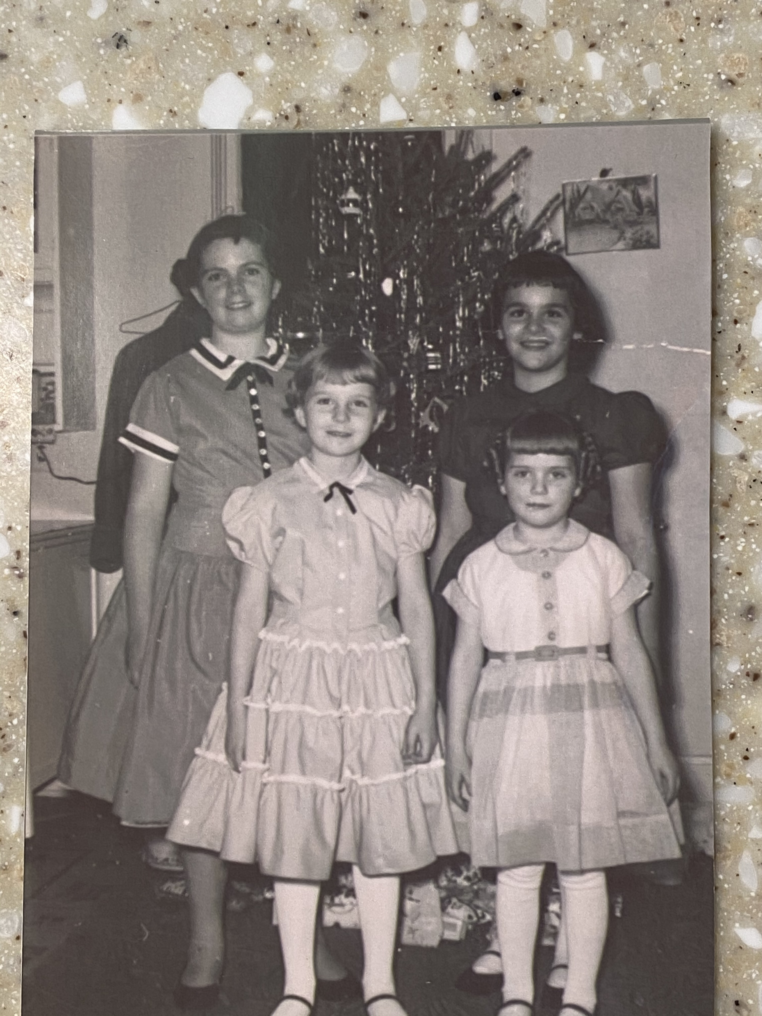

Myrtle Joyce, Alice, Hazel, and Bonnie, Christmas 1956

Chapter Fifty-Seven

The seizures started in 1957. Lila fainted at work and couldn’t be revived; she was taken to the hospital in an ambulance. She half expected to be told that she was pregnant again, even though she had turned down all offers of sex for the last two years. At first, the doctors were not sure what was wrong and told her they would need to run some tests. In the end, they said her symptoms were probably from the repeated pregnancies and toxemia; her kidneys were damaged and her blood pressure was out of control. Out of shame and misplaced loyalty, she never told them about the pills from Merlin.

The hospital asked her for her next of kin. She didn’t trust anyone and didn’t want to give them a name. Are your parents still alive? What about a sibling? She never did tell them anything, but they found her parents and brothers based on her last name. Reluctantly, she had returned to using her maiden name after the divorce; she felt like she had burned all of her bridges with the Schneiders.

By the time her father visited the hospital, she was in and out of consciousness. The seizures were lasting longer and becoming more frequent; Lila knew she was dying. Her father asked what she wanted to do with the girls. In tears she said, “I want Hazel and Bonnie to stay together.” When she was unable to leave the hospital, the state had sent them to live in the orphanage. In a flat tone that she could not read, her father said, “Izro will take them.” The thought was comforting. She had barely seen Izro in the last ten years, but she trusted her more than Veda and her mother.

Myrtle Joyce was fourteen and looked so much like her father. Sometimes in her dreams, Lila saw the men who had drifted in and out of her life: Lloyd, Daniel, Herman, Jack. Aside from John and Alice, she had never named the fathers on the children’s birth certificates. The social workers had asked repeatedly for names, but she didn’t know what to tell them. She didn’t know the men who had raped her; even years later, it gave her nightmares to think about the attack that led to Hazel’s birth.

The damage to her kidneys caused her body and face to swell uncontrollably. One day, a nurse gave her a mirror to hold while she brushed her hair. Lila barely recognized her own image.

*Epilogue*

When Lila died on October 7th, 1958, she was only 36 years old. She never knew what was in the pills that Merlin gave her. During World War II, Nazi troops were given enormous supplies of methamphetamine to help them overcome exhaustion.[3] When US troops entered the war, they were given amphetamines for similar reasons. They found that it not only kept them awake, but made them more focused, optimistic, and less hungry.[4] Both stimulants are highly addictive, increase users’ heart rate and blood pressure,[5] and are known to cause pregnancy complications, including pre-eclampsia[6] (previously known as toxemia).

In the 1940s and 50s, only five percent of white women in the United States were single mothers.[7] Social services like welfare were available, but many women were either unaware of them or too ashamed (perhaps too proud) to accept support from the government. When World War II ended, many women—even if they were married and/or well-educated—were frozen out of jobs that paid well enough to support a family.

At the end of her life Lila thought the Schneiders had abandoned her, but they had not. Despite the divorce, Herman claimed her body and buried her as “Lila Schneider” in Neshonoc Cemetery just north of West Salem. Four years after her husband died, Emma married Herman and they lived together until he died from a heart attack in 1973. Having met because of Lila’s children, they wanted to take Myrtle Joyce, Hazel, and Bonnie, but the state would not allow it since they had too little income and no legal claims. John lived with his father and Emma until 1963 when he was tragically killed in a tractor accident.

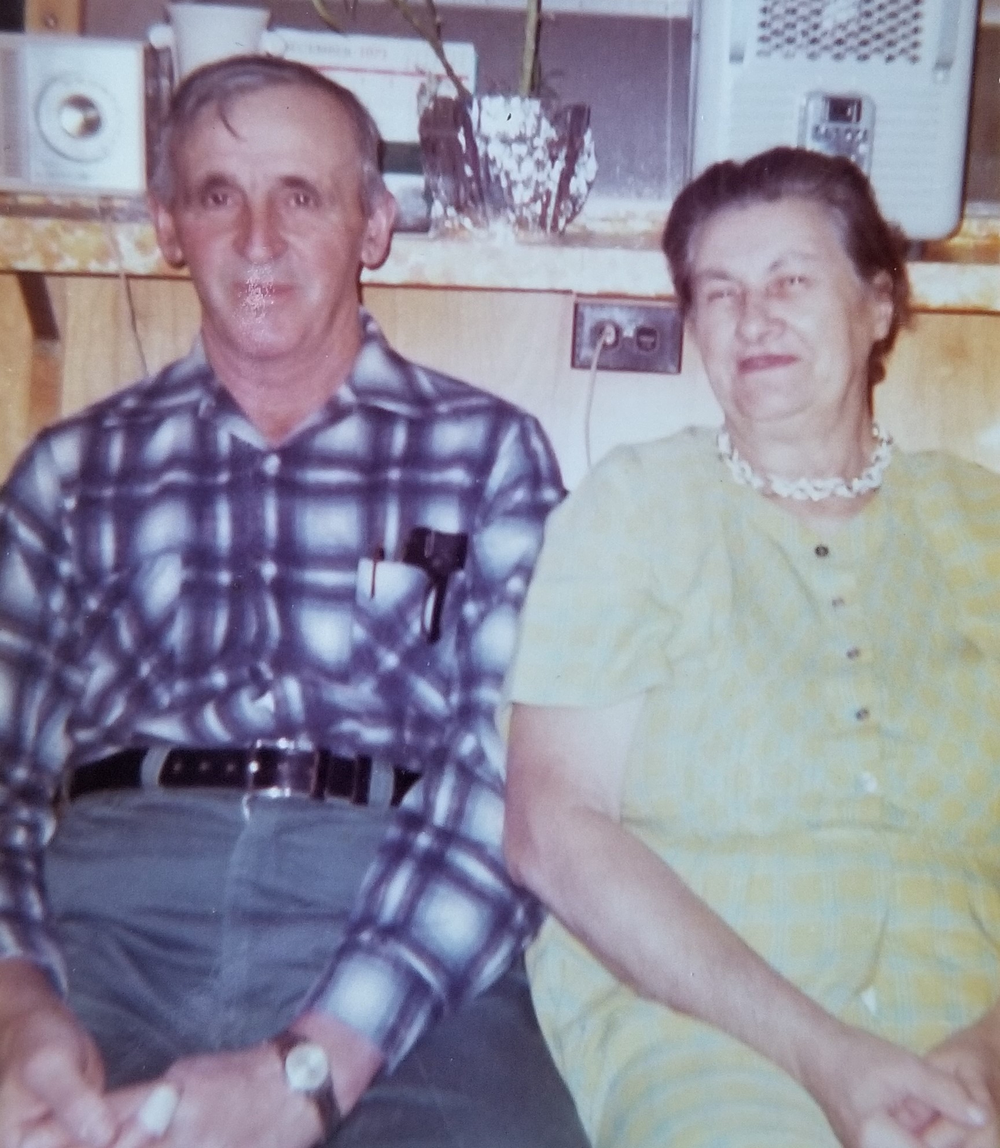

Herman and Emma, circa 1972

Like her mother, Alice struggled to live with Herman on the farm. She shuffled through various living arrangements including the orphanage and foster homes. As a teenager, she went to live with Myrtle and Carl Schneider and stayed with them during high school. Unlike her half-brother Randy, they did not adopt her.

After Lila’s death, Myrtle Joyce lived in foster homes until she aged out of the system. In 1964 when she became engaged, the announcement in the newspaper listed Herman Schneider as her father. Hazel and Bonnie were sent to live with Izro's son, LeRoy, however, the arrangement did not last. After LeRoy had a heart attack and his wife became pregnant again, they decided to give custody back to the state and the girls were sent to an orphanage. They were adopted by an unrelated couple with no biological children of their own. When the adoption papers were drawn up, Hazel requested to change her name to June. As adults, all of the siblings (including Larry) managed to find one another again and have stayed in touch.

Both of Lila’s parents outlived her by more than a decade, but none of the Slabacks took custody of her children for more than a few months. Veda died from cancer in 1971. She never went to nursing school and never worked outside of the home after she was married to Red. Her daughter, Patty, still visits Myrtle Joyce from time to time.

The effects of Lila’s life continue to ripple through the generations; she now has fifteen grandchildren and more than two dozen great-grandchildren, including me and my children. I was never encouraged to think of her as anything but a problem, but the process of writing this book has reshaped what I think about her life. She tried so hard to be herself and to live on her own terms, regardless of what anyone thought about her. This is the kind of courage it takes to disrupt generational patterns of dysfunction and discrimination. Lila paid a steep price, but with her story out in the open, I choose to draw from her strength and resilience.

Note:

I have done extensive historical research to recover this story, but I have compressed some events and guessed at many details. Any errors are my fault alone.

1. Ann Fessler (2006), *The Girls Who Went Away: The Hidden History of Women Who Surrendered Children for Adoption in the Decades Before Roe v. Wade*, New York: Penguin Books.
2. The WAVES (Women Accepted for Volunteer Emergency Service) was a program established in 1942 that allowed women with a high school diploma to enlist in the US Navy. Since she had not graduated from high school, Lila was not eligible to join.
3. R.J. Defalque and A.J. Wright (2011), “Methamphetamine for Hilter’s Germany: 1937-1945,” *Bulletin of Anesthesia History*, 29(2): pp. 21-4, 32.
4. Nicolas Rasmussen (2015), “Amphetamine-Type Stimulatnts: The Early History of Their Medical and Non-Medical Uses,” *International Review of Neurobiology*, 120: pp. 9-25.
5. Magnus Chan, Jocelyn Joy Chan, and James M. Wright (2020), “Effects of Amphetamines on Blood Pressure,” Cochrane Database of Systemic Reviews, <https://doi.org/10.1002/14651858.CD007896.pub3>
6. Vorapong Phupong and Darigar Darojn (2007), “Amphetamine Abuse in Pregnancy: the Impact on Obstetric Outcome,” *Archives of Gynecology and Obstetrics*, 276: pp. 167-170.
7. Donald J. Hernandez, *America’s Children: Resources from Family, Government, and the Economy*, New York: Russell Sage Foundation., See chart on page 309.